10 www.employmentnews.gov.in Employment News 7 - 13 May 2022

OFFICE OF THE DIRECTOR GENERAL ASSAM RIFLES, SHILLONG -793 010
ASSAM RIFLES TECHNICAL AND TRADESMEN RECRUITMENT RALLY 2022
(www.assamrifles.qov.in)

Memo No. 1.12016/Rect Branch/2022/195 Dated: 13 Apr 2022
- Last date of receipt of applications from eligible candidates for Assam Rifles Technical and Tradesmen Recruitment Rally 2022 is 20 Jul 2022 (23:59 hrs). Applications received thereafter will not be entertained. The online application SERVER will start functioning from 06 Jun 2022.
- Applications will be accepted through online mode only.
- Assam Rifles Technical and Tradesman Recruitment Rally 2022 is tentatively scheduled from 01 Sep 2022 onwards for enrolment into Group Band C posts against 1281 vacancies based on applications received from eligible male/ female candidates for the trades/ posts as mentioned in Appendix 'A' & 'B' . Candidate must be a citizen of India. Vacancies have been earmarked State/UT wise hence a candidate must submit Domicile/Permanent Resident Certificate (PRC) of State/UT while filling online application form. If a candidate produces Domicile/PRC issued by a State other than the State mentioned in his/her application, he/she shall not be allowed to change the State at the time of Verification of documents and his/her candidature shall be cancelled
straightaway. Therefore candidates should fill the application form very carefully.
- Candidates will be considered for recru itment in their respective State/UT on production of valid "Domicile/Permanent Residential Certificate (PRC)" issued by the Competent Authority so authorized by the concerned State/UT to prove their domiciliary status.

This notice is also available on the official website of the Assam Rifles at www.assamrifles.gov.in.
- How to Apply. To app ly, fill up the online application by clicking on "ONLINE APPLICATION" option on the website. The candidates will fill the requisi te details as­ prescribed in the application form. After the application has been filled up, the candidates has the option to make online payment via link given for online payment or alternatively the payment can be made at SBI Bank Counters as well. In both options the candidate will have to upload copy of the challan or receipt online.

- AGE RELAXATION. Age Relaxat ion available to different category of eligible candidates are as under·­

- 10% vacancies are earmarked for Ex-servicemen (ESM) In Rehg1ous Teacher, Operator Radio and Line, Armourer and AYA trades . If suitable ESM candidates are not available , vacancies reserved for ESM will be filled by non-ESM candidates of respective categories. All three Armed Forces i.e Regular Army, Navy and Air Force of the Union will be treated as Ex-Servicemen .
(a) | SC/ST - 5 years
(b) | OBC - 3 years
(c) | Serving Assam Rifles personnel (Gen/OBC) - Upto 40 years of age for Clerk and Upto 35 Years of age for Religious Teacher.
(d) | Serving Assam Rifles personnel (SC/ST) - Upto 45 years of age for Clerk Upto 35 Years of age for Religious Teacher.
(e) | Ex-Servicemen (UR) - 3 years after deduction of the military service rendered from the actual age as on the date of reckoning.
(f) | Ex-Servicemen (OBC) - 6 years (3+3) years after deduction of the military service rendered from the actual aqe as on the date of reckoninQ.
(g) | Ex-Servicemen (SC/ST) - 8 years (3+5) years after deduction of the military service rendered from the actual age as on the date of reckoning.

- Physical Standard Test (PST) for Naib Subedar (Religious Teacher), Warrant Officer (Veterinary Field Assistant), Warrant Officer (Radio Mechanic), Havildar (Operator Radio and Line). Rifleman (Nursing Assistant), Rifleman (Laboratory Assistant), Rifleman (Armourer) and Rifleman (Washerman) only.
SI Categories/States regions Chest for Male onl
No
  - For all cand idates except those mentioned below
ems ems ems

Candidates while reporting for Physical Standard Test (PST)/ Physical Efficiency Test (PET) will produce original copy of payment receipt / challan for official records . In case of non submission of receipt / challan the application may be rejected . The candidates will also produce the printed copy of ohline Application Form duly completed and a copy of notificati on downloaded from the Assam Rifles website, failing which the candidature of the applicants may be rejected. The online applications portal will be functioning from the day of publica tions of the advertisement to the last date of receipt of the applications.
5. All further information regarding conduct of various events of the recruitment rally will
be intimated to the candidates through Email/SMS only. Hence, providing functional
- Min imum height for the candidates falling in the
catego ries of Garh walis , Kumaonis , Gorkhas, Dogras, Marathas and candidates belonging to the State of Assam , Nag aland , Manipur , Mizoram, Tripura, Arunachal Pradesh, Meghalaya, Himac hal Pradesh , Kashmir, Leh and Ladakh Divisions of Jammu and Kashmir States.
- The minimum height for all candidates belonging to the Scheduled Tribes
19 t correspon Ing to eIg tan age as per me Ica stan
165
ems

162.5
ems
78
ems

76
ems
83
ems

81
ems

Email ID and mobile phone number in Online Application Form by the applicants is mandatory. The mobile phone number so provided should not be DND activated. The candidates will be responsible for non-receip t of informa tion re ga rding recruitment process due to providing of wrong Email ID and mobile phone numbe rs in Online
- Phy sical Standard Test (PST! for Naib Sube dar (Bri ge oa on y.
5/ Chest for
No Cate gories/ States regions Height Male only
Male Female Normal Ex ended

Application Form filled by them. Before submissio n of the online application, candidates must check that they have filled correct details in each field of the form. After submission of the online application form, no change/correction/modification
- For all canqidates except those mentioned
below

Relaxation
170 155 80 85
ems ems ems ems

will be allowed under any circumstan ces. Reques t received in this regard in any form like Post, Fax, Email, by hand etc shall not be entertained. Assam Rifles will not be responsible for the candidates not being able to submit their applications for any reason before closing date.
6. Application Fee. Fee structure and other details are as follows: - (a) Fee Structure: For Group B posts (i.e Religious Teacher and Bridg e & Road posts only) application fee is Rs. 200/- (Rupees two hundred only) and for Group C posts (i.e except Religious
- Cand idates falling in tl\e categories of hill areas of Garhwal, Kum aon, Himacha l Pradesh , Gorkhas, Dogras, Marathas, Sikkimies, Leh and Ladakh, Kashmir Valley and North Eastern States.
- The minimum height for all candidates belonging to the Scheduled Tribes.
165
ems

162.5
ems
155
ems

150
ems
78
ems

76
ems
83
ems

81
ems

Teacher and Bridge & Road posts) application fee is Rs. 100/- (Rupees one hundred only). (b) The fee will be deposited online by the candidates into SBI Current Account
Wight corresponding to height and age as per medical standard (For males and females)

Physical Standa rd Test (PST) for Havildar (Clerk) only.

No. 37088046712 in favour of HQ DGAR, Recruitment Branch, Shillong-10 at SBI SI
Laitkor Branch IFSC Code - SBIN0013883. (c) NO Fee is charged from candidates No

Categories/States regions

Height
Chest for Male only

belonging to Schedule Casts, Scheduled Tribes, Female and Ex-servicemen

Male Female Normal Expended

candidates. Fee once paid shall not be refunded under any circumstances nor will it be adjusted against any other expenses.
  - Centres for Physical Standard Test (PST) / Physical Efficient Test (PET)/Written
- For all candidates except those mentioned below
Relaxation
165 155
ems ems
77 82
ems ems

Test: PST, PET and Written test will be conducted at following centres. Centre and reporting date for PST/PET/Written test will be informed later through notification on the official website of the Assam Rifles at www.assamrifles.gov.in after successful submission of the online application . Option for choosing a centre is not available:­
  - Diphu (Assam), Karbianglong (Assam) (b) Sukhovi (Nagaland) (c) Dimapur (Nagaland) (d) Silchar, Masimpur (Assam) (e) Haflong (Assam).
  - Candidates seeking reservation benefits as Scheduled Castes/Scheduled Tribes/ Other Backward Classes/Economically Weaker Section (EWS) must ensure that they are in possession of the certificates in proper format prescribed by the competent authority in support of their claim at the time of reporting for Physical Efficiency
  - Candidates falling in the catego ries of Garhwalis , Kumaonis, Gorkhas, Dogras, Marathas and candidates belonging to the State of Sikk im, Nagaland , Arunachal Pradesh , Manipur , Tripura , Mizoram, Meghalaya, Assam, Himachal Pradesh, Kashmi r and Leh and Ladakh regions of Jammu and Kashmir.
  - The minimum height for all candidates belonging to the Scheduled Tribes.
162 .5
ems

162.5
ems
150
ems

150
ems
77
ems

76
ems
82
ems

81
ems

Test (PET), Physical Standard Test (PST) & Documents verification.
9. Candidates seeking relaxation in physical standards i.e. height. weight & chest by
Weight corresponding to height and age as per medical standard (For males and females)
- Physical Standard Test (PST) for Rifleman (AYA) Para-Medical Female only.

virtue of belonging to the specified categories (i.e. Garhawalis. Kumaonis , Gorkhas. SI
Dogras and Marathas) as applicable will have to furnish appropriate certificate as No

Categories/States regions

Height
Chest for Female

per format duly issued by the competent authori ty. ST candidates may avail the
- For all candidates exce t those mentioned below.
157 ems

relaxation on the production of valid ST certificate in support of their claim at the time of reporting for Physical Standard Test (PST), Physical Efficiency Test(PET).

10 . CANDIDATE BELONGING TO THE PHYSICALLY HANDICAPPED CATEGORY ARE NOT ELIGIBLE TO APPLY FOR THIS EXAMINATION .
- Only a single application per candidate will be accepted through online mode. Multiple applications will not be accepted.
- The minimum height of candidates falling in the categories 155 ems of Garhwalis, Kumaonis, Dogras, Marathas and candidates belonging to the states of Assam , Himachal Pradesh and
Jammu and Kashmir.
- The minimum height for candidates belonging to 150ems Scheduled Tribes (ST) except North Eastern States.

- Change of category and trade during any stage of the recruitment rally will not
be entertained.
- MOBILES AND OTHER ELECTRONIC GADGETS ARE BANNED WITHIN THE PREMISES OF RALLY SITES/TEST CENTRES.
- Qualitative Requirement and Age Criteria. The Qualitative Requirements (QRs) and age criteria for enrolment into advertised trades are mentioned at Appendix-A.
- Candidates should note that only the Date of Birth and Name as recorded in the Matriculation/ Secondary Examination Certificate or an equivalent certificate will be accepted by the Assam Rifles for determining the age and name. Subsequent request for its change will not be considered or granted.
- Cut off Date and Age Limit. 18-23 years as on 01 Aug 2022 will be the cut off date
- The minimum height for candidates hailing from North Eastern States ofArunachal Pradesh, Manipur, Meghalaya, Mizoram , Naga la nd, Sikkim and Tripura and Gorkha Territorial Administration (GTA) comprising of the three Sub-Division of Darjeeling District namely Darjeeling, Kalimpong and Kuresong.
- The minimum height for all Scheduled Tribes (ST) candidates hailing from the North-Eastern States of Arunachal Pradesh, Manipur, Meghalaya , Mizoram , Nagaland , Sikkim and Tripura and left Wing Extremism affected districts.
152.5
ems

147.5
ems

Exempted

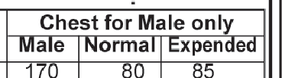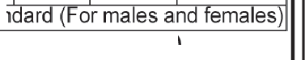for all candidates for determining the age criteria. Candidates should not have been born earlier than 01 Aug 1999 and later than 01 Aug 2004.
Weight corresponding to height and age as per medical standard for females)
Continued on page 11

!Continuedfrom page 10 I
- Physical Efficiency Test (PET) . (a) PET will be conducted for all the candidates qualified in initial verification of the documents . The parameters for PET are follows:
- (a)AII India except Ladakh Region (i) For Male Candidates -05 km run to qualify within 24 minutes. (ii) For Female Candidates -1.6 kmruntoqualify within 8.30 minutes. (b) Ladakh Region (i) For Male Candidates - 1.6 Km run to qualify within 6.30 minutes. (ii) For Female Candidates - 800 meter run to qualify within
4.00 minutes. (c) An undertaking certificate from each female candidates will be obtained by the board of officer before undergoing PET duly declaring that she is not pregnant. . A female candidate, who as a result of tests is found to be pregnant of 12 weeks standing or over, shall be declared temporarily unfit and appointment be held in abeyance until the confinement is over. The vacancy against which a women candidate was selected will be kept reserved for her. She will be re-examined for Physical Efficiency Test (PET) (six weeks after the date of confinement), subject to the production of medical certificate of fitness from a registered medical practitioner. The candidates who are successful in the PET/PST/Documentationwill be considered eligible for short-listing to the next stage i.e. Trade Test, Written Test, Detailed Medical Examination.
- Trade Test (Skill Test): Trade (Skill) Test for technical & tradesmen personnel will be conducted after the completion of PET/PST in continuation. No marks will be awarded for trade (skill) test. The candidates declared pass in the trade (skill) test will only be allowed to appear in the Written Test.
- Written Test: The question paper of written test will comprise of 100 marks. Minimum pass marks for General/EWS candidates is 35% and 33% marks for SC/STIOBC candidates. The candidates who are successful in the PET/PST/Documentatio/nTrade (Skill) test/Written test will be short-listing to the next stage ie and Detailed Medical Examination (DME) on the basis of their merit in the Written test will be about 4 times of the number of vacancies.
- Detailed Medical Examination (DME) and Review Medical Examinati on (RME): Detailed Medical Examination (DME) and Review Medical Examination (RME) will be conducted in terms of Uniform Guidelines for recruitm ent Medical Examination for GOs and NGOs in CAPFs and AR issued vide MHA UO No. AVl -1.12014-Rectt(SSB) dated 20.05.2015 and MHA OM No E.32012/ADG(Med)/DME&RME/DA-1f2020(Part File)/1166dated 31.05.2021 and as amended from time to time by the government. Rev iew Medical Examination (RME) of U fit candidat es in Detailed Medical Examination (DME) will be conducted in continuation.
- Merit List and Call for Training: The candidates who qualify in all aspects i.e Physical Standard Test (PST), Physical Efficiency Test (PET ), Trade Test (Skill Test), Written Examination and Medical Examination Test will be placed in Merit List depending upon the trade and category wise vacancie s allocated to States I UTs. Instruct ions to join the Training Centre for enrolment will be issued on the basis of Merit List. Please note that merely qualifying in all tests does not guarantee the Final Selection into the Assam Rifles. The Final Selection will only be made on the basis of position of the candidates in Merit List in accordan ce with the availability of vacancies against respective State/UT/ Category/ Trade.
- Pay Scale: Pay scale and other allowances will be applic able/admissibleas per the pay scale applicable to the Assam Rifles Personnel.
- Rejection of Applications: In case the information furnished by the candidates in the Application Form is found to be false at any stage of the Recruitment Rally and even at a later stage, the candidature of such candidates will be summarily rejected without any notice . Appropriate action will also be taken against such candidates as per the provisions of law by registering an FIR with the Police.
- Vacancies are tentative and may increase or decrease. The vacancies so notified are subject to variation and the Department has right to make any changes in the advertisement or cancel it without assigning any reasons.
31 Compassionate ground appointment scheme is not applicable in this Rally.
Appendix-'A' .
TRADE/ INITIAL RANK/ EDUCATION QUALIFICATION/ AGE LIMIT
- Trade -Bridge & Road. (Both Male & Female candidates), Initial Rank-Naib Subedar, Education Qualification - (a) Matric or equivalent from a recognised Board or University.
- Diploma in civil engineering from a recognised institution for Bridge and Road , Age Limit - 18-23 Years.
- Trade - Clerk. (Both Male & Female candidates), Initial Rank - Havildar, Education Qualification - (a) Intermediate or Senior Secondary School Certificate (10+2) examination from recognized Board/Uni versity or equivalent. (b) Skill Test Norms on Computer. English typing with minimum speed of 35 words per minute on computer OR Hindi typing with minimum speed of 30 words per minute on computer (Time allowed-10 minutes). Age Limit- 18-25 Years.
- Trade - Religious Teacher. (For Male candidates only), Initial Rank - Naib Subedar, Education Qualification - (a) Graduation with Madhyama in Sanskrit or Bhusan in Hindi (b) Age Limit - 18-30 Years.
- Trade -Operator Radio and Line. (For Male candidates only), Initial Rank - Havildar, Education Qualification - Matriculation pass or equivalent from a recognised board and two years Industrial Training Institute in Radio and Television or Electronics from a recognised Institute or 12th class pass or equivalent with Physics, Chemistry and mathematci s as subjects of study from a recognised Board or University or Institute. Age Limit- 18-25 Years.
- Trade - Radio Mechanic. (For Male candidates only), Initial Rank - Warrant Officer, Education Qualification - 10th from a recognised board with diploma in Radio and Television Technology or Electronics or Telecommunications or Computer or Electrical or Mechanical Engineering or Domestic appliances from any institution recognised by the Centra l Government or the State GovernmentOR 12 Standard or Intermediate or equivalent with aggregate marks of fifty percent with Physics, Chemistry and Mathematics from a recognised or University or institution . Age Limit- 18-23 Years.
- Trade - Armourer. (For Male candidates only), Initial Rank - Rifleman , Education Qualification - 10th class pass from a recognised Board. Age Limit - 18- 23 years.
- Trade - Laboratory Assistant. (For Male candidates only), Initial Rank - Rifleman, Education Qualification - 10th class pass with English , Maths, Science and Biology from a recognized Board, Age Limit - 18-23 Years.
- Trade - Nursing Assistant. (For Male candidates only), Initial Rank - Rifleman, Education Qualification - 10th class pass with English , Maths, Science and Biology from a recognized Board, Age Limit - 18-23 Years.
U) Trade - Veterinary Field Assistant. (For Male candidates only), Initial Rank- Warrant Officer, Education Qualification - 10+2 pass with two years diploma certificate in veterinary science from recognized University I Institute with one year experience in Veterinary field. Age Limit - 21-23 Years.
- Trade -AVA (Para-Medical}. (For Female candidates only), Initial Rank - Rifleman , Education Qualification - 10th class pass from a recognised Board. Age Limit-18-25 Years.
  - Trade• Washerman. (For Male candidates only) Initial Rank - Rifleman , Education Qualification - 10th class pass from a recognised Board. Age Limit - 18-23 Years.
Appendix- 'B'.
STATE/CATEGORY WISE ALLOTMENT OF VACANCIES ASSAM RIFLES TECHNICAL & TRADESMEN RECRUITMENT RALLY: 2022
S/No Trade SC ST OBC EWS GEN Total
    - Andaman & Nicober
(a) Havildar (Clerk) 0 0 0 0 1 1
Total 0 0 0 0 1 1
    - Andhra Pradesh
- Havildar (Clerk) 4 2 4 2 10 22
- Havildar (Operator Radio and Line) 5 3 9 3 14 34
- Warrant Officer (Radio Mechanic) 2 0 1 0 1 4
- Rifleman (Armourer) 0 1 1 0 0 2
- Naib Subedar (Bridge & Road) 0 0 0 0 1 1
- Rifleman (Laboratory Assistant) 0 0 0 0 1 1
- Rifleman (Nursing Assistant) 1 0 1 0 2 4
- Rifleman (AVA) 0 0 0 0 1 1
U) Rifleman (Washerman) 1 0 0 1 1 3
Total 13 6 16 6 31 72
    - Arunachal Pradesh
- Havildar (Clerk) 1 5 1 1 3 11
- Havildar (Operator Radio and Line) 0 9 0 2 9 20
- Warrant Officer (Radio Mechanic) 0 2 0 0 1 3
- Rifleman (Armourer) 0 0 0 0 1 1
Ce) Naib Subedar(Bridge & Road) 0 0 0 0 1 1
- Rifle man (Nursing Assistant) 0 1 0 1 1 3
- Warrant Officer (Veterinary Field Assistant) 0 1 0 0 0 1
- Rifleman (Washerman) 0 1 0 0 1 2
Total 1 19 1 4 17 42
    - Assam
- Havildar (Clerk) 0 4 1 2 2 9
- Naib Subedar(Rel igious Teacher) 0 0 0 0 1 1
- Havildar (Operator Radio and Line) 2 4 9 3 15 33
- Warrant Officer (Radio Mechanic) 0 0 1 0 1 2
- Rifleman (Armoure r) 1 0 0 0 1 2
- Naib Subedar(Bridge & Road) 0 0 0 0 1 1
- Rifleman (Laboratory Assi stant) 0 0 0 0 1 1
- Rifleman (Nursing Assistant) 0 1 1 0 2 4
U) Rifleman (AYA) 0 0 1 0 0 1
(k) Rifleman (Washerman) 1 0 1 1 0 3
Total 4 9 14 6 24 57
    - Biha r
(a) Havildar (Clerk) 2 0 3 1 5 11
(6) Naib Subedar( Religiou s Teacher) 0 0 0 0 1 1
- Havildar (Operator Radio and Line) 11 0 18 7 31 67
- Warrant Officer (Radio Mechanic) 1 0 1 1 2 5
- Rifleman (Armoure r) 1 0 1 0 2 4
- Rifleman (Laboratory Assistant ) 0 0 0 0 1 1
- Rifleman (Nursing Assistant) 1 0 3 1 4 9
- Warrant Officer (Veterinary Field Assistant) 0 0 0 0 2 2
UJ Rifleman (AYA) 0 0 1 0 0 1
(k) Rifleman (Washerman) |  | .,,. | V 1 |  | 0 | 2 | 1 | 2 | 6
Total |  |  | 17 |  | 0 | 29 | 11 | 50 | 107
6. | Chandigarh
(a) | Havildar (Clerk) |  |  | 0 | 0 | 0 | 0 | 1 | 1
(b) | Rifleman (Washerman) |  |  | 0 | 0 | 0 | 0 | 1 | 1
 | Total |  |  | 0 | 0 | 0 | 0 | 2 | 2
7. | Chhattishgarh
(a) | Havildar (Clerk) |  |  | 3 | 2 | 0 | 0 | 5 | 10
(b) | Havildar (Operator Radio and Line) |  |  | 2 | 5 | 1 | 2 | 6 | 16
(c) | Warrant Officer (Radio Mechanic) |  |  | 0 | 1 | 0 | 0 | 0 | 1
(d) | Rifleman (Armourer) |  |  | 0 | 0 | 0 | 0 | 1 | 1
(e) | Rifleman (Nursing Assistant) |  |  | 0 | 1 | 0 | 0 | 1 | 2
(f) | Rifleman (Washerman) |  |  | 0 | 0 | 1 | 0 | 1 | 2
 | Total |  |  | 5 | 9 | 2 | 2 | 14 | 32
8. | Dadar and Havely
(a) | Havildar (Clerk) |  |  | 0 | 0 | 0 | 0 | 1 | 1
 | Total |  |  | 0 | 0 | 0 | 0 | 1 | 1
9. | Delhi
(a) | Havildar (Clerk) |  |  | 0 | 0 | 1 | 0 | 1 | 2
(b) | Havildar (Operator Radio and Line) |  |  | 1 | 0 | 2 | 1 | 2 | 6
(c) | Naib Subedar(Bridge & Road) |  |  | 0 | 0 | 1 | 0 | 0 | 1
(d) | Rifleman (Nursing Assistant) |  |  | 0 | 0 | 1 | 0 | 0 | 1
(e) | Rifleman (Washerman) |  |  | 1 | 0 | 0 | 0 | 1 | 2
 | Total |  |  | 2 | 0 | 5 | 1 | 4 | 12
10 . | Daman & Diu
(a) | Havildar (Clerk) |  |  | 0 | 0 | 0 | 0 | 1 | 1
 | Total |  |  | 0 | 0 | 0 | 0 | 1 | 1
!Continuedon page 12

I

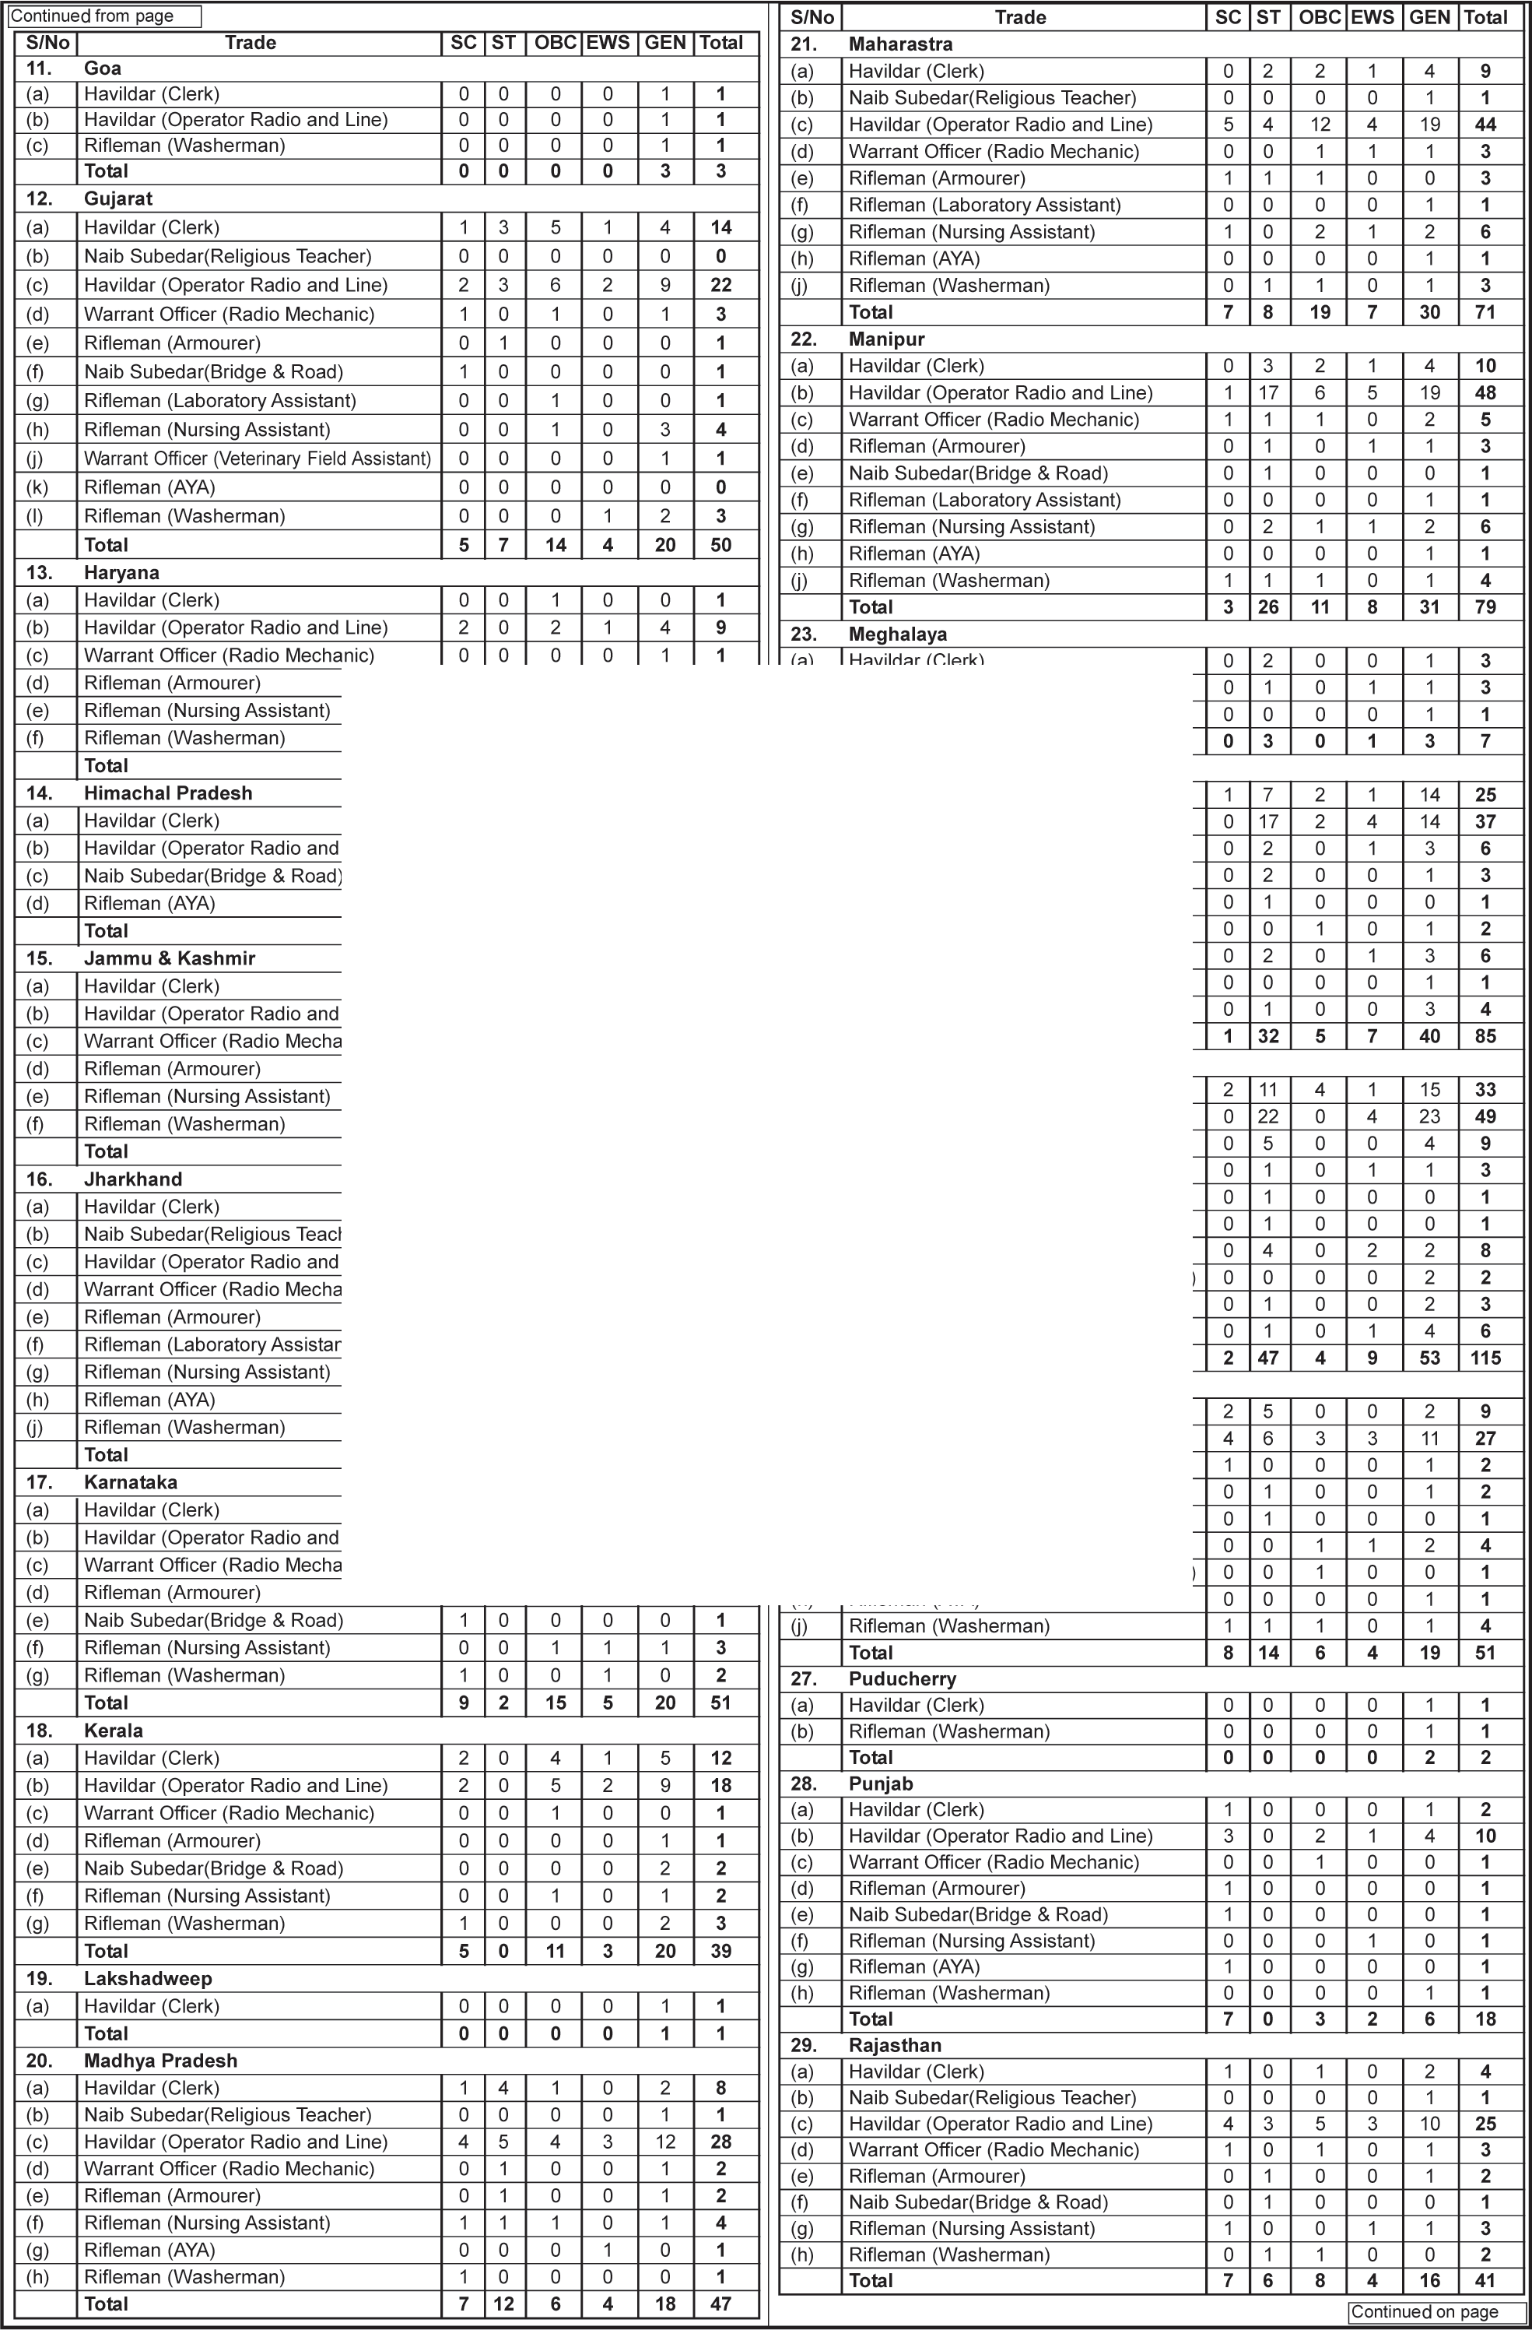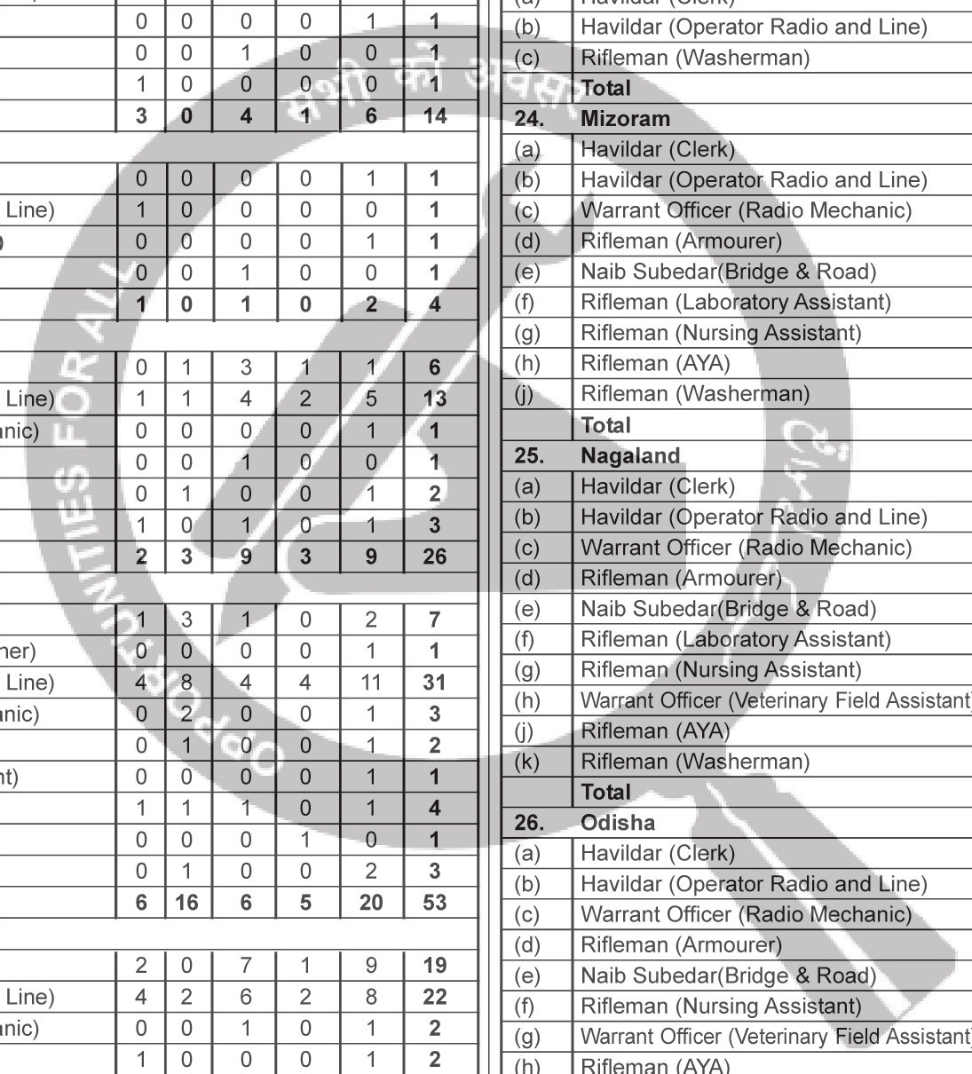12 www.employmentnews.gov.in Employment News 7 - 13 May 2022

11

13

Cont i nued from page 12

S/No | Trade |  |  | SC | ST |  | OBC | EWS | GEN |  |  | Total
30. | Tamilnadu
(a) | Havildar (Clerk) |  |  | 3 | 1 |  | 3 | 1 | 7 |  |  | 15
(b) | Havi ldar (Operator Radio and Line) |  |  | 5 | 0 |  | 7 | 3 | 11 |  |  | 26
(c) | Warrant Officer (Radio Mechanic) |  |  | 0 | 0 |  | 1 | 0 | 2 |  |  | 3
(d) | Rifleman (Armourer) |  |  | 1 | 0 |  | 0 | 0 | 1 |  |  | 2
(e) | Naib Subedar(Bridge & Road) |  |  | 0 | 0 |  | 1 | 0 | 0 |  |  | 1
(f) | Rifleman (Laboratory Assistant) |  |  | 1 | 0 | ,_ | 0 | 0 | 0 |  |  | 1
(g) | Riflema n (Nursing Assistant) |  |  | 1 | 0 |  | 1 | 1 | 1 |  |  | 4
(h) | Warrant Officer (Veterinary Field Assistant) |  |  | 0 | 0 |  | 0 | 0 | 1 |  |  | 1
(j) | Rifleman (Washerman) |  |  | 1 | 0 |  | j | 0 | 2 |  | - | 4
 | Total |  |  | 12 | 1 |  | 14 | 5 | 25 |  |  | 57
31.  (a) | Telangana  Havildar (Clerk) | I | ' | 2 | 0 | 4 |  | 1 | p |  |  | 14
(b) | Havi ldar (Operator Radio and Line) |  |  | 3 | 1 | 6 |  | 2 |  | 8 |  | 20
(c) | Warrant Officer (Radio Mechanic) |  |  | 0 | 0 | 0 |  | 0 |  | 3 |  | 3
(d) Rifleman (Armourer)
~ ..
.
1
0
0
0
1
2
"
I
,
(e) | Rifleman (Nursing Assistant) |  |  |  |  | 0 | 0 | 1 |  | 1 | 1 | 3
(f) | Rifleman (Washerman) |  | 'r.-:;, |  |  | 2 | 0 | 1 |  | 0 | 1 | 4
 | Total |  |  |  |  | 8 | 1 | 12 |  | 4 | 21 | 46
32. | Tripura
(a) | Havildar (Clerk) |  |  |  |  | 0 | 0 | 0 |  | 0 | 2 | 2
(b) Havildar (Operator Radio and Line) I I 1 |  |  |  |  |  |  | 1 |  | 0 | 1 | 1 | 4

I

(c) Rifleman (Nursing Assistant) • \ I 0 1
Total ' 1 2
\
0 0 0 1
o- 1 3 7

33. Uttar Pradesh
- Havi ldar (Clerk)
- Naib Subedar(ReligiousTeache)r
\ '\
- 3 2
'1 0 0
I
3 0 --6- 14
0 0 1 1

Havildar (Operator Radio and Line) \
16 1 21
8 31 77

Warrant Officer (Radio Mechanic) ',
1 0 2 1 2 6

(e) | Rifleman (Armourer) | 1 | 0 | 1 | 1 |  |  | 2 | 5
(f) | Rifleman (Laboratory Assistant) | 1 | 0 | 0 | 0 |  |  | 0 | 1
(g) | Rifleman (Nursing Assistant) | 2 | 0 | 3 | 1 |  |  | 4 | 10
(h) | Warrant Officer (Veterinary Field Assistant) | 0 | 0 | 0 | 0 |  |  | 2 | 2
(j) | Rifleman (AYA) | 0 | 0 | 0 | 0 |  |  | 1 | 1
(k) | R ifleman (Washerman) | 1 | 0 | 2 | 1 , |  | - | 2 | 6
 | Total | 25 | 3 | 32 | 12 |  |  | 51 | 123
34. | Uttrakhand
(a) | Havildar (Clerk) | 0 | 0 | 0 | 0 |  |  | 1 | 1
(b) | Naib Subedar(ReligiousTeacher) | 0 | 0 | 0 | 0 |  |  | 1 | 1
(c) | Havildar (Operator Radio and Line) | 1 | 0 | 1 | 1 |  |  | 1 | 4
(d) | Rifleman (Nursing Assistant) | 0 | 0 | 0 | 0 |  |  | 1 | 1
 | Total | 1 | 0 | 1 | 1 |  |  | 4 | 7
35. | West Bengal
(a) | Havildar (Clerk) | 1 | 0 | 1 | 2 |  |  | 2 | 6
(b) | Naib Subedar(Religious Teacher) | 0 | 0 | 0 | 0 |  |  | 1 | 1
(c) | Havildar (Operator Radio and Line) | 8 | 2 | 7 | 3 |  |  | 14 | 34
(d) | Warrant Officer (Radio Mechanic) | 2 | 0 | 0 | 0 |  |  | 1 | 3
(e) | Rifleman (Armourer) | 0 | 0 | 1 | 0 |  |  | 1 | 2
(f) | Nai b Subedar (Br idge & Road) | 0 | 0 | 1 | 0 |  |  | 0 | 1
(g) | Rifleman (Laboratory Assistant) | 0 | 0 | 0 | 1 |  |  | 0 | 1
(h) | Rifleman (Nursing Assistant) | 1 | 0 | 1 | 0 |  |  | 2 | 4
(j) | Rifleman (AYA) | 0 | 0 | 1 | 0 |  |  | 0 | 1
(k) | Rifleman (Washerman) | 1 | 1 | 1 | 0 |  |  | 0 | 3
 | Total | 13 | 3 | 13 | 6 |  |  | 21 | 56
      - Trade a licable forAssam Rifles Serving Personnel (De artmental Candidates}. Assam Rifles serving personnel (Departmental candidates) can apply in following trades only against the above advertised vacancy for their State/Category if meeting the qualitative requirements as per Appendix-A SI No. (b) & (c). Application received otherthanthese trades willbe rejected. Immediately on issueof notification, departmental candidates must apply for NOCto their CO/QC of Unit.NOC willbe issuedby Col(Record), HQDGAR in the devised fomnat. The candidates who fulfils the criterialaid downforappliedpostand based on service records entry willonly be issued NOCby Col (Rec), HQ DGAR after written recommendation receive from his/her CO/QC Unit through proper channel. The Departmental Candidates mustbring theirNOC while attending PET/PST. Departmental candidates must be qualified through all recruitment events. However, departmental candidates may availage relaxation only as per para 17 (c) &(d) as applicable.
 | S/No | Rank/Trade
 | (a) | Havildar (Clerk)
 | (b) | Naib Subedar (Religious Teacher)
      - In case of any query, the following help line numbers/ email may be conducted from 0900 hours to 1730 hours on any working day:-
(a) 0364-2585118 (b) 0364-2585119 (c) 9362828300
Sd/- (KS Thakur), Dy Comdt, S0 -2 (Reel)
EN 6/39 for Brig (Pers), HQ DGAR, Shillong

