**Biology Photosynthesis in Higher Plants**



Chapter

11

**Photosynthesis in Higher Plants**

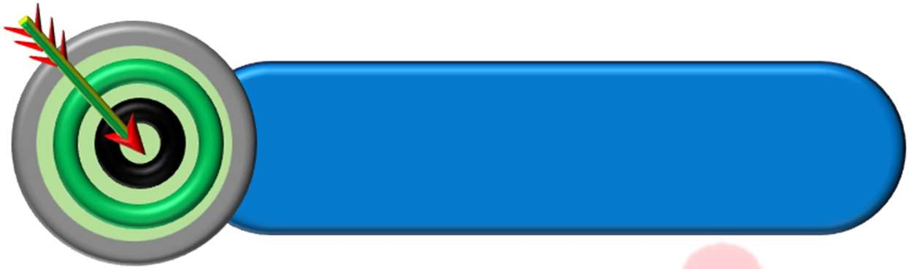

OBJECTIVES



**INTRODUCTION**



**WHAT DO WE KNOW?**

**EARLY EXPERIMENTS**

**WHERE DOES PHOTOSYNTHESIS TAKE PLACE?**



**HOW MANY TYPES OF PIGMENTS ARE INVOLVED IN PHOTOSYNTHESIS?**

**WHAT IS LIGHT REACTION?**

 **ELECTRON TRANSPORT CHAIN**

 **WHERE ARE THE ATP AND NADPH USED?**

 **THE C₄ PATHWAY (HATCH AND SLACK PATHWAY) ** **PHOTORESPIRATION**

**FACTORS AFFECTING PHOTOSYNTHESIS**

**INTRODUCTION**

The green plants make or rather synthesise the food they need through photosynthesis and are therefore called autotrophs. The synthesis of complex organic substances (carbohydrates) by green parts of the plants in the presence of light with the help of CO2 and H2O is called photosynthesis. It can be shown by following equation:

cholorophyll

6CO2 + 12H2O –––––––––→ C6H12O6 + 6H2O + 6O2

sunlight

Photosynthesis is anabolic, endothermic and redox process. First true oxygenic photosynthesis is observed in cyanobacteria. Green plants carry out ‘photosynthesis’, a physico-chemical process by which they use light energy to drive the synthesis of organic compounds. Radiant energy of sun is changed into chemical energy in this process. It is also called carbon dioxide assimilation. The use of energy from sunlight by plants doing photosynthesis is the basis of life on earth. Photosynthesis is important due to two reasons:

* It is the primary source of all food on earth.
* It is also responsible for the release of oxygen into the atmosphere by green plants.

Photosynthesis is a redox process in which water is oxidized to form while CO2 is reduced to form sugars. Thus, it is an oxidation-reduction reaction.

# WHAT DO WE KNOW?

## Variegated leaf experiment

**Aim:** To look for starch formation

**Protocol:** Take a destarched potted plant having variegated leaves and cover 2-3 leaves with the black paper. Expose the potted plant to sunlight for 1-2 hours. Pluck one covered leaf and one exposed leaf and test them for starch.

**Result:** The covered leaf does not show positive starch test showing that photosynthesis cannot occur in the absence of light. The exposed leaf shows blue and yellow parts where the blue colour or positive starch test occurs in the **chlorophyll**-containing parts.

## Half-leaf experiment

### Protocol

A part of a leaf is enclosed in a test tube containing some KOH-soaked cotton (which absorbs CO2), while the other half is exposed to air. The setup is then placed in light for some time.

On testing for starch later **in** the two halves of the leaf, it was found that the exposed part of the leaf tested positive for starch while the portion that was in the tube, tested negative.

**Result:** CO2 was required for photosynthesis.

# EARLY EXPERIMENTS

## Joseph Priestley (1733-1804)

In 1770, Priestley performed a series of experiments that revealed the essential role of air in the growth of green plants. He discovered oxygen in 1774

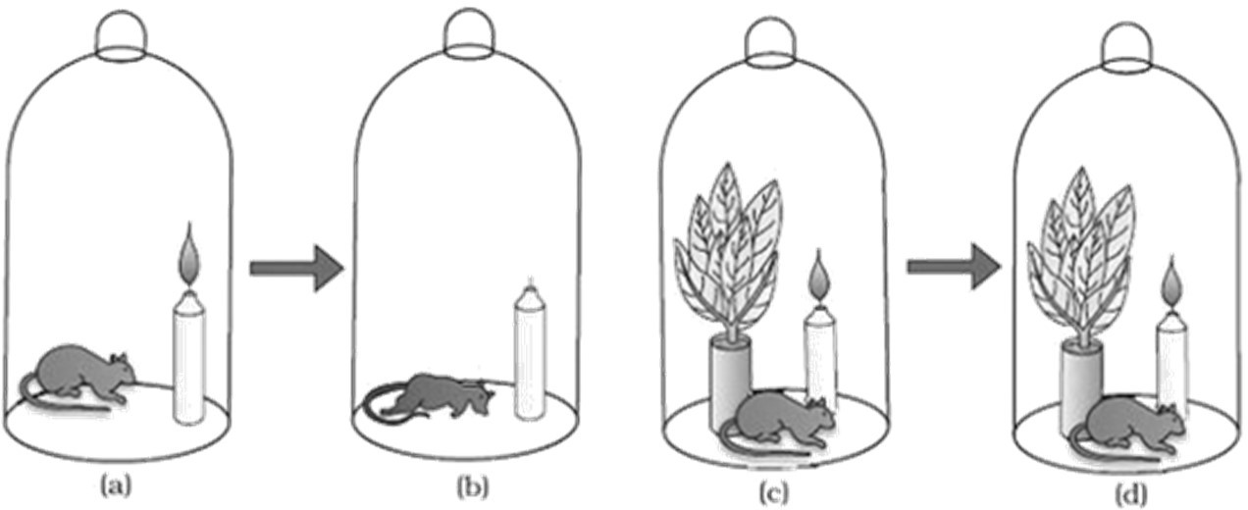

**Fig.:** Priestly’s experiment

**Observation:** Priestley’s experiment observed that a candle burning in a closed space- a bell jar, soon gets extinguished.

* + Similarly, a mouse would soon suffocate in a closed space.
  + But when he placed a mint plant in the same bell jar, he found that the mouse stayed alive and the candle continued to burn.

**Conclusion:** Burning candle or an animal that breathe the air, both somehow, damage the air.

**Hypothesis:** Plants restore to the air whatever breathing animals and burning candles remove.

## Jan Ingenhousz (1730-1799)

### Experiment

In an elegant experiment with an aquatic plant in bright sunlight, small bubbles were formed around the green parts while in the dark they did not. Later he identified these bubbles to be of oxygen.

### Result

He showed that only the green part of the plants can release oxygen. He also showed that sunlight is essential to the plant process that somehow purifies the air fouled by burning candles or breathing animals.

## Julius von Sachs (1854)

He provided evidence for production of glucose when plants grow. He showed the product of photosynthesis as glucose which is stored as starch. His later studies showed that the green substance in plants (chlorophyll) is located in special bodies (later called chloroplasts) within plant cells. He found that the green parts in plants is where glucose is made, and that the glucose is usually stored as starch.

## T.W Engelmann (1843-1909)

Using a prism, he split light into its spectral components and then illuminated a green alga, *Cladophora*, placed in a suspension of aerobic bacteria. The bacteria were used to detect the sites of O2 evolution. He observed that the bacteria accumulated mainly in the region of blue and red light of the split spectrum. A first action spectrum of photosynthesis was thus described. It resembles roughly the absorption spectra of chlorophyll a and b.

The empirical equation representing the total process of photosynthesis for oxygen evolving organisms was then understood as:

Light

CO2 + H2O –––––→ [CH2O] + O2

Where [CH2O] represented a carbohydrate (e.g., glucose, a six-carbon sugar)

## Cornelius van Niel (1897-1985)

A microbiologist, based on his studies of purple and green bacteria, he demonstrated that photosynthesis is essentially a light dependent reaction in which hydrogen from a suitable oxidisable compound reduces carbon dioxide to carbohydrates. This can be expressed by:

Light

2H2A + CO2 –––––→ 2A + CH2O + H2O

In green plants H2O is the hydrogen donor and is oxidised to O2.

When H2S instead is the hydrogen donor for purple and green sulphur bacteria, the ‘oxidation’ product is sulphur or sulphate depending on the organism and not O2.

He inferred that the O2 evolved by the green plant comes from H2O, not from carbon dioxide. This was later proved by using radioisotopic techniques.

**Carbon dioxide is necessary for photosynthesis. The chemical used to remove this gas most**

**effectively from entering a control apparatus is**

**Q3.**

**Q2. Which of the following experiments showed that carbon dioxide is essential for photosynthesis?**

(a) Half-leaf experiment (b) Variegated leaf experiment

(c) Priestley's experiment (d) Von Sach's experiment

**TOPIC CENTRIC EXERCISE -01**

**A variegated leaf experiment was done to prove that**

1. Carbon dioxide is essential for photosynthesis
2. Oxygen is essential for the growth of plants
3. Photosynthesis occurs only in green parts of the leaves
4. Photosynthesis occurs in all parts of the plant

**Q1.**

|  |  |  |
| --- | --- | --- |
|  |  |  |
|  | (a) Distilled water | (b) Sodium carbonate |
|  | (c) Calcium oxide | (d) Potassium hydroxide |
| **Q4.** | **Products of photosynthesis are** |  |
|  | (a) Carbon dioxide and food material | (b) Carbohydrates and oxygen |
|  | (c) Carbon dioxide and oxygen | (d) Formaldehyde and nitrogen |
| **Q5. Green parts of plants release O₂. The given conclusion was made by**  (a) Engelmann (b) Niel  (c) Ingenhousz (d) Sachs | | |

# WHERE DOES PHOTOSYNTHESIS TAKE PLACE?

Photosynthesis takes place in the green leaves of plants and other green parts of plants like stem etc. The most active photosynthetic tissue in higher plants is the mesophyll of leaves. Chloroplasts present in mesophyll cells are those cell organelles in which photosynthesis takes place. The pigments are located at thylakoid membrane of chloroplast. Usually, the chloroplasts align themselves along the walls of the mesophyll cells, such that they get the optimum quantity of the incident light.

Within the chloroplast, there is the membranous system consisting of grana, the stroma lamellae, and the fluid stroma.

The membrane system is responsible for trapping the light energy and also for the synthesis of ATP and NADPH. In stroma, enzymatic reactions incorporate CO2 into the plant leading to the synthesis of sugar, which in turn forms starch. The former set of reactions, since they are directly light driven are called **light reactions**.

The latter are not directly light driven but are dependent on the products of light reactions (ATP and NADPH). Hence, to distinguish the latter they are called, by convention, as **dark reactions**.

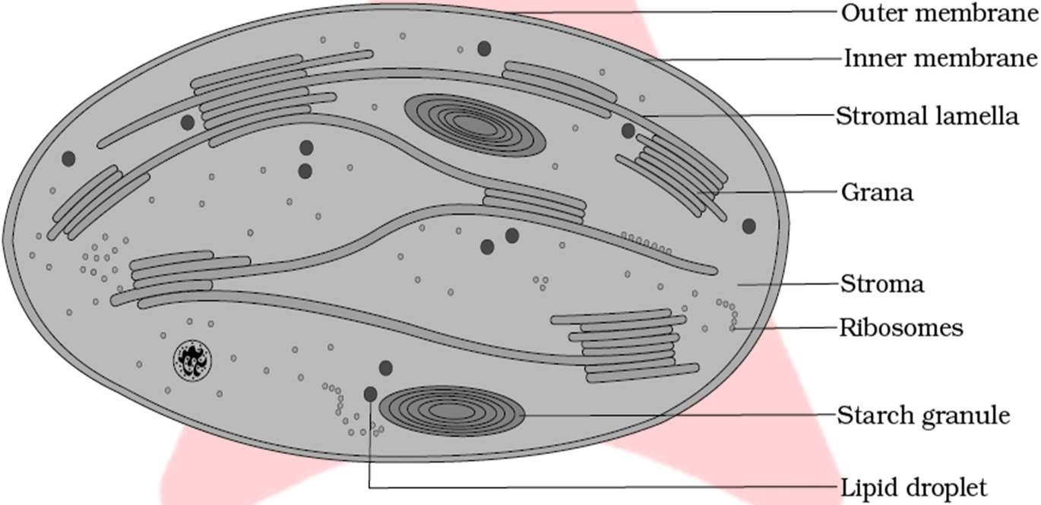

**Fig.:** Diagrammatic representation of chloroplast

### Distribution of chloroplast

In photosynthetic eukaryotes, photosynthesis occurs in the subcellular organelle known as the chloroplast. This double membrane-enclosed organelle possesses a third system of membranes called **thylakoids**.

A stack of thylakoids forms a granum. Adjacent grana are connected by unstacked membranes called **stroma lamellae**. The fluid compartment surrounding the thylakoids, called the **stroma**

In eukaryotic algae, pigment are present in thylakoid lamellae, they are covered by double membrane thus chloroplasts are present but thylakoids do not pile up to form grana.

In higher plants thylakoids pile up and form stalks of coin-like structures called grana (singular granum).

|  |  |  |
| --- | --- | --- |
| **TOPIC CENTRIC EXERCISE -02**  **Q1. The sugar synthesis caused by the enzymatic reaction takes place in** | | |
|  | (a) Grana | (b) Thylakoid |
|  | (c) Cisternae | (d) Stroma |
| **Q2.** | **Chlorophyll is present:** |  |
|  | (a) In the grana of chloroplasts | (b) Dispersed throughout chloroplast |
|  | (c) In the stroma of chloroplasts | (d) On the surface of chloroplast |

**Q3.**

**_** **commonly refers to the fluid filled inner space chloroplasts surrounding thylakoids and**

**grana.**

(a) Cisternae (b) Stroma

(c) Granum (d) Stomata

**Q4. Usually chloroplasts align themselves along the walls of to get the optimum quantity of the incident light.**

(a) Mesophyll cells (b) Thylakoid

(c) Bundle sheath cells (d) Stroma lamellae

**Q5. Stroma in the chloroplasts of higher plant contains**

1. Chlorophyll
2. Light-dependent reaction enzymes
3. Light-independent reaction enzymes
4. Both (b) and (c)

# HOW MANY TYPES OF PIGMENTS ARE INVOLVED IN PHOTOSYNTHESIS?

Pigments are substances that have an ability to absorb light, at specific wavelengths.

A chromatographic separation of the leaf pigments shows that the colour of leaves is due to four pigments. Types of pigments in the chloroplasts:

1. **Chlorophyll a** - Bright or blue green in the chromatogram.
2. **Chlorophyll b -** Yellow-green
3. **Xanthophylls** - Yellow
4. **Carotene** - Yellow to yellow-orange

## Chlorophyll Pigments

Each chlorophyll molecule consists of two parts, **porphyrin head & phytol tail**. Head consists of tetrapyrrole or porphyrin in which 4 pyrrole molecules are arranged in a cyclic manner containing Mg atom at its centre. Chl. has methyl group and chl b has an aldehyde group on the second pyrrole. Chlorophyll a is the chief pigment associated with photosynthesis.

Chlorophyll 𝑎 − C55H72O5N4Mg

Chlorophyll 𝑏 − C55H70O6N4Mg

## Accessory Pigments-

All pigments other than chlorophyll a are called accessory pigments. These have two major roles in photosynthesis:

* 1. They absorb light of different wavelengths and transfer the energy to chlorophyll molecules; thus, they are also called **antenna molecules**. This enables a wider range of wavelength of incoming light to be utilized for photosynthesis. Chlorophyll b accounts for about one-fourth of total chlorophyll content.
  2. Carotenoids protect plant from excessive heat and prevent photo-oxidation (oxidative destruction by light) of chlorophyll pigments. Thus, they are also called **"Shield Pigments".**

Let us study the graph showing ability of pigments to absorb lights of different wavelengths.

### Absorption and action spectra Absorption spectrum

* The graph showing the amount of different wavelengths of light absorbed by a substance is called absorption spectrum.
* Out of seven colours (VIBGYOR) of visible light, green light remains unabsorbed and is reflected back imparting green colour to the leaves.
* Chl. *a* and chl, *b* absorb maximum blue followed by red region of spectrum chal a and chl. b

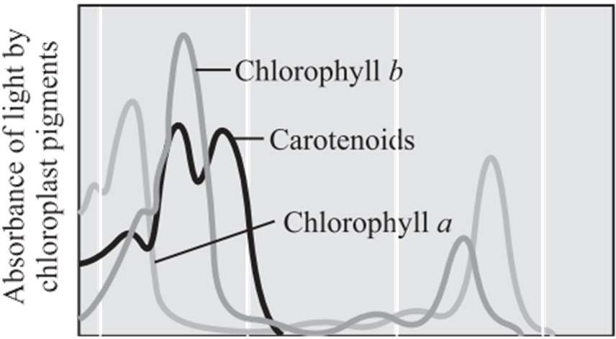

**Fig.:** Graph showing the absorption spectrum of chlorophyll a, b and the carotenoids

### Action spectrum

* It is a graph showing actual rate of photosynthesis measured in terms of O2production at different wavelength of light. It is maximum in red followed by blue and minimum in green light.
* 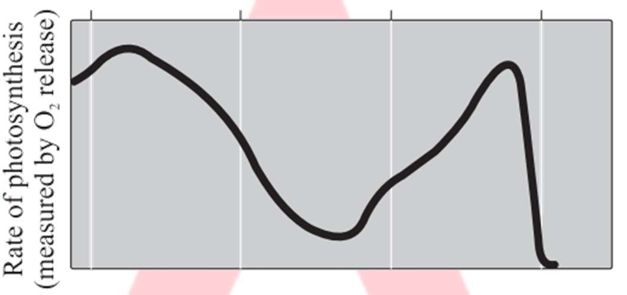Engelmann using a prism split light into its spectral components and then illuminated a green alga, *Cladophora* placed in a suspension of aerobic bacteria. The bacteria were used to detect the sites of O2 evolution. He observed that the bacteria accumulated mainly in the region of blue and red light of the split spectrum. A first action spectrum of photosynthesis was thus described. It resembles roughly the absorption spectra of chlorophyll a and b.

**Fig.:** Graph showing action spectrum of photosynthesis

Action spectrum of photosynthesis corresponds closely to absorption spectra of chlorophyll a showing that chlorophyll a is the chief pigment associated with photosynthesis.

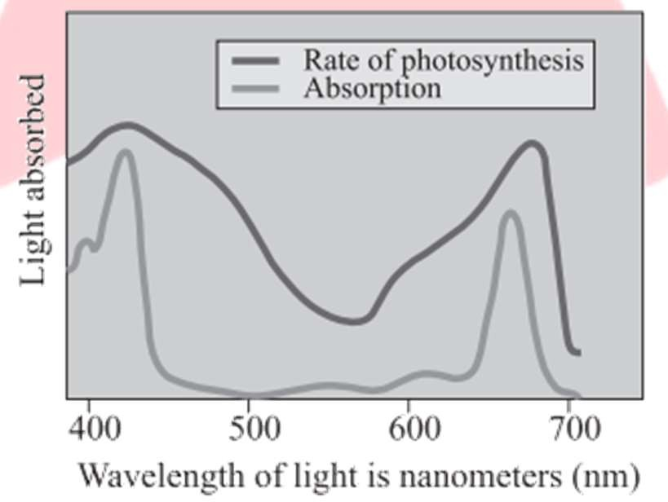

**Fig.:** Graph showing action spectrum of photosynthesis superimposed on absorption spectrum of chlorophyll a

These graphs, together, show that most of the photosynthesis takes place in the blue and red regions of the spectrum, some photosynthesis does take place at the other wavelengths of the visible spectrum. These graphs depict that maximum photosynthesis occurs at the wavelength at which there is maximum absorption by chlorophyll a i.e., in the blue and red regions.

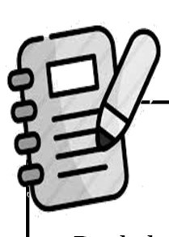

**Critical Thinking**

Red drop & Emerson enhancement effect Emerson while determining the quantum yield of photosynthesis in Chlorella by using monochromatic light of different wavelengths, noticed a sharp decrease in quantum yield at wavelength greater than 680 nm. The fall in photosynthetic yield beyond red region of spectrum is called **Red drop**. Emerson further supplied additional shorter wavelengths of light along with far red light (more than 680nm) He found that quantum yield increased. It is called Emerson enhancement effect.

**Q1.**

**TOPIC CENTRIC EXERCISE-03**

**Most of the photosynthesis takes place in which regions the spectrum?**

(a) Blue region (b) Red region

(c) Green light region (d) Both (a) and (b)

**Q2. Most effective wavelength of light for photosynthesis is:**

(a) Yellow (b) Violet

(c) Red (d) Green

**Q3. Which of the following is the main function of carotenes**

(a) Not an accessory pigment (b) Prevent photo-oxidation

(c) Helps in photosynthesis (d) Helps in transpiration

**Q4. Which is not an accessory pigment?**

(a) Carotene (b) Xanthophyll

(c) Chlorophyll (d) Chlorophyll

**Q5. Which technique is used to separate the leaf pigments of any green plant?**

(a) SDS- PAGE (b) Column chromatography

(c) Affinity chromatography (d) Paper chromatography

# WHAT IS LIGHT REACTION?

Light reactions or the ‘Photochemical’ phase include: Light absorption, water splitting and oxygen release, Formation of high-energy chemical intermediates, ATP and NADPH.

Several protein complexes are involved in the process. The pigments are organised into two discrete photochemical **light harvesting complexes (LHC)** within the **Photosystem I (PS I) and Photosystem II (PS II).**

These are named in the sequence of their discovery, and not in the sequence in which they function during the light reaction.

The LHC are made up of hundreds of pigment molecules bound to proteins. Each photosystem has all the pigments (except one molecule of chlorophyll a) forming a light harvesting system also called **antennae.**

These pigments help to make photosynthesis more efficient by absorbing different wavelengths of light. The single chlorophyll a molecule forms the **reaction centre**.

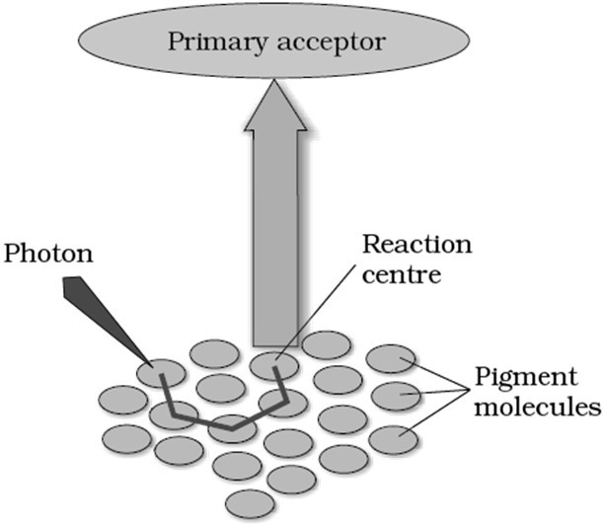

**Fig.:** The light harvesting complex

**Table: Differences between PS-I & PS-II**

|  |  |
| --- | --- |
| **PS-I** | **PS-II** |
| It is located on the stacks of thylakoid and stroma  lamellae membranes | It is present on appressed portions of the thylakoid  membrane |
| P700 is a reaction centre in PS-I. | P680 is reaction centre in PS-II. |
| It is involved in both cyclic and non-cyclic  photophosphorylation. | It is involved only in non-cyclic photophosphorylation |
| During non-cyclic photophosphorylation, it obtains  electron from PS-II. | It obtains electron through photolysis of water. |
| Molecular oxygen is not evolved in this system. | Molecular oxygen is evolved due to photolysis of  water. |

**Q1.**

**TOPIC CENTRIC EXERCISE -04**

**In PS I, the reaction centre chlorophyll a has an absorption peak at**

**Q2.**

(a) 700 nm

(c) 680 nm

**Photochemical phase does not include**

1. Light absorption
2. Water splitting and O2 release
3. ATP and NADPH formation
4. CO2 fixation

(b) 780 nm

(d) 600 nm

**Q3. In PS II, the reaction centre chlorophyll has an absorption peak at**

(a) 700 nm (b) 780 nm

(c) 680 nm (d) 600 nm

**Q4. Which of the following is not related to the light reaction?**

(a) Photochemical phase (b) Light absorption

(c) Electron transport (d) Water splitting

**Q5. What occurs during the light reaction of photosynthesis?**

1. Chlorophyll is produced
2. Water splits to form 2H+& O2
3. CO2 is given off as a waste
4. Sugar is formed from CO2 and water

# THE ELECTRON TRANSPORT

In photosystem the reaction centre chlorophyll a absorbs 680 nm wavelength of red-light causing electrons to become excited and jump into an orbit farther from the atomic nucleus. These electrons are picked up by an electron acceptor which passes them to an electrons transport system consisting of cytochromes. The process through which ATP is synthesised by cells (in mitochondria and chloroplasts) is named phosphorylation.

Photophosphorylation is the synthesis of ATP from ADP and inorganic phosphate in the presence of light. It is of **two** types:

1. Cyclic Electron Transport Chain
2. Non-Cyclic Electron Transport Chain or Z-Scheme

## Cyclic Electron Transport Chain

The process of cyclic photophosphorylation involves only PS I and this process takes place in the stroma lamellae membrane. When only PS I is functional, the electron is circulated within the photosystem and the phosphorylation occurs, due to cyclic flow of electrons.

Its reaction centre is P700 of Chl. a. When the reaction centre of PS I receives red light of 700 nm wavelength, they become excited and electrons are transferred to another acceptor molecule that has a greater redox potential. After losing the electron the photocentre becomes oxidized.

The electron transport is called cyclic because the electron emitted from PS-I returns back to PS-I passing through several intermediates.

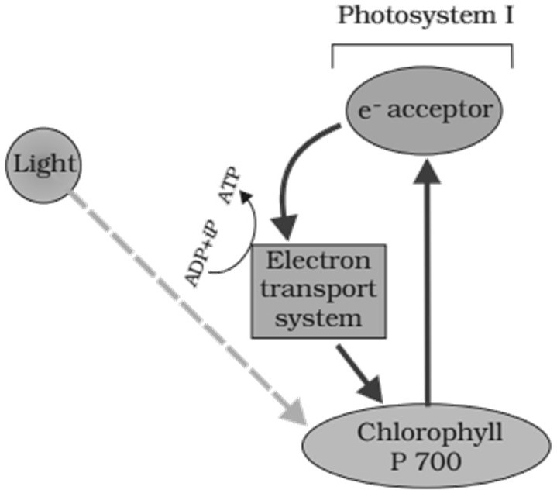

**Fig.:** Cyclic photophosphorylation



**Clue Finder**

The cyclic flow results only in the synthesis of ATP, but not of NADPH + H+ because the excited electron does not pass on to NADP+ but is cycled back to the PS I complex through the electron transport chain. Cyclic photophosphorylation also occurs when only light of wavelengths beyond 680 nm are available for excitation

## Non-Cyclic Electron Transport Chain or Z-Scheme

It is carried out in collaboration of both PS-I and PS-II in which the electron expelled by the excited photocentre does not return back to it.

First in PS II, the P680 molecule absorbs 680 nm wavelength of red-light causing electrons to become excited and jump into an orbit which is farther from the atomic nucleus.

These electrons are picked up by an electron acceptor which passes them to an **electron transport system of cytochromes.** This movement of electrons is downhill on redox potential scale. The electrons are then passed onto the pigments of PS I, without being used as they pass through the electron transport chain. Simultaneously, electrons in the reaction center of PS I (P700) are excited when they receive light of wavelength 700 nm and these electrons are transferred to another acceptor molecule that has a greater redox potential. These electrons are then moved downhill again to a molecule of NADP+. The addition of these electrons reduces the NADP+ to NADPH + H+.

The whole scheme of transfer of electrons, starting from the PS II, uphill to the acceptor, down the electron transport chain to PS I, excitation of electrons, transfer to another acceptor and finally downhill to NADP+ causing it to be reduced to NADPH + H+ is called **Z-scheme**. This shape is formed when all the carriers are placed in a sequence on a redox potential scale

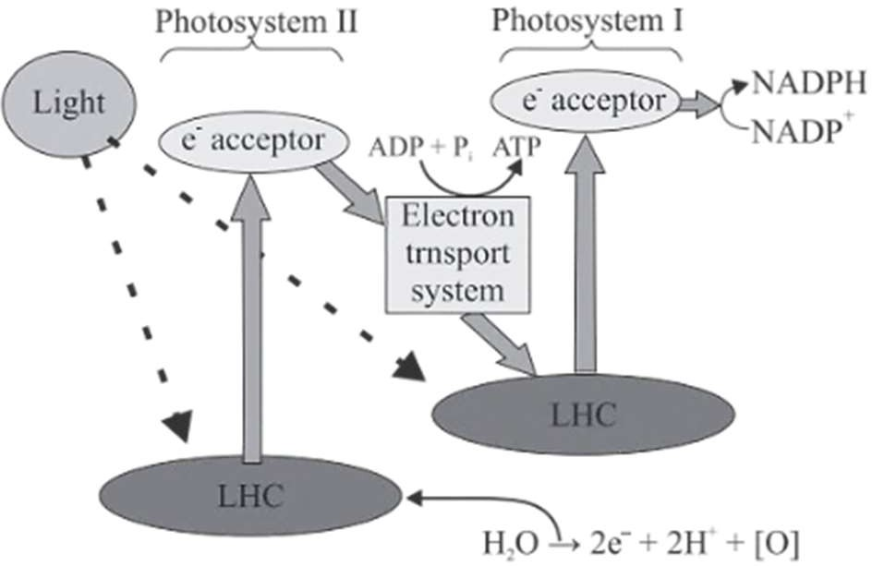

**Fig.:** Z scheme (non-cyclic photophosphorylation) of light reaction

## Photolysis of Water

The phenomenon of breaking up of water into hydrogen and oxygen in the illuminated chloroplasts is called photolysis.

The electrons that were moved from photosystem II must be replaced. This is achieved by electrons available due to splitting of water.

The splitting of water is associated with the PS II; water is split into2H+, [O] and electrons. This creates oxygen, one of the net products of photosynthesis.

The electrons needed to replace those removed from photosystem I are provided by photosystem II.

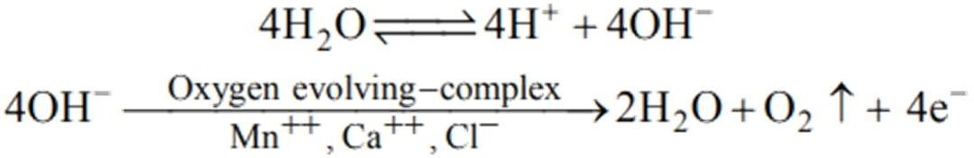

The water splitting complex is associated with the PS II, which itself is physically located on the inner side of the membrane of the thylakoid.

**Table:** Cyclic and Non-Cyclic Photophosphorylation

|  |  |
| --- | --- |
| **Non-cyclic Photo-phosphorylation** | **Cyclic Photo-phosphorylation** |
| Both photosystems are functional in a sequence (PS  II first & PS I later). | Only PS I is functional. |
| ATP and NADPH + synthesized. | Only ATP is synthesized not NADPH + H+ |
| Take place in membrane or lamellae of the grana. | Take place in stroma lamellae.  In stroma lamellae both PS II & NADP reductase enzyme is absent. |

## Chemiosmotic Hypothesis

This hypothesis was proposed by **Mitchell** in 1961.

**ATP synthesis** is linked to development of **proton gradient across** the membrane of **thylakoid and mitochondria**.

When protons in the stroma decrease in number, while in the lumen there is accumulation of protons, a proton gradient formed resulting into the decrease in pH in the lumen.

**Chemiosmosis** requires a **membrane, a proton pump, a proton gradient** and **ATPase**. The ATPase enzyme consists of:

* + - * CFo is present in the thylakoid membrane and forms a transmembrane channel that carries out facilitated diffusion of protons across the membrane.
      * CF1 protrudes on the outer surface of the thylakoid membrane on the side that faces the stroma.

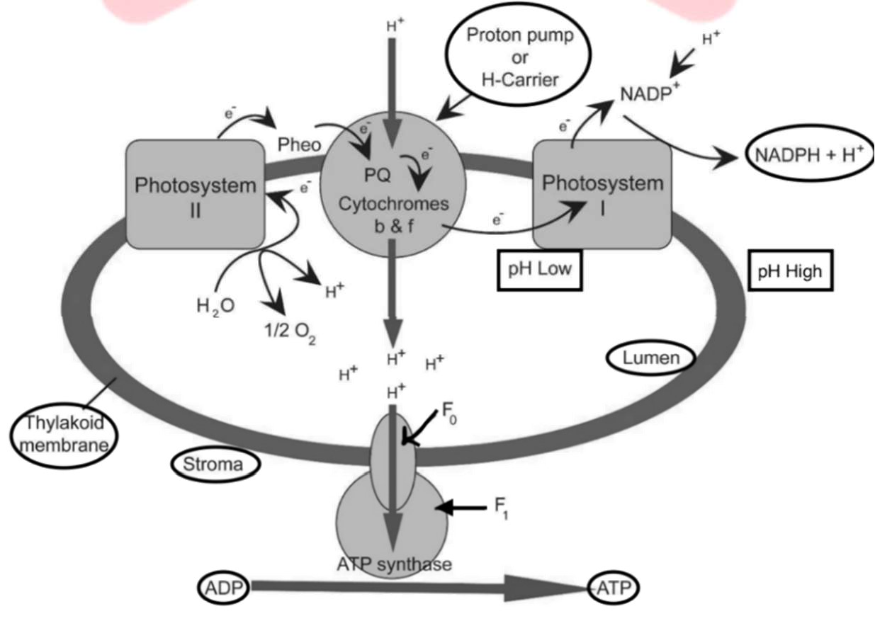

**Fig.:** Synthesis of ATP according to Chemiosmotic Hypothesis in light reaction.

### Processes that take place during the activation of electrons and their transport are:

1. Since splitting of the water molecule takes place on the inner side of the membrane, the protons or hydrogen ions that are produced by the splitting of water accumulate within the lumen of the thylakoids.
2. As electrons move through the photosystems, protons are transported across the membrane. This happens because the primary accepter of electron which is located towards the outer side of the membrane transfers its electron not to an electron carrier but to an H+ carrier. Hence, this molecule removes a proton from the stroma while transporting an electron. When this molecule passes on its electron to the electron carrier on the inner side of the membrane, the proton is released into the inner side or the lumen side of the membrane.
3. The NADP reductase enzyme is located on the stroma side of the membrane. Along with electrons that come from the acceptor of electrons of PS I, protons are necessary for the reduction of NADP+ to NADPH + H+.These protons are also removed from the stroma.

Energy is used to pump protons across a membrane, to create a gradient or a high concentration of protons within the thylakoid lumen.

ATPase has a channel that allows diffusion of protons back across the membrane; this releases enough energy to activate ATPase enzyme that catalyses the formation of ATP.



**Critical Thinking**

The proton gradient is important because it is the breakdown of this gradient that leads to release of energy. The gradient is broken down due to the movement of protons across the membrane to the stroma through the trans membrane channel of the CFO of the ATP synthase.

**Q1.**

**TOPIC CENTRIC EXERCISE-05**

**The products of light reaction are**

**Q2.**

(a) ATP

(c) NADPH

**Water splitting complex is found in**

(b) O2

(d) ATP, NADPH, and O2

1. PS II and located on outer side of thylakoid membrane
2. PS II and located on inner side of the thylakoid membrane
3. PS I and located on outer side of the thylakoid membrane
4. PS I and located on inner side of the thylakoid membrane

**Q3. The name of the scheme given to the transport of electrons is called as**

(a) Z scheme (b) W scheme

(c) Y scheme (d) E scheme

**Q4. Which of the following represents a correct sequence in noncyclic photophosphorylation?**

1. PSI →ATP production → PS II → NADPH production
2. PSI → NADPH production→ PS II → ATP production
3. PS II → ATP production → PSI→ NADPH production
4. PS II → NADPH production → PSI→ ATP production

**Q5. During Z scheme, electrons excited by absorption of light in PS I are transferred to the primary acceptors, and therefore must be replaced. The replacements come directly from**

(a) NADP (b) ATP

(c) PS II (d) Water

# WHERE ARE THE ATP AND NADPH USED?

The products of light reaction are ATP, NADPH and O2 O2 diffuses out of the chloroplast. ATP and NADPH are used to drive the processes leading to the synthesis of food, i.e., sugars. This is the **biosynthetic phase** of photosynthesis.

Biosynthetic phase does not directly depend on the presence of light but is dependent on the products of the light reaction, i.e., ATP and NADPH, besides CO2 and H2O This could also be verified as immediately after light becomes unavailable, this biosynthetic process continues for some time and then stops. But, if then, light is

made available again, the synthesis starts again. Hence, calling the biosynthetic phase as the dark reaction is a misnomer. The dark reaction occurs through Calvin cycle.CO2 is combined with H2O to produce or sugars.

The use of radioactive 14C by (Melvin Calvin) in algal photosynthesis studies led to the discovery that the first

CO2 fixation product was a 3-carbon organic acid.

He also contributed to working out the complete biosynthetic pathway; hence it was called Calvin cycle after him.

## Calvin cycle

It is a thermosensible activity which takes place in **stroma of chloroplast**. It occurs in all photosynthetic plants. In this process, ATP and NADPH are utilized and carbohydrates are formed through the reduction & assimilation of .CO2

The first stable product identified was 3-phosphoglyceric acid (PGA), hence it is named C3 pathway. Calvin cycle occurs in all photosynthetic plants whether they have C3 or C4 pathway.

* + 1. **Primary Acceptor of** 𝐂𝐎𝟐

The primary acceptor molecule during the C3 cycle is a five-carbon ketose sugar-Ribulose bisphosphate (RuBP). The enzyme for CO2 fixation is RuBisCO (Ribulose Bisphosphate Caboxylase Oxygenase). It is the most abundant enzyme on earth. It is characterised by the fact that its active site can bind to both CO2 and O2 hence the name. RuBisCO has a much greater affinity for CO2 than for O2 and the binding is competitive. It is the relative concentration of and that determines which of the two will bind to the enzyme. Before the scientists discovered the 5-carbon ketose sugar as primary acceptor it was believed that since the first product was a C3 acid, the primary acceptor would be a 2-carbon compond.

## Stages of Calvin Cycle

Calvin cycle can be described under three stages:

1. **Carboxylation:** It is the fixation of CO2 into a stable organic intermediate. In this, CO2 is utilised for the carboxylation of RuBP. This reaction is catalysed by the enzyme RuBisCO and it results in the formation of two molecules of 3-PGA (3-Phosphoglyceric acid).
2. **Reduction:** These reactions lead to the formation of glucose. The steps involve utilisation of two molecules of ATP for phosphorylation and two of NADPH for reduction, per molecule of CO₂ fixed. The fixation of six molecules of CO2 and six turns of the cycle are required for the removal of one molecule of glucose from the pathway.
3. **Regeneration:** For the cycle to continue uninterrupted, regeneration of the CO₂ acceptor molecule is crucial. This step requires one ATP for phosphorylation to form RuBP. To make one molecule of glucose six turns of the cycle are required. 18 ATP and 12 NADPH molecules are used to make a molecule of glucose. Hence, for every CO2 molecule entering the Calvin cycle, three molecules of ATP and two molecules of NADPH are required. For every CO2 molecule entering Calvin cycle, three molecules of ATP and two molecules of NADPH are required. It is to meet this difference in number of ATP and NADPH that the cyclic phosphorylation takes place. RuBisCO and many other enzymes of Calvin cycle are regulated by light.

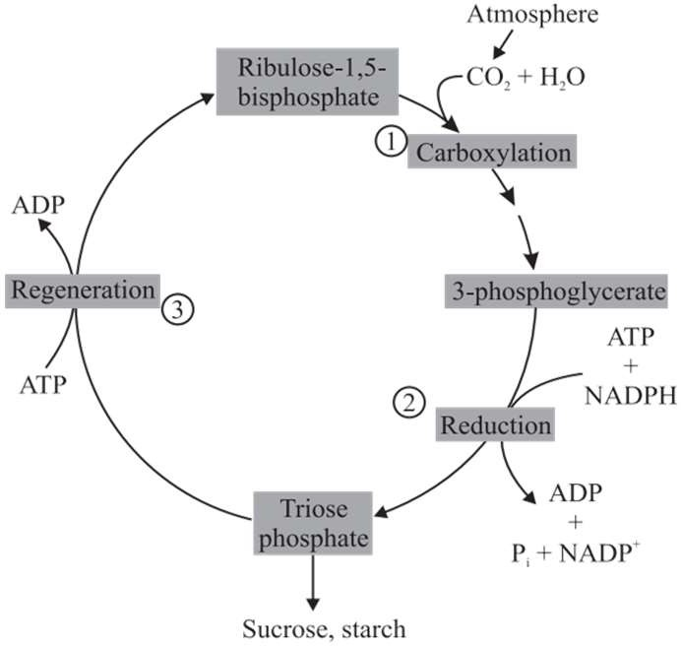

**Fig.:** The Calvin cycle

|  |  |
| --- | --- |
| **In** | **Out** |
| 6 CO2 | 1 Glucose |
| 18 ATP | 18 ADP |
| 12 NADPH | 12 NADP |

**Q1.**

**TOPIC CENTRIC EXERCISE -06**

**In photosynthesis, hydrogen is transferred from the light reaction to dark reactions by :-**

(a) NAD+ (b) ADP

(c) ATP (d) NADP+

**Q2. One molecule of glucose in Calvin cycle is formed from**

(a) 6CO₂ + 12 АТР + 2NADPH (b) 6CO2+ 30ATP + 12 NADPH

(c) 6CO2 + 18ATP + 12 NADPH (d) 6CO2+ 18ATO + 30 NADPH

**Q3. Which of the following enzyme is used for carboxylation of RuBP?**

(a) Phosphopentokinase (b) Hexose kinase

(c) Peroxidase (d) RuBisCO

**Q4. CO₂ combines with RuBP in the presence of enzyme RuBisCO to form 3-PGA. This process of Calvin cycle is included under**

(a) Carboxylation (b) Oxygenation

(c) Reduction (d) Regeneration

**Q5. In the Calvin cycle, RuBP carboxylase results in the formation of** **number of**

**PGA molecules.**

(a) 2 (b) 1

(c) 4 (d) 3

# THE C₄ PATHWAY (HATCH AND SLACK PATHWAY)

**Hatch & Slack** (1967) discovered this alternative pathway for CO2 fixation hence also called as Hatch and Slack cycle. It is also called C4 cycle because first stable compound is 4C compound oxaloacetic acid (OAA) in this cycle. Plants that are adapted to dry tropical regions have the C4 pathway. e.g., Sugarcane, Maize, Sorghum etc. In these plants, **double fixation** of carbon dioxide occurs.

C4 plants are special as they have a special type of leaf anatomy, they can tolerate higher temperatures, they show a response to high intensities of light, they lack a wasteful process called photorespiration, thus they show greater productivity and higher yield as compared to the plants.

The C4 pathway requires the presence of two types of cells i.e., **mesophyll cells** and **bundle sheath cells**. The particularly large cells around the vascular bundles of C₄ plants are called bundle sheath cells, these cells may form several layers around the vascular bundles, they are characterised by having large number of chloroplasts, grana are absent, thick walls impervious to gaseous exchange and no intercellular spaces. This special anatomy of leaves of the C4, plants is called **'Kranz' anatomy.** 'Kranz' means wreath and is a reflection of the arrangement of cells.

## Process of Hatch-Slack Pathway

It is a cyclic process. The primary CO2 acceptor is a three-carbon molecule **phosphoenol pyruvate (PEP)** and it is present in mesophyll cells. The enzyme that catalyses this CO2 fixation is **PEP carboxylase or PEPcase**. The mesophyll cells of C₄ plants lack the enzyme RuBisCO. The 4-carbon oxaloacetic acid (OAA) is formed in the mesophyll cells. It is then converted to other four-carbon compounds like malic acid or aspartic acid in the mesophyll cells itself, these are then transported to the bundle sheath cells. In the bundle sheath cells, these C4 acids are broken down to release CO2 and a three-carbon molecule. The CO2 released in the bundle sheath cells enters the C3 or the Calvin pathway.

The bundle sheath cells are rich in an enzyme RuBisCO, but lacks PEPcase. The three-carbon molecule is transported back to the mesophyll cells where it is converted to PEP again with the help of a **cold sensitive enzyme,** called PEP synthetase, thus completing the cycle.

Thus, the basic pathway that results in the formation of the sugars, the Calvin pathway is common to the C3 and

C4 plants.

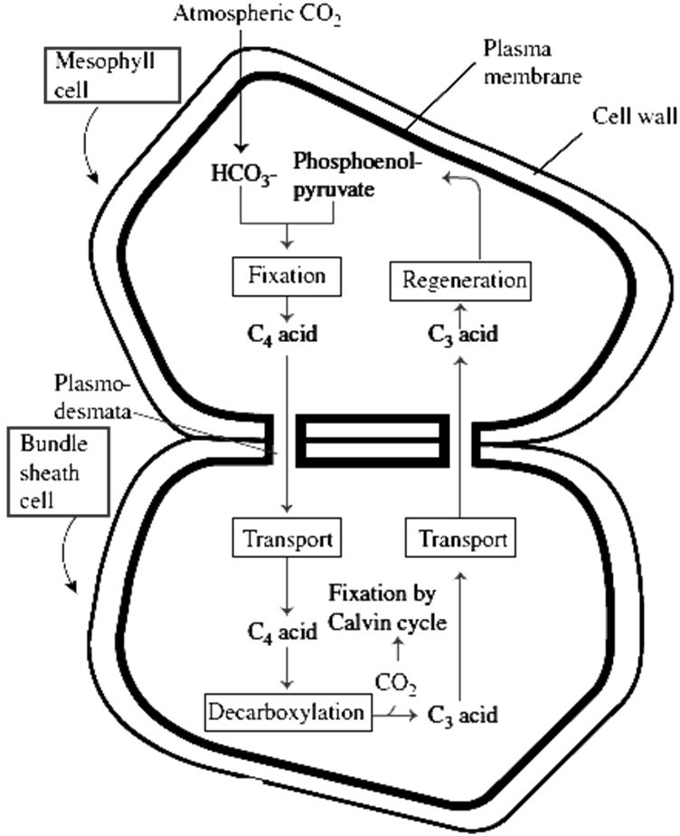

**Fig.:** Diagrammatic representation of the Hatch and Slack Pathway

Regeneration of PEP from C3 acid requires 2 ATP equivalent. However, there is no net gain or loss of NADPH in

C4 **cycle.**

ATP consumed in C4 Plants:

C4 cycle – 2 ATP per CO2 fixed C3 cycle – 3 ATP per CO2 fixed Total – 5 ATP per CO2 fixed

Thus, to from a hexose or to fix 6 CO2, ATP =30 ATP are consumed Some major differences between C3 pathway and C4 pathway are:

|  |  |
| --- | --- |
| 𝐂𝟑 **Pathway** | 𝐂𝟒 **Pathway** |
| 1. The primary acceptor of CO2 is RuBP carbon compound. - a five-carbon compound 2. The first stable product is 3-phosphoglycerate (3C-compound). 3. It occurs in the mesophyll cells of the leaves. 4. It is a slower process of carbon fixation. 5. 3ATP are consumed to fix one CO2 . | 1. The primary acceptor of CO₂ is PEP - a three- carbon compound. 2. The first stable product is oxaloacetic acid (4C- compound). 3. It occurs in the mesophyll and bundle-sheath cells of the leaves. 4. It is a faster process of carbon fixation. 5. 5 ATP are consumed to fix one CO2. |

## Importance of 𝑪𝟒 Plants

1. They can tolerate saline conditions due to abundant occurrence of organic acids (malic and oxaloacetic acid) in them which lowers their water potential than that of soil.
2. C4 pathway provides more CO2 for RuBP, RuBP carboxylase enzyme is less sensitive to CO2.
3. C4 plants are mostly found in hot deserts where high temperature and high light intensity are found. These conditions stimulate photorespiration in plants but photorespiration is absent in C4 plants

**Q1.**

**TOPIC CENTRIC EXERCISE -07**

**The first product of CO₂-fixation in C4-plants is:**

(a) Oxaloacetate (b) Phosphoenol-pyruvate

(c) Malic acid (d) Phosphoglyceric acid (PGA)

**Q2. Which one is an example of C4 - plant?**

(a) Papaya (b) Pea

(c) Potato (d) Maize

**Q3. Primary acceptor of CO₂ in Hatch and Slack pathway is**

(a) OAA (b) RuBP

(c) Malic Acid (d) PEP

**Q4.**

**In C4-pathway, initial carbon dioxide fixation occurs in chloroplasts of:**

**Q5.**

(a) Mesophyll cells

(c) Bundle sheath cells

**In case of C4, pathway, the first step is**

(a) CO₂ combines with RUBP

(c) CO₂ combines with PEP

(b) Guard cells

(d) All the above

(b) CO₂ combines with PGA

(d) CO₂ combines with RMP

# PHOTORESPIRATION

Photorespiration is a process which involves loss of fixed carbon as CO₂ in plants in the presence of light. It is initiated in chloroplasts. This process does not produce ATP or NADPH and is a **wasteful process**.

Photorespiration occurs usually when there is high concentration of oxygen. Under such circumstances, RuBisCO, the enzyme that catalyses the carboxylation of RuBP during the first step of Calvin cycle, functions as an oxygenase. Some O₂ does bind to RuBisCO and hence CO₂ fixation is decreased. The RuBP binds with O₂ to form one molecule of PGA (3C compound) and phosphoglycolate (2C compound) in the pathway of photorespiration. There is neither the synthesis of sugar, nor of ATP. Rather, it results in the release of CO₂ with the utilisation of ATP. It leads to a 25 percent loss of the fixed CO2. O₂ is first utilized in chloroplast and then in peroxisomes.

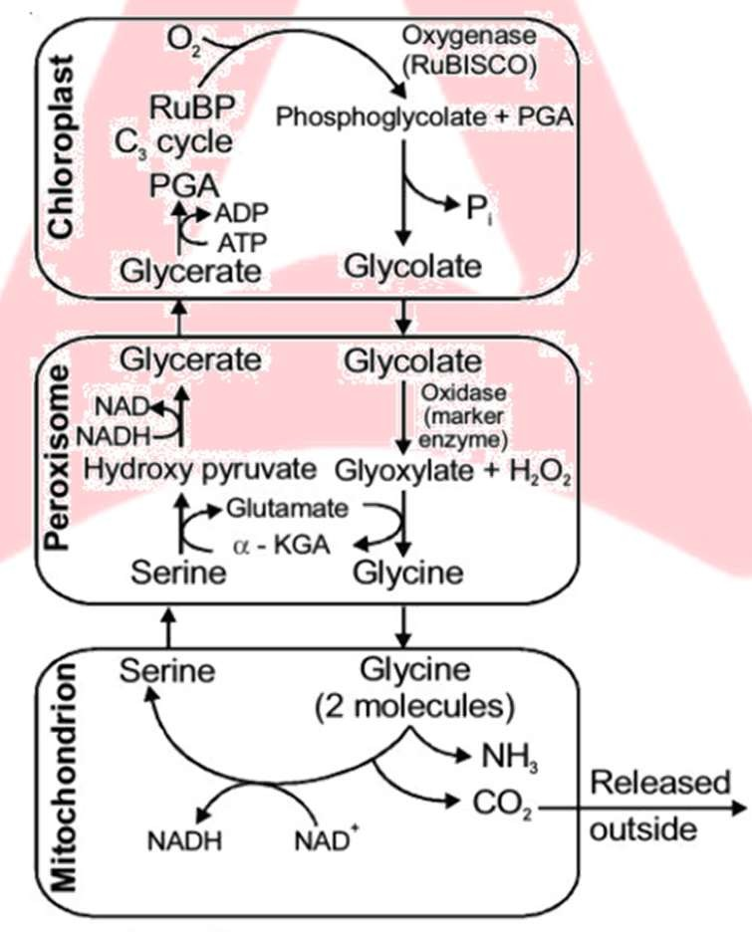

**Clue Finder**

RuBisCO that is the **most abundant enzyme** in the world is characterised by the fact that its active site can bind to both CO2 and O2 – hence the name.

In the photorespiratory pathway there is no synthesis of ATP or NADPH.

**Fig.**:C2 cycle

Photorespiration or C₂ cycle involves three organelles viz., chloroplast, peroxisomes and mitochondria. Loss of CO₂ occurs in mitochondria.

In C4 plants, photorespiration does not occur. This is because these plants have a mechanism that increases the concentration of CO₂ at the enzyme site. During the C4 pathway, when the C4 acid from the mesophyll cells is broken down in the bundle sheath cells, it releases CO₂ - this results in increasing the intracellular concentration of . This in turn, ensures that the RuBisCO functions as a carboxylase minimising the oxygenase activity.

Thus, the productivity and yields are better in C4 plants as compared to plants. In addition, the C₄ plants show tolerance to higher temperature also.





**Critical Thinking**

Photorespiration is not related to aerobic respiration as aerobic respiration occurs throughout the day and night in all types of cells, but photorespiration occurs in presence of light in green cells only. ATP is produced in aerobic respiration unlike photorespiration where ATP is consumed. Photorespiration utilizes a part of light energy and saves the plant from photo-oxidative damage.

**Q1.**

**TOPIC CENTRIC EXERCISE -08**

**Which of following characteristic cannot help us to differentiate between** 𝐂𝟑 **and** 𝐂𝟒 **plants?**

(a) Carbon dioxide acceptor molecule (b) Presence of Kranz anatomy

**Q2.**

(c) Photorespiration

**What does the name RuBisCO imply?**

(d) Calvin cycle

1. Its active site can bind to oxygen and carbon dioxide
2. It leads to the combination of oxygen and carbon dioxide
3. It uses carbon and oxygen to breakdown sugar
4. It uses carbon and oxygen to breakdown RuBP

**Q3. What factor determines the binding of carbon dioxide to the active site of RuBisCO?**

1. Intensity of sunlight (b) Number of chloroplasts

(c) Opening and closing of stomata (d) Relative O₂ and CO₂ concentration

**Q4. Why is carbon dioxide fixation decreased in plants?**

(a) Phosphoglycerate formation (b) Unavailability of RuBP

(c) Oxygen binds to RuBisCO (d) Oxygen binds to RuBP

**Q5. Which of the given fact following is not true regarding photorespiration?**

1. ATP is not synthesized
2. 1 molecule of phosphoglycerate is formed
3. 1 molecule of phosphoglyceraldehyde is formed
4. The active site of RuBisCO binds to oxygen

## FACTORS AFFECTING PHOTOSYNTHESIS

The rate of photosynthesis is very important in determining the yield of the plants including crop plants. An understanding of the factors that affects photosynthesis is very necessary. Photosynthesis is under the influence of both external and internal (plant) factors.

The **external factors** include the availability of sunlight, temperature, CO₂ concentration and water. Though several factors interact and simultaneously affect photosynthesis rate, at any point the rate is determined by the factors available at sub-optimal levels.

The **plant** factors include the number, size, age and orientation of leaves, mesophyll cells and chloroplasts, internal CO₂ concentration and amount of chlorophyll. The plant factors are dependent on the genetic predisposition and the growth of the plant.

**In 1905, Blackman** gave the **Law of Limiting factors**. When several factors affect any biochemical process, then this law comes into effect. This states that:

If a chemical process is affected by more than one factor, then its rate will be determined by the factor which is nearest to its minimal value. It is the factor which directly affects the process if its quantity is changed.

To illustrate the law, suppose light intensity supplied to a leaf is just sufficient to utilize 5 mg of per CO2 hour in photosynthesis. As the CO₂ supply is increased, the rate also increases till 5 mg of CO2 enters the leaf per hour. After that, any further increase in the supply of CO₂ does not have any affect upon the rate. Light has now become the limiting factor and further increase in rate of photosynthesis will occur only by increasing the intensity of light.

## External factors affecting photosynthesis

* + 1. **Light:**

It is an essential factor for photosynthesis. It affects the rate of photosynthesis as:

1. **Light intensity**: There is a linear relationship between incident light and CO₂ fixation at low light intensities. At higher light intensities, gradually the rate does not show further increase as other factors become limiting. The light saturation occurs at 10 percent of the total sunlight available to plants. Increase in incident light beyond a point causes the breakdown of chlorophyll and thus resulting in decrease in photosynthesis. Hence, except for plants in shade or in dense forests, light rarely becomes a limiting factor.

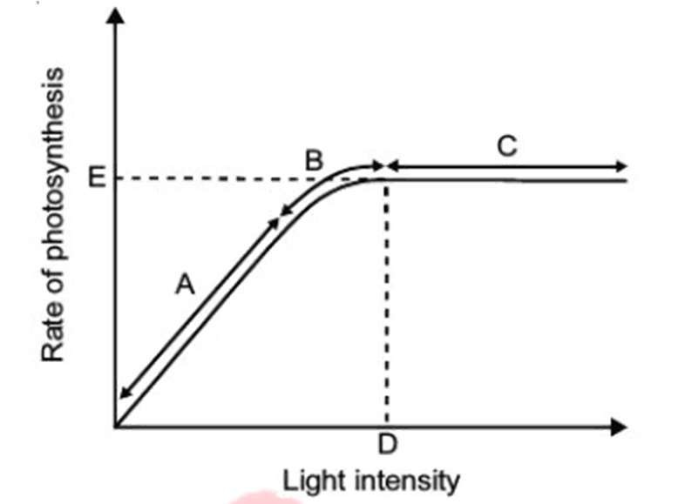

**Fig.:** Graph of light intensity on the rate of photosynthesis

1. **Light quality:** Light between 400-700 nm wavelength constitute the photosynthetically active radiation (PAR). Maximum photosynthesis takes place in red and blue light of the visible spectrum and minimum photosynthesis takes place in green light.
2. **Duration of light:** Light duration does not affect the rate of photosynthesis, but it affects the overall photosynthesis.

## Carbon dioxide Concentration:

It is a major limiting factor influencing the rate of photosynthesis. The concentration of CO₂ is very low in the atmosphere (between 0.03 percent and 0.04 percent). This level of carbon dioxide is far below the requirement for optimum photosynthesis. Increase in concentration up to 0.05 percent can cause an increase in the rate of photosynthesis but beyond this level, it becomes damaging over longer periods.

The C3 and C4 plants respond differently to CO₂ concentration. At low light intensities neither type responds to high CO2 concentration. At high light intensities, both C3 and C4 plants show increase in the rate of photosynthesis. The C4 plants show saturation at about 360 µIL-1 (ppm), while C3 plants show saturation only beyond 450 µIL-1 (ppm), thus, the current concentration of CO2 is limiting for C3 plants.

As plants respond to higher concentration by showing increased rate of photosynthesis, leading to higher productivity, this has been used for the production of greenhouse crops like tomatoes and bell pepper. These crops are allowed to grow in enriched atmosphere that leads to higher yields (CO₂ fertilization effect).

## Temperature:

Photosynthesis can take place over a wide range of temperatures. The light reactions are temperature senstive but they are affected to a much lesser extent. The dark reactions being enzymatic are temperature controlled. Again, the temperature optimum for photosynthesis of different plants also depends on the habitat that they are adapted to. Tropical plants have a higher temperature optimum than the plants adapted to temperate climates.

The C4 plants respond to higher temperatures and they show higher rate of photosynthesis, while plants have much lower temperature optimum. Optimum temperature in C3 plant is 20-25°C and for C4 plant is 30-45°C.



**Clue Finder**

The minimum temperature at which most plants start photosynthesis is 0-5°C. It is as low as - 35°C for gymnosperms. Maximum temperature at which photosynthesis can occur is 50-55°C for desert plants and 70-75°C for hot spring algae.

## Water:

Water is one of the raw materials utilized for the process of photosynthesis. Photosynthetic process utilizes less than 1% of the water absorbed by a plant, hence it is rarely a limiting factor in photosynthesis. Water stress causes the stomata to close, hence reducing the CO₂ availability as gaseous exchange could not occur. Also, water stress makes leaves wilt, thus reducing the surface area of the leaves and the metabolic activity reduces as well. Thus, the effect of water as a factor is more through its effect on the plant, rather than directly on photosynthesis.

**Q1.**

**TOPIC CENTRIC EXERCISE -09**

**Which of these is not an internal factor affecting photosynthesis?**

(a) Chlorophyyll content of the leaves (b) Mesophyll cells and chloroplast

(c) Internal CO2 concentration (d) Availability of sunlight

**Q2. Which of these is not an effect of water stress?**

(a) Closing of stomata (b) Increase in metabolism

(c) Wilting of leaves (d) Reduction in surface area of leaves

**Q3. What is the atmospheric concentration of carbon dioxide?**

(a) 0.3–0.4% (b) 3–4%

(c) 0.03–0.04% (d) 0.003–0.004%

**Q4. The** 𝐂𝟒 **plants are photosynthetically more efficient than** 𝐂𝟑 **plants because**

1. The CO2 efflux is not prevented
2. Photorespiration is negligible
3. The CO2 compensation point is more
4. CO2 generated during photorespiration is trapped and recycled through PEP carboxylase

**Q5. When day light hours are increased, the rate of photosynthesis:**

(a) Decreases (b) Increases

(c) Remains unchanged (d) None of the above

### Solved Examples Ex: 1. Photosynthesis is a/an _.

(a) Physio-chemical Process (b) Physical Process

(c) Chemical Process (d) Energy wasting process

**Sol. (a)** Photosynthesis is the physiochemical process by which green plants and some other organisms use sunlight to synthesize nutrients from carbon dioxide and water and it generates oxygen as a by- product.

### Ex: 2. What are the functions of accessory pigments

1. They enable a wider range of wavelengths of incoming light to be used for photosynthesis.
2. They absorb light and transfer to the reaction centre.
3. They protect the reaction centre from photo-oxidation
4. All of the above

**Sol. (d)** Accessory pigments are light-absorbing compounds that trap light energy and channels it to chlorophyll a, the primary pigment, which initiates the reactions of photosynthesis. Accessory pigments include the carotenoids, phycobiliproteins, and chlorophylls b,c and d. Indeed, they not only enable a wider range of wavelengths of incoming light to be utilized for photosynthesis but also protect chlorophyll a from photo-oxidation.

### Ex: 3. Splitting of water is related to:

(a) Photosystem I (b) Photosystem II

(c) Both (a) & (b) (d) Cyclic-photophosphorylation

**Sol. (b)** PS−II is located on the inner surface of appressed parts of grana thylakoids. P680 of PS−II absorbs light energy, gets excited and transfers its electrons to an electron acceptor and becomes a strong oxidant. It paves the way for light dependent splitting of water called photolysis.

### Ex: 4. ATP Synthesis in photosynthesis involves:

(a) Establishment of a proton gradient (b) Oxidation of water

(c) Reduction of NADP+ (d) Flow of electrons

**Sol. (a)** ATP synthesis is linked to the development of a proton gradient across the membrane of the thylakoid

### Ex: 5. Which one of the following is reduced during the dark reactions of photosynthesis:

(a) Carbon dioxide (b) Oxygen

(c) Water (d) Iron

**Sol. (a)** CO2 is reduced during the dark reactions of photosynthesis.

### Ex: 6. As per Z-scheme of light reaction, the electrons move -

(a) Uphill in redox potential scale (b) From low to high energy level

(c) Downhill in redox potential scale (d) Both (a) & (c)

**Sol. (d)** In the Z-scheme, electrons move uphill in the redox potential scale when excited by light and then downhill through the electron transport chain to produce ATP and NADPH.

### Ex: 7. Process by which C4 acid is converted into C3 acid in Hatch and Slack Pathway is known as:

(a) Carboxylation (b) Regeneration

(c) Reduction (d) Decarboxylation

**Sol. (d)** The process by which C4 acid is converted into C3 acid in the Hatch and Slack pathway is known as Decarboxylation, as it involves the release of CO₂.

### Ex: 8. Factor not affecting photosynthesis is:

(a) Light (b) Water

(c) Soil (d) Temperature

**Sol. (c)** The correct answer is Soil, as photosynthesis primarily depends on light, water, and temperature, while soil composition has an indirect effect.

### Ex: 9. No. of carbons in the primary 𝐂𝐎𝟐 fixation product of 𝐂𝟒 plants is:

(a) 2 (b) 3

(c) 4 (d) 5

**Sol. (c)** The correct answer is 4, as the primary CO₂ fixation product in C₄ plants is oxaloacetic acid (OAA), which has four carbon atoms.

### Ex: 10. Cyclic Photophosphorylation does not produce:

(a) NADPH (b) ATP

(c) Electrons (d) None of these

**Sol. (a)** The correct answer is NADPH, as cyclic photophosphorylation only produces ATP and does not generate NADPH since electrons cycle back to PSI instead of reducing NADP⁺.



**Exercise-01 Level -01**

1. A plant is provided with ideal conditions for photosynthesis and supplied with isotope 14CO₂. When the products of the process are analysed carefully, what would be the nature of products?
   1. Both glucose and oxygen are normal.
   2. Both glucose and oxygen are labelled.
   3. Only glucose is labelled and oxygen is normal.
   4. Only oxygen is labelled but glucose is normal.
2. In photosynthesis, the light-independent reactions take place at
   1. Photosystem II (b) Stromal matrix

(c) Thylakoid lumen (d) Photosystem I

1. ****A reduction in the quantity of oxygen evolution during 3 photosynthesis may be observed at
   1. Light having wavelength 700 nm
   2. Light having wavelength less than 680 nm
   3. Light having wavelength 560 nm
   4. Light having wavelength 680 nm.
2. Which of the following scientists concluded by his experiments that green plant parts play a role in purifying the noxious air only in the presence of sunlight?
   1. Priestley (b) Ingenhousz

(c) Sachs (d) Engelmann

1. Light reaction in photosynthesis occurs in
   1. Stroma (b) Lamellae

(c) Grana (d) Outer membrane.

1. Which of the following is/are formed during Z- scheme of 6 photophosphorylation?
   1. ATP (b) NADPH

(c) O2 (d) All of these

1. Who provided the evidence that glucose is formed during 7 photosynthesis and is then stored in the form of starch?
   1. Sachs (b) Engelmann

(c) Van Niel (d) Blackman

1. Which of the following statements regarding cyclic flow of electrons during light reactions is false?
   1. This process takes place in the stromal lamella.
   2. ATP synthesis takes place.
   3. NADPH + is synthesised.
   4. Takes place only when light of wavelength beyond 680 nm is available for excitation.
2. Which statement about photosynthesis is false?
   1. The enzymes required for carbon fixation are located only in the grana of chloroplasts.
   2. In plants, both PS I and PS II are required for the formation of NADPH + .
   3. The electron carriers involved in photophosphorylation are located on the thylakoid membranes.
   4. Photosynthesis is a redox process in which water is oxidised and carbon dioxide is reduced.
3. During Z scheme, electrons excited by absorption of 10 light in PS I are transferred to the primary acceptors, and therefore must be replaced. The replacements come directly from
   1. NADP (b) ATP

(c) PS II (d) Water

1. Which one of the following statements about the events of non-cyclic photophosphorylation is not correct?
   1. Only one photosystem participates
   2. ATP and NADPH are produced
   3. Photolysis of water takes place
   4. O₂ is released
2. PS II is located on
   1. Inner side of thylakoid membrane
   2. Outer side of thylakoid membrane
   3. Lumen of thylakoid membrane
   4. Stroma lamellae.
3. Photosynthesis cannot continue for long if during light reaction, only cyclic photophosphorylation takes place This is because
   1. Only ATP is formed, NADPH + H' is not formed
   2. Photosystem I stops getting excited at a wavelength of light beyond 680 nm
   3. There is unidirectional cyclic movement of the electrons
   4. There is no evolution of O2
4. Which of the following statements is true with regard to the light reaction of photosynthesis?
   1. In PS II the reaction centre chlorophyll a has an absorption peak at 700 nm, hence is called P700
   2. In PS I the reaction centre chlorophyll has an

absorption maximum at 680 nm and is called

P680

* 1. The splitting of water molecule is associated with PSI
  2. Photosystems I and II are involved in Z scheme.

1. Which of the following is produced during the light phase of photosynthesis?
   1. ATP
   2. NADPH
   3. Both ATP and NADPH
   4. Carbohydrates
2. Photochemical phase does not include
   1. Light absorption
   2. Water splitting and release
   3. ATP and NADPH formation
   4. CO2 fixation
3. During non-cyclic photophosphorylation, electrons 17 are continuously lost from the reaction centre of PS II. Which source is used to replace these electrons?
   1. Sunlight (b) O2

(c) H2O (d) CO2

1. Refer the given reaction

2H2O → 4H+ + O2 + 4e–

Where does this reaction take place in the chloroplasts of plants

* 1. Outer surface of thylakoid membrane
  2. Inner surface of thylakoid membrane
  3. In the matrix (stroma)
  4. Intermembrane space

1. During fixation of one molecule of CO₂ by C3, plants, number of ATP and NADPH required are
   1. 3 ATP and 2 NADPH
   2. 5 ATP and 2 NADPH
   3. 12 ATP and 12 NADPH
   4. 2 ATP and 3 NADPH
2. In cycle for the fixation of every CO₂ molecule, the reduction and regeneration steps require
   1. 3 ATP and 2 NADPH2
   2. 2 ATP and 2 NADPH2
   3. 2 ATP and 3 NADPH2
   4. 3 ATP and 3 NADPH2
3. Identify the incorrect statement with respect to Calvin cycle.
   1. 18 molecules of ATP are synthesised during carbon fixation.
   2. NADPH + H+ produced in light reaction is used in dark reacion
   3. The carboxylation of RuBP is catalysed by RuBisCO.
   4. The first stable intermediate compound formed is phosphoglycerate.
4. Select the incorrect statement with respect to kranz anatomy.
   1. Undifferentiated mesophyll occurs in concentric layers around vascular bundles.
   2. Centrifugal chloroplasts are present in bundle sheath cells.
   3. Large sized bundle sheath cells are arranged in a wreath-like manner in one to several layers.
   4. Chloroplasts of bundle sheath cells possess well-developed grana lamellae.
5. A plant is adapted to grow in some shady habitat. It will have
   1. Extensive root system
   2. Larger photosynthetic units than plants in sun
   3. Higher fixation of CO₂ than sun plants
   4. Narrow and shorter leaves.
6. At normal temperature, the enzyme RuBisCO has
   1. More affinity for CO2 than for O₂
   2. More affinity for O₂ than for CO2
   3. Equal affinity for both
   4. More affinity for sugars, than for CO2
7. The rate of photosynthesis is higher in
   1. Very high light
   2. Continuous light
   3. Red light
   4. Green light.
8. All are correct for photorespiration, except-
   1. Also known as C-2 cycle
   2. No synthesis of ATP
   3. Primary acceptor of Oxygen is RuBP
   4. Primary product is 4C compound
9. In photorespiration, the number of ATP and NADPH synthesised are respectively
   1. 1 and 3 (b) 2 and 3

(c) 3 and 4 (d) 0 and 0.

1. Which one of the following is wrong in relation to photorespiration?
   1. It occurs in chloroplast.
   2. It occurs in day time only.
   3. It is a characteristic of C4 plants.
   4. It is a characteristic of C3 plants.
2. Which of the following is not an external factor influencing photosynthesis?
   1. CO2 concentration
   2. O2 concentration
   3. Availability of water
   4. Chlorophyll concentration
3. A process that makes important difference between 𝐶3 and 𝐶4 plants is
   1. Transpiration (b) Glycolysis

(c) Photosynthesis (d) Photorespiration

1. In a plant, the light reaction products ATP and NADPH are left in some amount in the evening. The dark reaction will
   1. Stop when light is not available
   2. Continues throughout night at it does not requires light
   3. Stop as NADPH are preserved for next morning
   4. Continue till ATP and NADPH are not consumed.
2. Absorption spectrum of chl a shows maximum absorption in
   1. Blue and green
   2. Blue and red
   3. Red and green
   4. Red and far red
3. If green plant cells are incubated with O18 labelled water, which of the following molecules will become radioactive when the cells are exposed to light?
   1. O2 (b) CO2

(c) H2O (d) Sugar

1. Followings are the statements given for C3 and C4

plants. Find the incorrect statement.

* 1. C3 and C4 are derived from product of initial carbon fixation.
  2. Initial acceptor of atmospheric CO2 is same in both C3and C4plants.
  3. CO2plant shows presence of RuBisCO in bundle sheath cell.
  4. In high CO2 concentration photorespiration does not occur.

1. What is incorrect about Kranz anatomy?
   1. The bundle sheath cells form several layers around the vascular bundle.
   2. They are characterized by large number of chloroplasts.
   3. There is no intercellular space.
   4. They are having thin walls permeable to gaseous exchange.
2. RuBisCO enzyme is most abundant protein of chloroplast. Which cells have no RuBisCO enzymes?
   1. Mesophyll cells of plants
   2. Mesophyll cells of C4 plants
   3. Bundle sheath cells of all plants
   4. Bundle sheath cells of C4 plants
3. Which of the following statements regarding C4

pathway is false?

* 1. The primary CO2 acceptor is phosphoenol pyruvate.
  2. The enzyme responsible for CO2 fixation is PEPcase.
  3. The mesophyll cells lack RuBisCO enzyme.
  4. The bundle sheath cells contain the enzyme PEPcase.

1. When availability of light to a plant is stopped, the dark reaction will
   1. Immediately stop
   2. Stop after some time
   3. Continue along with slow pace
   4. It occurs only in dark at it does not required light.
2. Bundle sheath cells
   1. Are rich in PEP carboxylase
   2. Lack RuBisCO
   3. Lack both RuBisCO and PEP carboxylase
   4. Are rich in RuBisCO
3. In a photosystem, the antennae are formed by
   1. All the pigment molecules
   2. All the pigment molecules excluding all chl b
   3. Carotenoids and xanthophylls
   4. All pigment molecules excluding one chl molecule.
4. In light reaction, the electrons move from one to other system along
   1. Downhill
   2. Uphill
   3. First uphill then downhill
   4. First downhill then uphill.
5. Which is true for photosynthesis?
   1. Both carbon dioxide and water are oxidised.
   2. Both carbon dioxide and water are reduced.
   3. Carbon dioxide is oxidised and water is reduced.
   4. Carbon dioxide is reduced and water is oxidised.
6. O2 concentration in atmosphere is very high than CO2. Even then usually RuBisCO causes carboxylation because of
   1. Its very high affinity with CO₂ than O2
   2. O2 binding sites are usually inactive
   3. Higher number of CO2 binding site than O₂ sites
   4. Conformation of active sites suitable to bind O₂
7. Select the correct statement.
   1. In photosystem I photocentre is P680-
   2. Photosystem I is connected with photolysis of water.
   3. Photosystem I receives electrons from photosystem II.
   4. Photosystem I is present in appressed part of grana thylakoids.
8. Present concentration of CO2 in atmosphere is very low i.e., between 0.03-0.04%. At this concentration, is limiting factor for
   1. C3 plants
   2. C4 plant
   3. Both 𝐶3 and C4 plants
   4. Mostly for C4 plants.
9. The enzyme involved in CO2 fixation in C4 plant is
   1. RuBisCO in 1st fixation, PEP carboxylase in 2nd fixation
   2. PEP carboxylase in 1st fixation, RuBisCO in 2nd fixation.
   3. RuBP oxygenase in 1st fixation, RuBP carboxylase in 2nd fixation.
   4. PEP carboxylase in 1st fixation, PEP oxygenase in 2nd fixation
10. In C4 plants, the source of CO2, for its second time fixation is
    1. 3C organic acid (b) 2C organic acid

(c) 4C organic acid (d) 5C carbohydrate

1. What is incorrect for cyclic photophosphorylation?
   1. ATP is generated due to cyclic flow of electron.
   2. Cyclic photophosphorylation occurs in grana.
   3. Synthesis of only ATP occurs, not NADPH + H+
   4. Wavelength of light above 680 nm causes only cyclic phosphorylation.
2. Which of the following is not an accessory pigment?
   1. Chlorophyll (b) Xanthophyllal

(c) Carotenoid (d) Chlorophyll

1. The first stable product of C4 pathway is
   1. OAA (b) PGA

(c) PGAL (d) DHAP



**Exercise-02 Level -02**

1. ****Consider the following statements and choose the correct option
   1. Light reactions, like dark reactions, are also temperature sensitive but are affected to a much lesser extent.
   2. C3 plants respond to higher temperatures and show higher rate of photosynthesis.
      1. Only A is correct
      2. Only B is correct
      3. Both A and B are incorrect
      4. Both A and B are correct
2. How many features given below are present in bundle sheath cells of C4 plants?
3. Thin walled
4. Having large number of agranal chloroplasts
5. Large cells
6. Impervious to gaseous exchange
7. Presence of intercellular space

(a) Five (b) Four

(c) Two (d) Three

1. Dark reaction is not directly dependent on light but usually do not occur at night. Why?
2. Plant usually opens their stomata at night
3. In night, CO2 concentration is high for these reactions to occur
4. Dark reaction is dependent on the products of light reaction
5. Night is often too cold for these reactions to occur
6. In plants having Kranz anatomy “Formation of malic acid occurs in A of leaves and B carboxylation occurs in bundle sheath cells

Select the option that correctly fills the blanks A and B.

|  |  |  |
| --- | --- | --- |
|  | **A** | **B** |
| (a) | Guard cells | Second |
| (b) | Mesophyll cells | First |
| (c) | Epidermal cells | First |
| (d) | Mesophyll cells | Second |

1. In photosynthesis, CO2
2. Has different saturation concentrations for C3

and C4 plants at a higher light intensity

1. Is not a limiting factor, influencing the rate of photosynthesis
2. Is required at very low concentration for C3

plants to obtain higher yields

1. Has no effect on C4 plants
2. In leaves of higher plants, a pigment which appears yellow – green in the chromatogram helps
3. In absorption of light of different wavelength.
4. To prevent oxidative destruction of chlorophyll pigment by light.
5. By absorbing wavelength beyond visible spectrum which increases the efficiency of photosynthesis.

(a) Only b (b) Only b & c

(c) All a, b & c (d) Only a & b

1. How many features below are **not** related with photorespiration?
   1. Occurs in C4 plants
   2. Three organelle are involved
   3. No synthesis of sugar
   4. Out of three, only one organelle with two membranes
      1. B and C (b) A, B and C

(c) B, C and D (d) B and D

1. How many components listed below are associated with mesophyll cells of Hatch and Slack pathway?

PEP, 3PGA, PEPcase, RuBisCO, PSI, PS II, RuBP,

NADPH, Aspartic acid

(a) Three (b) Five

(c) Six (d) Four

1. Maize and sugarcane plants show saturation at about
2. 360 ppm of CO2
3. 20% of full sunlight
4. 50% of full sunlight
5. 500 ppm of CO2
6. At low temperature, plants are less efficient due to-
7. High energy requirement for CO2 fixation
8. Cold sensitivity of PEP synthetase enzyme
9. High rate of PEP synthetase enzyme
10. Low CO2 affinity of PEPcase
11. Select the **incorrect** statement about chloroplast
12. Usually, chloroplast align themselves along the walls of mesophyll cells, so that they get optimum quantity of incident light
13. Within chloroplast there is a membranous system consisting of grana, stroma lamellae and stroma
14. There is a clear division of labour
15. In grana is CO2 fixed
16. Given below is a diagram of chloroplast. Identify (i), (ii), (iii) and (iv)

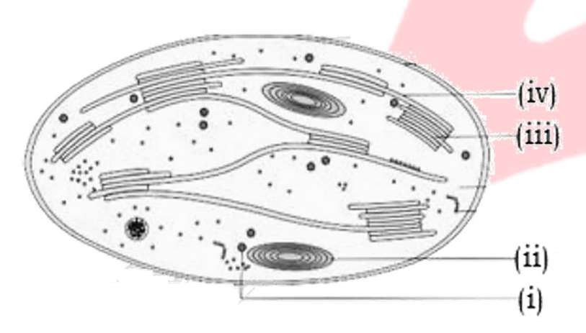

1. i=Starch granule, ii-Lipid droplet, iii-Stroma lamella, iv-Grana
2. i-Starch granule, ii-Lipid droplet, iii-Grana, iv-

Stroma lamella

1. i-Lipid droplet, ii-Starch granule, iii-Grana, iv-

Stroma lamella

1. i-Lipid droplet, ii-Starch granule, iii-Stroma lamella, iv-Grana
2. If a plant is kept in dark for a long time-
3. Starch will be synthesized in chloroplast
4. ATP will be synthesized in chloroplast but no starch
5. NADPH will be synthesized in chloroplast but no starch
6. None of these
7. Select the correct statement for the graph below which explains the graph correctly.

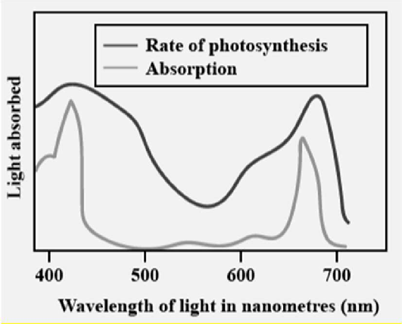

1. The action spectrum shows a graphic representation of
2. Absorption spectrum depicts the relative rates of photosynthesis of different wavelengths of light
3. Action spectrum of photosynthesis corresponds closely to absorption spectrum of chlorophyll-a
4. None of the above
5. Choose correct order of events in light reaction-
6. ATP & NADPH formation
7. Water Splitting
8. Oxygen release
9. Light absorption

(a) III, IV, II, I (b) IV, III, I, II

(c) IV, II, III, I (d) II, III, IV, I

1. Water splitting is associated with-
2. PS I located on inner side of thylakoid membrane
3. PS II located on inner side of thylakoid membrane
4. PS I located on outer stroma lamellae
5. PS II located on outer stroma lamellae membrane
6. The O2 is released in-
7. Lumen of thylakoid
8. Outer side of thylakoid
9. Stroma.
10. Cytoplasm
11. Given below is the diagram of Cyclic photophosphorylation. Identify the correct site for: I- water splitting, II- NADP+ reduction, III- ATP synthesis

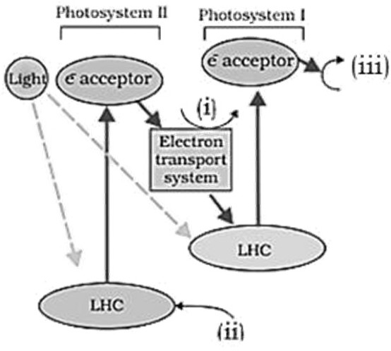

|  |  |  |  |
| --- | --- | --- | --- |
|  | **i** | **ii** | **iii** |
| (a) | I | II | III |
| (b) | II | I | III |
| (c) | III | II | I |
| (d) | III | I | II |

1. I. Cyclic photophosphorylation needs PS-I and PS-II.
2. Cyclic photophosphorylation produces NADP

+ H+ and ATP.

1. Cyclic photophosphorylation involves H2O.
2. Electrons are recycled in cyclic photophosphorylation.

Identify the correct and incorrect statements and select the option accordingly.

* 1. I, II and III are incorrect, IV is correct
  2. I, II and IV are incorrect, III is correct
  3. I, II and III are incorrect, II is correct
  4. IV, III and II are incorrect, I is correct

1. NADP reductase enzyme is located on of thylakoid membrane.
2. Stroma side (outer side)
3. Lumen side (i.e. outer side)
4. Stroma Side (i.e. inner side)
5. Lumen side (i.e. inner side)
6. Given below diagram represents Hatch and Slack pathway. Identify (i), (ii) and (iii)

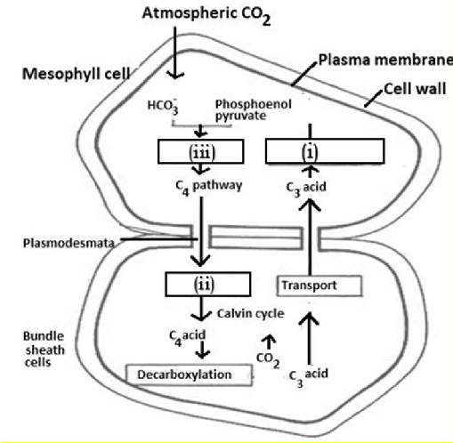

1. i-Fixation, ii-Decarboxylation, iii-Regeneration
2. i-Transport, ii-Fixation, iii-Regeneration
3. i-Regeneration, ii-Transport, iii-Fixation
4. i-Regeneration, ii-Decarboxylation, iii-Fixation
5. Which of the following is formed during non-cyclic photophosphorylation in photosynthesis?
6. Glucose and Hydrogen donor
7. Glucose, O2 and Hydrogen
8. ATP, Hydrogen donor and O2
9. O2 donor, ATP and Hydrogen
10. The compound that is used to absorb CO2 in Moll’s half leaf experiment is-

(a) HCl (b) NaOH

(c) MgCl2 (d) KOH

1. Photorespiration is not seen in C4 plants because they -
2. Use RuBisCO to initiate CO2 fixation in mesophyll cells
3. Use PEP carboxylase to initiate CO2 fixation in mesophyll cells
4. Have RuBP to act as oxygenase
5. Do not carry out the Calvin cycle
6. Consider the following matching pairs-

|  |  |  |
| --- | --- | --- |
| I. Julius von Sachs | – | Showed that green substance in plants located in special  bodies |
| II. Cornelius van Niel | – | Demonstrated photosynthesis is essentially a light-  dependent reaction |
| III. Jan Ingenhousz | – | Experimented with an  aquatic plant |
| IV. T.W.  Engelmann | – | Experimented by using prism, green algae and anaerobic  bacteria |

How many of the above are correctly matched?

1. Only I and II
2. Only I, II and III
3. Only II, III and IV
4. All are correct
5. Mark the **incorrect** matching pair w.r.t part of chloroplast and their function

|  |  |  |  |
| --- | --- | --- | --- |
| (a) | Stroma of  chloroplast | - | CO2 reduction |
| (b) | Lumen of  thylakoid | - | Photolysis of H2O |
| (c) | Stroma lamellae | - | Synthesis of ATP |
| (d) | Grana of  chloroplast | - | Regeneration of  RuBP |

1. Consider the following statements-
2. Functioning of PS-I is not necessary to synthesize
3. Splitting of water is associated with PS-II
4. ATP or NADPH is not formed during photorespiration
5. Except for plants in shade or in dense forests, light is a limiting factor for photosynthesis.

How many statements are correct?

* 1. Only I and II
  2. Only II, III and IV
  3. Only II and III
  4. All are correct

1. How many glucose molecules are produced by use of 18 ATP and 12 NADPH in photosynthesis in C3 plants?

(a) Six (b) Four

(c) One (d) Two

1. For regeneration of one molecule of RuBP in Calvin cycle, the requirement of ATP and NADPH are respectively-

(a) 1 and 0 (b) 3 and 2

(c) 2 and 2 (d) 1 and 1

1. Consider the following statement and select the correct option.
2. At low light intensity, C3 plants show increase in rate of photosynthesis with increase in CO2 concentration.
3. At low temperature, increase in water concentration increases rate of photosynthesis
   1. Only (I) is correct
   2. Only (II) is correct
   3. Both (I) and (II) are correct
   4. Both (I) and (II) are incorrect
4. The importance of photosynthesis is because of
5. Simple organic compounds are converted into organic food
6. It is source of food for all organisms.
7. It releases oxygen from CO2
8. It releases oxygen in the atmosphere.

(a) 2 and 4 only (b) 1 and 3 only

(c) 2 and 3 only (d) 1 and 4 only

1. Reactions that occur in photochemical phase are
   1. Absorption of light
   2. Splitting of water
   3. Release of oxygen
   4. Formation of ATP and NADPH
   5. Utilisation of ATP and NADPH
   6. Synthesis of sugars
      1. A, B, C, D, (b) B, C, D, F

(c) A, C, E, (d) A, B, C, F

1. The basic feature of typical C4 plants showing 'Kranz' anatomy is
2. The presence of few chloroplasts in number in bundle sheath cells
3. The presence of chloroplasts in mesophyll and epidermal cells
4. The presence of typical chloroplasts with well- formed grana in bundle sheath cells and presence of chloroplasts in the epidermal cells
5. The presence of large number of chloroplasts in bundle sheath cells and typical chloroplasts with well-formed grana in mesophyll cells.
6. Among the given factors, identify the external factors that affects the rate of photosynthesis and select the correct option accordingly
7. Temperature
8. External CO₂ concentration
9. Chlorophyll arrangement
10. Water

(a) I, II and IV (b) I, II and III

(c) II, III and IV (d) I, III and IV

1. Factors affecting photosynthesis are
2. Number and size of leaves
3. Age and orientation of leaves
4. Amount of chlorophyll
5. CO2 concentration Select the correct option.

(a) I, II and IV only (b) I and III only

(c) III and IV (d) I, II, III and IV

1. Contribution of Ingenhousz in elucidation of process of photosynthesis is that
2. Only green parts of plants exposed to sunlight can convert foul air (CO₂) into pure air O2
3. Green plants convert light energy into chemical energy.
4. Plants have the capacity to purify foul air.
5. Sunlight is the ultimate source of energy for plants and animals
6. Choose the correct statement w.r.t. dark reactions of photosynthesis.
7. These reactions are also called as carbon reactions.
8. These reactions occurs in darkness only and they are dependent on light directly.
9. These reactions are dependent on the products of photochemical reactions (ATP and NADPH).
10. It includes C₂ cycle.

(a) I and II (b) I and III

(c) II and IV (d) III and IV

1. Given graph represents the absorption spectra of three photosynthetic pigments, chl 𝛼, chl 𝑏 and 𝛽- carotene.

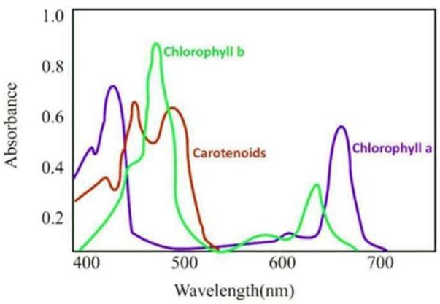

Select the correct statement regarding this.

1. Chl *a* and chl *b* absorb maximum light in blue and red wavelength of light respectively.
2. Rate of photosynthesis is maximum in blue and red wavelength of light.
3. The graph showing the absorption spectrum of chlorophyll a, b and the carotenoids.
4. All of these.
5. Consider the following statements regarding photosynthesis.
6. ATP formation during photosynthesis is termed as photophosphorylation.
7. Kranz anatomy pertains to leaves of C4 plants.
8. Reduction of NADP+ to NADPH occurs during Calvin cycle
9. Photochemical phase occurs inside the stroma lamellae.

Of the above statement

* 1. (i) and (ii) are correct.
  2. (iii) and (iv) are correct.
  3. (i) and (iii) are correct.
  4. (i) and (iv) are correct.

1. Consider the following statements.
2. In photosynthesis, the proton accumulation takes place outside the thylakoid membrane.
3. The electrons needed to replace these removed from PS II are provided by PS I.
4. In cyclic photophosphorylation, oxygen is not released (as there is no photolysis of water) and NADPH is also not produced.

Of these statements given above

* 1. (i) is correct but (ii) and (iii) are incorrect.
  2. (i) and (ii) are incorrect but (iii) is correct.
  3. (ii) is correct but (i) and (iii) are incorrect.
  4. (i) and (ii) are correct but (iii) is incorrect.

1. Which one of the following is incorrect about the activities associated with PSI and PSII in non-cyclic photophosphorylation?
2. Water is oxidised in PS II, but not in PS I.
3. Photons (light) are needed to activate both PS I and PS II.
4. Photolysis of water and formation of ATP +

NADPH + H+ occurs

1. Production of NADPH + H+ is associated with PS II not with PS I.
2. What would be the effect on the concentration of protons during photosynthesis?

|  |  |  |
| --- | --- | --- |
|  | Stroma of  chloroplast | Thylakoid luminal  fluid |
| (a) | Decrease | Increase |
| (b) | Increase | Decrease |
| (c) | Decrease | No effect |
| (d) | No effect | Increase |

1. During light-dependent reactions, light energy is converted into chemical potential energy through the process of chemiosmosis in the chloroplasts. Which of the following statements about this process is/are incorrect?
2. The electron carriers of phosphorylation are located in the stroma.
3. During phosphorylation, the chloroplast stroma becomes more acidic than the interior of thylakoid membrane.
4. Protons diffuse through the protein channels which are ATP synthase molecule.
5. NADPH is formed from NADP+ on the stroma side of the thylakoid in the chloroplast.

(a) Only (ii) (b) (iii) and (iv)

(c) Only (iv) (d) (i) and (ii)

1. The graph given below shows the effect of light intensity on the rate of photosynthesis. Which of the following statement regarding the graph is correct?

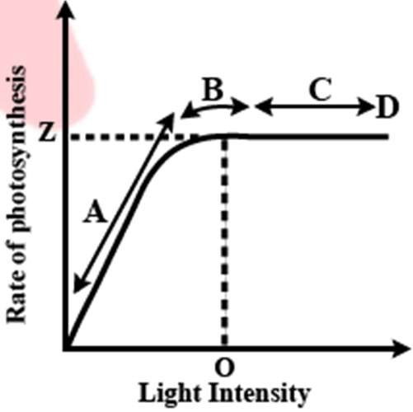

1. Light is a limiting factor in the region A.
2. Region C represents that the rate of photosynthesis is not increased further by increasing light intensity because some other factor becomes limiting.
3. Point D represents the intensity of light at which some other factor becomes limiting.
4. All of these
5. The diagram represents the Calvin cycle

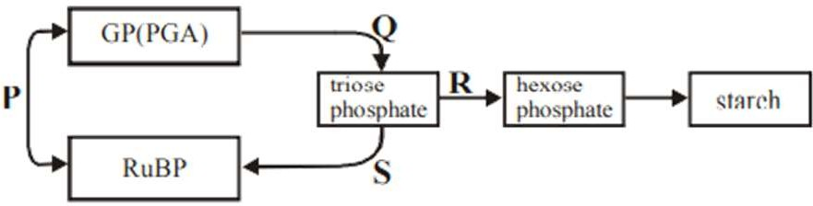

At which step is CO2 incorporated?

(a) P (b) Q

(c) R (d) S

1. Select the incorrect statement.
2. Tropical plants have a higher temperature optimum than the plants adapted to temperate climates.
3. Carbon dioxide is the major limiting factor for photosynthesis.
4. Plants have a much lower temperature optimum than plants.
5. Water stress causes the stomata to open and increasing availability.
6. With reference to factors affecting the rate of photosynthesis which of the following statements is not correct?
7. Increasing atmospheric CO2 concentration up to 0.05% can enhance fixation rate.
8. C3 plants respond to higher temperature with enhanced photosynthesis while C4 plants have much lower temperature optimum.
9. Tomato is a greenhouse crop which can be grown in CO2 enriched atmosphere for higher yield.
10. Light saturation for CO2 fixation occurs at 10% of full sunlight.
11. C4 plants avoid photorespiration by
12. Performing Calvin cycle at night
13. Fixing CO₂ into organic acid in night and releasing CO₂ in day
14. Using PEP carboxylase to fix CO₂ to RuBP
15. Keeping the stomata opened during the day.
16. Which of the following statement are correct?
17. Photorespiration is favoured by high O2 low

CO2 rise in temperature, high light intensity.

1. Chloroplasts of bundle sheath cells of C4 plants are granal, have PEPcase but no RuBisCO.
2. Chloroplasts of mesophyll cells of C4 plants are granal, have PEPcase but no RuBisCO.
3. Maize and sorghum are C4 plants.
   1. (i), (iii) and (iv) (b) (i) and (iv)

(c) (ii) and (iii) (d) Only (iv)

1. Choose the correct statement w.r.t. Julius von Sachs discovery.
2. He provided the evidence for the production of glucose.
3. He showed that chloroplasts is located in special bodies called chlorophyll within plant cells.
4. He found that in all parts of plants glucose is made.
5. He found that glucose is usually stored as glycogen in plants.



**Exercise-03 Level -03**

## Assertion & Reason Based Questions

1. **Assertion:** Six turns of Calvin cycle are required to make one molecule of glucose.

**Reason:** In each turn of Calvin cycle there is fixation of only one CO2 while 6CO2 are required for each glucose.

* 1. If both assertion and reason are true and reason is the correct explanation of assertion.
  2. If both assertion and reason are true but reason is not the correct explanation of assertion.
  3. If assertion is true but reason is false
  4. If both assertion and reason are false

1. **Assertion:** Photosynthetically C3 plants are less efficient than C4 plants.

**Reason:** The operation of C3 pathway requires the involvement of mesophyll cells and bundle-sheath cells.

* 1. If both assertion and reason are true and reason is the correct explanation of assertion.
  2. If both assertion and reason are true but reason is not the correct explanation of assertion.
  3. If assertion is true but reason is false
  4. If both assertion and reason are false

1. **Assertion:** Protons or hydrogen ions produced by photolysis of water accumulate in the lumen of thylakoids.

**Reason:** The splitting of water is associated with the PS II.

* 1. If both assertion and reason are true and reason is the correct explanation of assertion.
  2. If both assertion and reason are true but reason is not the correct explanation of assertion.
  3. If assertion is true but reason is false
  4. If both assertion and reason are false.

1. **Assertion:** Photorespiration may occur during day time in mesophyll cells of plants.

**Reason:** It happens due to the oxygenase activity of RuBisCO**.**

* 1. If both assertion and reason are true and reason is the correct explanation of assertion.
  2. If both assertion and reason are true but reason is not the correct explanation of assertion.
  3. If assertion is true but reason is false
  4. If both assertion and reason are false

1. **Assertion:** In all the photosynthetic plants, first stable product of carbon fixation during Calvin cycle is 3-phosphoglycerate.

**Reason:** 3-phosphoglycerate is always the first product of carbon fixation during dark reaction whether fixation occurs with the help of PEPcase or RuBisCO.

* 1. If both assertion and reason are true and reason is the correct explanation of assertion.
  2. If both assertion and reason are true but reason is not the correct explanation of assertion.
  3. If assertion is true but reason is false
  4. If both assertion and reason are false.

1. **Assertion:** Cyclic photophosphorylation synthesizes both NADPH and ATP.

**Reason:** Cyclic photophosphorylation involves both PS-I and PS-II.

* 1. If both assertion and reason are true and reason is the correct explanation of assertion.
  2. If both assertion and reason are true but reason is not the correct explanation of assertion.
  3. If assertion is true but reason is false
  4. If both assertion and reason are false.

1. **Assertion:** Only one photosystem i.e., PS-I is present in all prokaryotes.

**Reason:** In prokaryotes, photolysis of water does not take place.

* 1. If both assertion and reason are true and reason is the correct explanation of assertion.
  2. If both assertion and reason are true but reason is not the correct explanation of assertion.
  3. If assertion is true but reason is false
  4. If both assertion and reason are false.

1. **Assertion:** Carboxylation is the most crucial step of the Calvin cycle.

**Reason:** In this CO2 is utilised for the carboxylation of RuBP.

* 1. If both assertion and reason are true and reason is the correct explanation of assertion.
  2. If both assertion and reason are true but reason is not the correct explanation of assertion.
  3. If assertion is true but reason is false
  4. If both assertion and reason are false.

1. **Assertion:** O2 is liberated in the noncyclic photophosphorylation.

**Reason:** Liberation of oxygen is due to photolysis of water.

* 1. If both assertion and reason are true and reason is the correct explanation of assertion.
  2. If both assertion and reason are true but reason is not the correct explanation of assertion.
  3. If assertion is true but reason is false
  4. If both assertion and reason are false.

1. **Assertion:** There are two main pathway of biosynthetic phase of photosynthesis.

**Reason:** This biosynthetic phase does not directly depend on the presence of light.

* 1. If both assertion and reason are true and reason is the correct explanation of assertion.
  2. If both assertion and reason are true but reason is not the correct explanation of assertion.
  3. If assertion is true but reason is false
  4. If both assertion and reason are false.

1. **Assertion:** Proton gradient is important for photophosphorylation.

**Reason:** Breakdown of proton gradient provide enough energy to cause a conformational change in the F0 particle of ATPase which makes the enzyme to synthesize ATP.

* 1. Both Assertion and Reason are True and the Reason is a correct explanation of the Assertion.
  2. Both Assertion and Reason are True but Reason is not a correct explanation of the Assertion.
  3. Assertion is True but the Reason is False.
  4. Assertion is False but the Reason is True.

1. **Assertion:** Leaves of C4 plants show Kranz anatomy.

**Reason:** C4 plants possess two types of chloroplast.

* 1. If both assertion and reason are true and reason is the correct explanation of assertion.
  2. If both assertion and reason are true but reason is not the correct explanation of assertion.
  3. If assertion is true but reason is false
  4. If both assertion and reason are false.

1. **Assertion:** Photorespiration is a wasteful process. **Reason:** Photorespiration occurs in both C3 and C4 plants.
   1. If both assertion and reason are true and reason is the correct explanation of assertion.
   2. If both assertion and reason are true but reason is not the correct explanation of assertion.
   3. If assertion is true but reason is false
   4. If both assertion and reason are false.
2. **Assertion:** CO2 is the major limiting factor for photosynthesis.

**Reason:** If CO2 is increasing continuously, there will be an increase in photosynthesis.

* 1. If both assertion and reason are true and reason is the correct explanation of assertion.
  2. If both assertion and reason are true but reason is not the correct explanation of assertion.
  3. If assertion is true but reason is false
  4. If both assertion and reason are false.

1. **Assertion:** In C3 plants, photosynthetic efficiency is reduced at high temperature.

**Reason:** C4 plants have more efficient photosynthesis at high temperature.

* 1. If both assertion and reason are true and reason is the correct explanation of assertion.
  2. If both assertion and reason are true but reason is not the correct explanation of assertion.
  3. If assertion is true but reason is false
  4. If both assertion and reason are false.

## Statement Based Questions

1. **Statement I:** Ingenhousz showed that formation of pure air is carried out by green plants only in the presence of sunlight.

**Statement II:** Engelmann worked on Cladophora.

* 1. Both statements are correct
  2. Both statements are incorrect
  3. Statement I is correct but statement II is incorrect
  4. Statement I is incorrect but statement II is correct.

1. **Statement I:** Chlorophyll a and chlorophyll b are structurally different.

**Statement II:** Light absorption by pigments Chl a and Chl b occurs at different absorption regions.

* 1. Both statements are correct
  2. Both statements are incorrect
  3. Statement I is correct but statement II is incorrect
  4. Statement I is incorrect but statement II is correct.

1. **Statement I:** First CO₂ fixation product in C3 cycle is C3 acid.

**Statement II:** Primary acceptor in C3 cycle is a 2- carbon compound.

* 1. Both statements are correct
  2. Both statements are incorrect
  3. Statement I is correct but statement II is incorrect
  4. Statement I is incorrect but statement II is correct.

1. **Statement I:** Low temperature inhibits photosynthesis.

**Statement II:** Low temperature inactivates the enzymes of plants.

* 1. Both statements are correct
  2. Both statements are incorrect
  3. Statement I is correct but statement II is incorrect
  4. Statement I is incorrect but statement II is correct.

1. **Statement I:** The temperature optimum for photosynthesis of different plants also depends on the habitat that they are adapted to.

**Statement II:** C3 plants respond to lower temperatures and show lower rate of photosynthesis.

* 1. Both statements are correct
  2. Both statements are incorrect
  3. Statement I is correct but statement II is incorrect
  4. Statement I is incorrect but statement II is correct.

1. **Statement I:** The single chlorophyll a molecule forms the reaction centre.

**Statement II:** The light harvesting complexes are made up of hundreds of pigment molecules bound to proteins.

* 1. Both statements are correct
  2. Both statements are incorrect
  3. Statement I is correct but statement II is incorrect
  4. Statement I is incorrect but statement II is correct.

1. **Statement I:** OAA is the first product of CO₂ fixation in C3 pathway.

**Statement II:** The first product of CO₂ fixation in C4

pathway is PGA.

* 1. Both statements are correct
  2. Both statements are incorrect
  3. Statement I is correct but statement II is incorrect
  4. Statement I is incorrect but statement II is correct.

1. **Statement I:** Each photosystem has all the pigments forming a light harvesting system also called antennae.

**Statement II:** All the pigments help to make photosynthesis more efficient by absorbing different wavelength of light.

* 1. Both statements are correct
  2. Both statements are incorrect
  3. Statement I is correct but statement II is incorrect
  4. Statement I is incorrect but statement II is correct.

1. **Statement I:** C3 plants respond to increase CO2 concentration by increasing rate of photosynthesis. **Statement II:** The higher productive of some greenhouse crops such as tomatoes and bell pepper is due to increase CO2 concentration.
   1. Both statements are correct
   2. Both statements are incorrect
   3. Statement I is correct but statement II is incorrect
   4. Statement I is incorrect but statement II is correct.
2. **Statement I:** In photosynthesis during ATP synthesis protons accumulate in the lumen of thylakoid.

**Statement II:** Biosynthetic phase of photosynthesis is also termed as dark reaction,

* 1. Both statements are correct
  2. Both statements are incorrect
  3. Statement I is correct but statement II is incorrect
  4. Statement I is incorrect but statement II is correct.

1. **Statement I:** Carboxylation is the most crucial step of Calvin cycle where CO2 is utilized for the carboxylation of RuBP

**Statement II:** Carboxylation is catalysed by the enzyme RuBisCO which results in the formation of two molecules of 3PGA.

* 1. Both statements are correct
  2. Both statements are incorrect
  3. Statement I is correct but statement II is incorrect
  4. Statement I is incorrect but statement II is correct.

1. **Statement I:** Photorespiration decreases photosynthetic output.

**Statement II:** In photorespiratory pathway, neither ATP nor NADPH is produced.

* 1. Both statements are correct
  2. Both statements are incorrect
  3. Statement I is correct but statement II is incorrect
  4. Statement I is incorrect but statement II is correct.

1. **Statement I:** Photorespiration interferes with the successful functioning of Calvin cycle.

**Statement II:** Photorespiration oxidises ribulose- 1,5 biphosphate which is an acceptor of CO2 in Calvin cycle.

* 1. Both statements are correct
  2. Both statements are incorrect
  3. Statement I is correct but statement II is incorrect
  4. Statement I is incorrect but statement II is correct.

1. **Statement I:** In green plants PSI and PSII are required for the synthesis of NADPH + H+ **Statement II**: Photosynthesis is a physico-chemical process.
   1. Both statements are correct
   2. Both statements are incorrect
   3. Statement I is correct but statement II is incorrect
   4. Statement I is incorrect but statement II is correct.
2. **Statement I:** Joseph priestly discovered oxygen in 1770.

**Statement II:** In Half-leaf experiment, KOH-soaked cotton absorbs CO2

* 1. Both statements are correct
  2. Both statements are incorrect
  3. Statement I is correct but statement II is incorrect
  4. Statement I is incorrect but statement II is correct.

1. **Statement I:** Separation of the leaf pigments of any green plant can be done through paper chromatography

**Statement II:** Pigments are substances that have an ability to absorb light, at specific wavelengths.

* 1. Both statements are correct
  2. Both statements are incorrect
  3. Statement I is correct but statement II is incorrect
  4. Statement I is incorrect but statement II is correct.

1. **Statement I:** Greenhouse crops such as tomatoes and bell pepper are allowed to grow in carbon dioxide enriched atmosphere that leads to higher yields.

## Match up Based Questions

1. Match the Column I with Column II.

|  |  |  |  |
| --- | --- | --- | --- |
|  | **Column I (Scientist/Phy siologist)** |  | **Column II (Contribution)** |
| 1. | Priestely | A | Light is essential  for photosynthesis |
| 2. | Engelmann | B. | Evolved O2 comes from H2O |
| 3. | Ingenhousz | C. | Action spectrum of photosynthesis |
| 4. | van Niel | D. | Discovery of O2 |

**Statement II:** The bundle sheath cells of C4

lack PEPcase.

1. Both statements are correct
2. Both statements are incorrect

plants

1. 1–D, 2–A, 3–C, 4–B
2. 1–B, 2–D, 3–C, 4–A
3. Statement I is correct but statement II is incorrect
4. Statement I is incorrect but statement II is correct.
5. **Statement I:** First action spectrum of photosynthesis was described by von Sachs. **Statement II:** By the middle of the nineteenth century the key features of plant photosynthesis were known.
   1. Both statements are correct
   2. Both statements are incorrect
   3. Statement I is correct but statement II is incorrect
   4. Statement I is incorrect but statement II is correct.
6. **Statement I:** For every CO2 molecule entering the Calvin cycle, 2 molecules of ATP and 1 molecule of NADPH are required

**Statement II:** Plants that are adapted to dry tropical regions use the C3 pathway or the Calvin cycle as the main biosynthetic pathway.

* 1. Both statements are correct
  2. Both statements are incorrect
  3. Statement I is correct but statement II is incorrect
  4. Statement I is incorrect but statement II is correct.

1. **Statement I:** Phosphoglycolate is produced in C3 plant but not in C4 plant.

**Statement II:** C3 cycle occurs in maize and

sorghum

* 1. Both statements are correct
  2. Both statements are incorrect
  3. Statement I is correct but statement II is incorrect
  4. Statement I is incorrect but statement II is correct.

1. 1–B, 2–C, 3–D, 4–A
2. 1–D, 2–C, 3–A, 4–B
3. Match the items in column I with those in column II

|  |  |  |  |
| --- | --- | --- | --- |
|  | **Column-I** |  | **Column-II** |
| (I) | RuBP  carboxylase | A. | Mesophyll cell |
| (II) | PEP case | B. | Photorespiration |
| (III) | Phosphoglycolate | C. | Fixation in C3  plants |

* 1. I–C, II–B, III–A
  2. I–C, II–A, III–B
  3. I–A, II–B, III–C
  4. I–A, II–C, III–B

1. Match column I with column II and select the correct option from the given codes.

|  |  |  |  |
| --- | --- | --- | --- |
|  | **Column-I** |  | **Column-II** |
| A. | C4 plants | (i) | No synthesis of ATP or NADPH |
| B. | Chlorophyll-b | (ii) | Photo-oxidation of  H2O |
| C. | PS II | (iii) | Accessory photosynthetic  pigment |
| D. | Photorespirat  ion | (iv) | Kranz anatomy |

* 1. A–(iv), B–(iii), C–(ii), D–(i)
  2. A–(i), B–(ii), C–(iii), D–(iv)
  3. A–(iv), B–(iii), C–(i), D–(ii)
  4. A–(iii), B–(ii), C–(iv), D–(i)

1. Match column-I with column-II and select the correct answer using the codes given below:

|  |  |  |  |
| --- | --- | --- | --- |
|  | **Column-I** |  | **Column-II** |
| A | Grana of  chloroplast | I | Yellow green in  chromatogram |
| B | Stroma of  chloroplast | II | Light reaction |
| C | Chlorophyll a | III | Dark reaction |
| D | Chlorophyll b | IV | Blue green in  chromatogram |

* 1. A–IV, B–III, C–II, D–I
  2. A–I, B–II, C–IV, D–III
  3. A–IV, B–I, C–III, D–II
  4. A–II, B–III, C–IV, D–I

1. Match the column.

|  |  |  |  |
| --- | --- | --- | --- |
|  | **Column A** |  | **Column B** |
| 1. | Light reaction | A | Utilisation of NADPH |
| 2. | Dark reaction | B | Stroma |
|  |  | C | Stromal lamellae |
|  |  | D | Synthesis of ATP |
|  |  | E | Synthesis of sugars |

* 1. 1– A, B, C :2–D, E
  2. 1– B, C :2–A, D, E
  3. 1–A, E :2–B, C, D,
  4. 1–C, D :2–A,B, E

1. Which of the following with respect to early experiments of photosynthesis is wrongly matched?

|  |  |  |  |
| --- | --- | --- | --- |
| (a) | Joseph Priestly | – | Showed that plants release O2 |
| (b) | Jan Ingenhousz | – | Showed that sunlight is essential for  photosynthesis |
| (c) | Julius von Sach | – | Proved that plants  produce glucose when they grow |
| (d) | T.W.  Engelmann | – | Showed that the green substance is located within special bodies in  plants |

1. Match the column I and II and choose the correct combination from the options given.

|  |  |  |  |
| --- | --- | --- | --- |
|  | **Column I** |  | **Column II** |
| A. | Purple and green  bacteria | i | T.W. Engelmann |
| B. | Light reaction | ii | Carbon reaction |
| C. | Cladophora | iii | Photochemical  reaction |
| D. | Dark reaction | iv | van Niel |

* 1. A–iii, B–iv, C–i, D–ii
  2. A–iv, B–iii, C–i, D–ii
  3. A–ii, B–iii, C–iv, D–i
  4. A–ii, B–iv, C–i, D–iii

1. Match the following and choose the correct combination.

|  |  |  |  |
| --- | --- | --- | --- |
|  | **Column-I** |  | **Column-II** |
| A | Light reaction | i | RuBP |
| B | Dark reaction | ii | Phosphoglycolate |
| C | Carboxylation | iii | Photolysis |
| D | Photorespiration | iv | Stroma |

* 1. A–iv, B–ii, C–i, D–ii
  2. A–ii, B–iii, C–iv, D–i
  3. A–iii, B–iv, C–i, D–ii
  4. A–i, B–ii, C–ii, D–iv

1. Match the column I and II and choose the correct combination from the option given.

|  |  |  |  |
| --- | --- | --- | --- |
|  | **Column I** |  | **Column-II** |
| A | RuBP | (i) | Light reaction |
| B | Phosphoglycerate | (ii) | 5-carbon  compound |
| C | Grana | (iii) | Water splitting complex |
| D | Photosystem II | (iv) | 3-carbon compound |

* 1. A–ii, B–iii, C–iv, D–i
  2. A–i, B–ii, C–iv, D–iii
  3. A–ii, B–iv, C–i, D–iii
  4. A–ii, B–iv, C–i, D–iii

1. Find out the mismatched pair:

|  |  |  |  |
| --- | --- | --- | --- |
| (a) | C4 plants | → | Kranz anatomy |
| (b) | Primary CO2  fixation product of  C4 plants | → | OAA |
| (c) | Primary CO2  acceptor of C3  plants | → | RuBP |
| (d) | C3 plants | → | Maize |

1. Match the following columns:

|  |  |  |  |
| --- | --- | --- | --- |
| A | Mesophyll cells of C3 plant | 1 | Have large  number of chloroplast |
| B | Bundle sheath cell of C4 plant | 2 | Malic acid formation |
| C | Mesophyll cell  of C4 plant | 3 | PGA formation |

* 1. A-3, B-1, C-2
  2. A-1, B-2, C-3
  3. A- 3, B-2, C-1
  4. A-2, B-3, C-1

1. Match the following columns:

|  |  |  |  |
| --- | --- | --- | --- |
| A | Chlorophyll | 1 | Formed in non-cyclic  photophosphorylation |
| B | NADPH | 2 | Soluble in organic  solvent |
| C | FeS | 3 | Primary e- acceptor of  PS-I |

* 1. A-1, B-2, C-3
  2. A-3, B-1, C-2
  3. A- 3, B-2, C-1
  4. A- 2, B-1, C-3

1. Match the following columns:

|  |  |  |  |
| --- | --- | --- | --- |
| A | Cyclic photophos-  phorylation | 1 | Oxygen is evolved |
| B | Non-cyclic photophos-  phorylation | 2 | Product is ATP only |
| C | C3 cycle | 3 | Requires 3 ATP  per 𝐶𝑂2 fixation |
| D | C4 cycle | 4 | Requires 5 ATP  per 𝐶𝑂2 fixation |

* 1. A - 2, B - 1, C - 3, D - 4
  2. A - 4, B - 3, C - 1, D - 2
  3. A - 2, B - 1, C - 4, D - 3
  4. A - 3, B - 4, C - 2, D - 1

1. Match the following columns:

|  |  |  |  |
| --- | --- | --- | --- |
| A | C3 plant | 1 | RuBP binds with 𝑂2 |
| B | C4 plant | 2 | Productivity low at  high temperature |
| C | Photorespirati  on | 3 | Productivity high at  high temperature |

1. How may molecules of ATP and NADPH are required for every molecule of CO2 fixed in the Calvin cycle? **(2024)**



**Exercise-04 Previous Year Questions**

* 1. 2 molecules of ATP and 2 molecules of NADPH
  2. 3 molecules of ATP and 3 molecules of NADPH
  3. 3molecules of ATP and 2 molecules of NADPH
  4. 2 molecules of ATP and 3 molecules of NADPH

1. Which of the following are required for the dark reaction of photosynthesis? **(2024)**

A. Light B. Chlorophyll

1. CO2 D. ATP E. NADPH

Choose the correct answer from the options given below:

* 1. B, C and D only
  2. C, D and E only
  3. D and E only
  4. A, B and C only

1. Given below are two statements: **(2024) Statement I:** In C3 plants, some O2 binds to RuBisCO, hence CO2 fixation is decreased. **Statement II:** In C4 plants, mesophyll cells show very little photorespiration while bundle sheath cells do not show photorespirations.
   1. Both statements I and statement II are false
   2. Statement I is true but statement II is false
   3. Statement I is false but statement II is true
   4. Both statement I and statement II are true
2. A-3, B-2, C-1
3. A- 2, B- 3, C-1
4. A-2, B-1, C-3
5. A-1, B-2, C-3
6. Match the following columns:

|  |  |  |  |
| --- | --- | --- | --- |
| A | Z scheme | 1 | Part of PS-I and granal  thylakoid |
| B | Magnesium | 2 | Located at the centre of  the porphyrin ring in chlorophyll |
| C | FNR enzyme | 3 | Electron move from  PS-II to PS-I |

* 1. A-1, B-2, C-3
  2. A-3, B-1, C-2
  3. A- 3, B-2, C-1
  4. A- 2, B-1, C-3

1. How many ATP and NADPH2 are required for the synthesis of one molecule of Glucose during Calvin cycle? **(2023)**
   1. 18 ATP and 12 NADPH2
   2. 12 ATP and 16 NADPH2
   3. 18 ATP and 16 NADPH2
   4. 12 ATP and 12 NADPH2
2. The reaction centre in PS II has an absorption maxima at **(2023)**
   1. 700 nm (b) 660 nm

(c) 780 nm (d) 680 nm

1. Which of the following combinations is required for chemiosmosis? **(2023)**
   1. Membrane, proton pump, proton gradient,

NADP synthase

* 1. Proton pump, electron gradient, ATP synthase
  2. Proton pump, electron gradient, NADP synthase
  3. Membrane, proton pump, proton gradient, ATP synthase

1. Given are two statements:

**Statement I:** The primary CO2 acceptor in C4 plants is phosphoenolpyruvate and is found in the mesophyll cells.

**Statement II:** Mesophyll cells of C4 plants lack RuBisCo enzyme.

In the light of the above statements, choose the correct answer from the options given below:

### (2022)

* 1. Both Statement I and Statement II are correct
  2. Both Statement I and Statement II are incorrect
  3. Statement I is correct but Statement II is incorrect
  4. Statement I is incorrect but Statement II is correct

1. Which one of the following is not true regarding the release of energy during ATP synthesis through chemiosmosis? It involves: **(2022)**
   1. Breakdown of proton gradient
   2. Breakdown of electron gradient
   3. Movement of protons across the membrane to the stroma
   4. Reduction of NADP to NADPH2 on the stroma side of the membrane
2. What is the role of large bundle sheath cells found around the vascular bundles in C4 plants? **(2022)**
   1. Grana lamellae have both PS I and PS II.
   2. Cyclic photophosphorylation involves both PS I and PS II.
   3. Both ATP and NADPH + H+ are synthesized during non-cyclic photophosphorylation.
3. The oxygenation activity of RuBisCo enzyme in photorespiration leads to the formation of:

### (2020)

* 1. 1 molecule of 3-C compound
  2. 1 molecule of 6-C compound
  3. 1 molecule of 4-C compound and 1 molecule of 2-C compound
  4. 2 molecules of 3-C compound

1. In light reaction, plastoquinone facilitates the transfer of electrons from: **(2020)**
   1. Cytb6f complex to PS-I
   2. PS-I to NADP+
   3. PS-I to ATP synthase
   4. PS-II to *Cy*𝑡𝑏6f complex
2. During non-cyclic photophosphorylation, when electrons are lost from the reaction centre at PS II,

what is the source which replaces these electrons?

* 1. To provide the site for photorespiratory pathway
  2. To increase the number of chloroplast for the operation of Calvin cycle
  3. To enable the plant to tolerate high temperature

1. Water
2. Carbon dioxide
3. Light
4. Oxygen

### (2020)

* 1. To protect the vascular tissue from high light intensity

1. The first stable product of CO2 fixation in sorghum is: **(2021)**
   1. Oxaloacetic acid
   2. Succinic acid
   3. Phosphoglyceric acid
   4. Pyruvic acid
2. Which of the following statements is incorrect?

### (2021)

* 1. Stroma lamellae have PS I only and lack NADP reductase.

1. Which of the following statements is incorrect?

### (2020)

* 1. In C4 plants, the site of RuBisCO activity is mesophyll cell
  2. The substrate molecule for RuBisCO activity is a 5-carbon compound
  3. RuBisCO action requires ATP and NADPH
  4. RuBisCO is a bifunctional enzyme

 **Answer keys**

|  |  |  |  |  |  |  |  |  |  |
| --- | --- | --- | --- | --- | --- | --- | --- | --- | --- |
| **TOPIC CENTRIC EXERCISE -01 Answer Key** | | | | | | | | | |
| **1.** | (c) | **2.** | (a) | **3.** | (d) | **4.** | (b) | **5.** | (c) |

|  |  |  |  |  |  |  |  |  |  |
| --- | --- | --- | --- | --- | --- | --- | --- | --- | --- |
| **TOPIC CENTRIC EXERCISE -02 Answer Key** | | | | | | | | | |
| **1.** | (d) | **2.** | (a) | **3.** | (b) | **4.** | (a) | **5.** | (c) |

|  |  |  |  |  |  |  |  |  |  |
| --- | --- | --- | --- | --- | --- | --- | --- | --- | --- |
| **TOPIC CENTRIC EXERCISE -03 Answer Key** | | | | | | | | | |
| **1.** | (d) | **2.** | (c) | **3.** | (b) | **4.** | (c) | **5.** | (d) |

|  |  |  |  |  |  |  |  |  |  |
| --- | --- | --- | --- | --- | --- | --- | --- | --- | --- |
| **TOPIC CENTRIC EXERCISE -04 Answer Key** | | | | | | | | | |
| **1.** | (a) | **2.** | (d) | **3.** | (c) | **4.** | (c) | **5.** | (b) |

|  |  |  |  |  |  |  |  |  |  |
| --- | --- | --- | --- | --- | --- | --- | --- | --- | --- |
| **TOPIC CENTRIC EXERCISE -05 Answer Key** | | | | | | | | | |
| **1.** | (d) | **2.** | (b) | **3.** | (a) | **4.** | (c) | **5.** | (c) |

|  |  |  |  |  |  |  |  |  |  |
| --- | --- | --- | --- | --- | --- | --- | --- | --- | --- |
| **TOPIC CENTRIC EXERCISE -06 Answer Key** | | | | | | | | | |
| **1.** | (d) | **2.** | (c) | **3.** | (d) | **4.** | (a) | **5.** | (a) |

|  |  |  |  |  |  |  |  |  |  |
| --- | --- | --- | --- | --- | --- | --- | --- | --- | --- |
| **TOPIC CENTRIC EXERCISE -07 Answer Key** | | | | | | | | | |
| **1.** | (a) | **2.** | (d) | **3.** | (d) | **4.** | (a) | **5.** | (c) |

|  |  |  |  |  |  |  |  |  |  |
| --- | --- | --- | --- | --- | --- | --- | --- | --- | --- |
| **TOPIC CENTRIC EXERCISE -08 Answer Key** | | | | | | | | | |
| **1.** | (d) | **2.** | (a) | **3.** | (d) | **4.** | (c) | **5.** | (c) |

|  |  |  |  |  |  |  |  |  |  |
| --- | --- | --- | --- | --- | --- | --- | --- | --- | --- |
| **TOPIC CENTRIC EXERCISE -09 Answer Key** | | | | | | | | | |
| **1.** | (d) | **2.** | (b) | **3.** | (c) | **4.** | (b) | **5.** | (c) |

|  |  |  |  |  |  |  |  |  |  |
| --- | --- | --- | --- | --- | --- | --- | --- | --- | --- |
| **Exercise-01 Level -01 Answer Key** | | | | | | | | | |
| 1. (c) 2. (b) 3. (a) 4. (b) 5. (c) | 1. (d) 2. (a) 3. (c) 4. (a) 5. (c) | 1. (a) 2. (a) 3. (a) 4. (d) 5. (c) | 1. (d) 2. (c) 3. (b) 4. (a) 5. (a) | 1. (a) 2. (d) 3. (b) 4. (a) 5. (c) | 1. (d) 2. (d) 3. (c) 4. (d) 5. (d) | 1. (d) 2. (b) 3. (a) 4. (b) 5. (d) | 1. (b) 2. (d) 3. (b) 4. (d) 5. (d) | 1. (c) 2. (d) 3. (a) 4. (c) 5. (a) | 1. (b) 2. (c) 3. (b) 4. (d) 5. (a) |

|  |  |  |  |  |  |  |  |  |  |
| --- | --- | --- | --- | --- | --- | --- | --- | --- | --- |
| **Exercise-02 Level -02 Answer Key** | | | | | | | | | |
| 1. (a) 2. (d) 3. (c) 4. (d) 5. (a) | 1. (d) 2. (a) 3. (b) 4. (a) 5. (b) | 1. (d) 2. (c) 3. (d) 4. (c) 5. (c) | 1. (b) 2. (a) 3. (d) 4. (a) 5. (a) | 1. (c) 2. (c) 3. (d) 4. (b) 5. (b) | 1. (d) 2. (c) 3. (c) 4. (a) 5. (d) | 1. (a) 2. (a) 3. (d) 4. (a) 5. (d) | 1. (a) 2. (b) 3. (d) 4. (a) 5. (b) | 1. (d) 2. (a) 3. (d) 4. (d) 5. (a) | 1. (d) 2. (b) 3. (c) 4. (a) 5. (a) |

|  |  |  |  |  |  |  |  |  |  |
| --- | --- | --- | --- | --- | --- | --- | --- | --- | --- |
| **Exercise-03 Level -03 Answer Key** | | | | | | | | | |
| 1. (a) 2. (d) 3. (a) 4. (a) 5. (c) | 1. (d) 2. (d) 3. (b) 4. (a) 5. (b) | 1. (a) 2. (a) 3. (c) 4. (c) 5. (b) | 1. (a) 2. (a) 3. (c) 4. (a) 5. (a) | 1. (a) 2. (b) 3. (a) 4. (a) 5. (a) | 1. (a) 2. (a) 3. (a) 4. (a) 5. (d) | 1. (a) 2. (a) 3. (d) 4. (d) 5. (c) | 1. (d) 2. (b) 3. (a) 4. (d) 5. (d) | 1. (d) 2. (b) 3. (c) 4. (c) 5. (d) | 1. (a) 2. (d) 3. (a) 4. (b) 5. (c) |

|  |  |  |  |  |  |  |  |  |  |  |  |
| --- | --- | --- | --- | --- | --- | --- | --- | --- | --- | --- | --- |
| **Exercise-04 Previous Year Questions** | | | | | | | | | | | |
| **1.** | (c) | **3.** | (b) | **5.** | (d) | **7.** | (a) | **9.** (b) | **11.** (c) | **13.** (d) | **15.** (a) |
| **2.** | (b) | **4.** | (a) | **6.** | (d) | **8.** | (c) | **10.** (a) | **12.** (a) | **14.** (a) |  |