**Q1.** Choose the alternative which most closely resembles the mirror image of the given combination.



(a) 

(b) 

(c) 

(d) 

**Q2.** Find the alternative which contains figure (A) as its part.

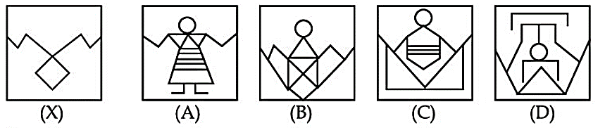

(a) (A)

(b) (B)

(c) (C)

(d) (D)

**Q3.** Find the next term in given series.

2, 5, 10, 17, 26, ?

(a) 35

(b) 36

(c) 37

(d) 47

**Q4.** What will be the measurement of the angle made by the hour and minute hands of a clock when the time is 'quarter past 3'?

(a) $6\frac{1°}{2}$

(b) 10°

(c) $7\frac{1°}{2}$

(d) $8\frac{1°}{2}$

Q5. Find the missing character in the given question:

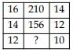

(a) 90

(b) 100

(c) 110

(d) 120

Q6. Raj is standing in the middle of a square field. He starts walking diagonally to North—East and after reaching midway, he turns right and reaches the far end of the field. Then, he turns right and starts walking. In the midway, he again turns right and starts walking. In halfway, he turns to his left and reaches a new far end. In what direction is Raj now?

(a) North

(b) South

(c) North—West

(d) South—West

Q7. An accused is more powerful than the deceased. Police are less powerful than the court but more powerful than the lawyer. Accused bends his head before police. Who is the most powerful?

(a) Court

(b) Accused

(c) Police

(d) Lawyer

Q8. Which of the following diagram indicates the best relation between Teacher, Writer and Dancer.

(a)

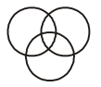

(b)

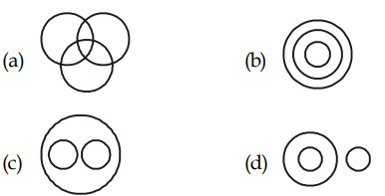

(c)



(d)



**Q9.** **Statements:**

(I) All Forces are energies

(II) All energies are powers

(III) No power is heat

**Conclusions:**

(I) Some forces are definitely not powers

(II) No heat is force

(a) If only (I) follows

(b) If only (II) follows

(c) If both (I) and (II) follows

(d) If neither (I) nor (II) follows

Q10. P is the brother of Q and R. S is R’s mother. T is P’s father. Which of the following statements cannot be definitely true?

(a) T is Q’s father.

(b) S is P’s mother.

(c) P is S’s son.

(d) Q is T’s son.

Solutions

S1. Ans. (c)

Sol.



S2. Ans. (b)

Sol.



S3. Ans. (c)

Sol.

The pattern is + 3, + 5, +7, +9, +11.

So next term in series = 26 +11 = 37

S4. Ans. (c)

Sol.

The angle between the hour and minute hand will be:

θ = $|\frac{13×15}{2}$– 30 × 3| = 7.50

S5. Ans. (c)

Sol.

16 × 14 – 14 = 210: 14 × 12 – 12 = 156:

Therefore, missing number = 12 × 10 – 10 = 110

S6. Ans. (d)

Sol.

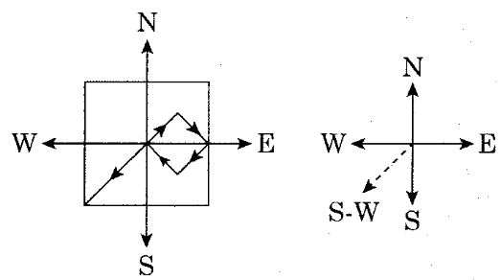

Raj is in South West direction

S7. Ans. (a)

Sol.

accused > deceased

court > police> lawyer

police > accused

so, court > police > lawyer > accused > deceased

S8. Ans. (a)

Sol.

Some teachers are writer and they also are related to dancer.

S9. Ans. (b)

Sol. Only (II) follows.

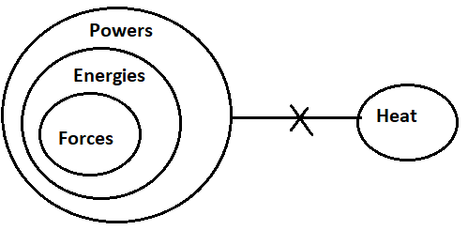

S10. Ans. (d)

Sol. P, Q, R are children of same parents. So, S, who is R’s mother and T, who is P’s father will be mother and father of all three. However, it is not mentioned whether Q is male or female. So, option (d) cannot be definitely true.