**MATHEMATICS**

**PAGEMAKER10**

**AREA**

Q1. The area inside the parabola $5x^{2}-y=0$ but outside the parabola $2x^{2}-y+9=0$ is

(a) $12\sqrt{3}$ sq. units

(b) $6\sqrt{3}$ sq. units

(c) $8\sqrt{3}$ sq. units

(d) $4\sqrt{3}$ sq. units

L1Difficulty1

Qtag Mathematics

Qcreator Pagemaker10

Q2. Let $f\left(x\right)=$ minimum $\left(x+1\right), \sqrt{x-1})$ for all $x≤1.$ Then the area bounded by $y=f(x)$ and the $x$-axis is

(a) $\frac{7}{3}$ sq. units

(b) $\frac{1}{6}$ sq. units

(c) $\frac{11}{6}$ sq. units

(d) $\frac{7}{6}$ sq. units

L1Difficulty1

Qtag Mathematics

Qcreator Pagemaker10

Q3. Area enclosed between the curves $\left|y\right|=1-x^{2}$ and $x^{2}+y^{2}=1$ is

(a) $\frac{3π-8}{3}$ sq. units

(b) $\frac{π-8}{3}$ sq. units

(c) $\frac{2π-8}{3}$ sq. units

(d) None of these

L1Difficulty1

Qtag Mathematics

Qcreator Pagemaker10

Q4. The area of the region enclosed by the curves $y=x\log{x}$ and $y=2x-2x^{2}$ is

(a) $\frac{7}{12}$ sq. units

(b) $\frac{1}{2}$ sq. units

(c) $\frac{5}{12}$ sq. units

(d) None of these

L1Difficulty1

Qtag Mathematics

Qcreator Pagemaker10

Q5. The area enclosed between the curves $y=\log_{e}\left(x+e\right), x=\log_{e}\left(\frac{1}{y}\right)$ and the $x$-axis is

(a) 2 sq. units

(b) 1 sq. units

(c) 4 sq. units

(d) None of these

L1Difficulty1

Qtag Mathematics

Qcreator Pagemaker10

Q6. Area bounded by $y=\frac{1}{x^{2}-2x+2}$ and $x$-axis is

(a) $2π$ sq. units

(b) $\frac{π}{2}$ sq. units

(c) 2 sq. units

(d) $π$ sq. units

L1Difficulty1

Qtag Mathematics

Qcreator Pagemaker10

Q7. Area bounded by the curve $xy^{2}=a^{2}\left(a-x\right)$ and the $y$-axis is

(a) $πa^{2}/2$ sq. units

(b) $πa^{2}$ sq. units

(c) $3πa^{2}$ sq. units

(d) None of these

L1Difficulty1

Qtag Mathematics

Qcreator Pagemaker10

Q8. The area of the closed figure bounded by $x=-1, y=0, y=x^{2}+x+1$ and the tangent to the curve $y=x^{2}+x+1$ at $A(1, 3)$ is

(a) 4/3 sq. units

(b) 7/3 sq. units

(c) 7/6 sq. units

(d) None of these

L1Difficulty1

Qtag Mathematics

Qcreator Pagemaker10

Q9. The area bounded by $y=\sec^{-1}{x, y=cosec^{-1}}x$ and line $x-1=0$ is

(a) $\log\left(3+2\sqrt{2}\right)-\frac{π}{2}$ sq. units

(b) $\frac{π}{2}-\log{(3+2\sqrt{2}})$ sq. units

(c) $π-\log_{e}{3}$ sq. units

(d) None of these

L1Difficulty1

Qtag Mathematics

Qcreator Pagemaker10

Q10. The area of the region whose boundaries are defined by the curves $y=2\cos{x, y=3\tan{x}}$ and the $y$-axis is

(a) $1+3\ln\left(\frac{2}{\sqrt{3}}\right)$ sq. units

(b) $1+\frac{3}{2}\ln{3-3\ln{2}}$ sq. units

(c) $1+\frac{3}{2}\ln{3-\ln{2}}$ sq. units

(d) $\ln{3-\ln{2}}$ sq. units

L1Difficulty1

Qtag Mathematics

Qcreator Pagemaker10

**Solutions**

S1. Ans. (a)

Sol.

Given $5x^{2}-y=0,$ and (1)

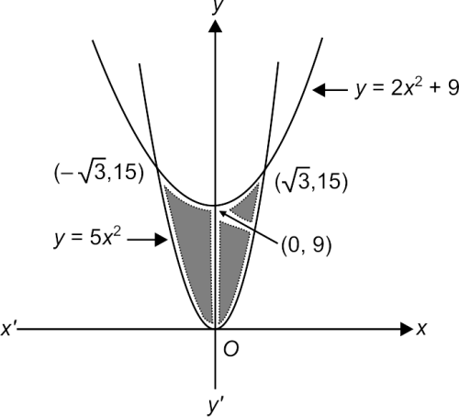

$2x^{2}-y+9=0$ (2)

Eliminating $y,$ we get

$5x^{2}-\left(2x^{2}+9\right)=0$

$⇒$ $3x^{2}=9⇒x=-\sqrt{3}, \sqrt{3}$

$∴$ required area

= $2\int_{0}^{\sqrt{3}}{\left(2x^{2}+9\right)-5x^{2})dx}$

= $2\int_{0}^{\sqrt{3}}{\left(9-3x^{2}\right)dx}$

= 2 ${\left[9x-x^{3}\right]}_{0}^{\sqrt{3}}$

= 2 $\left[9\sqrt{3}-3\sqrt{3}\right]$

= $12\sqrt{3}$ sq. units

S2. Ans. (d)

Sol.

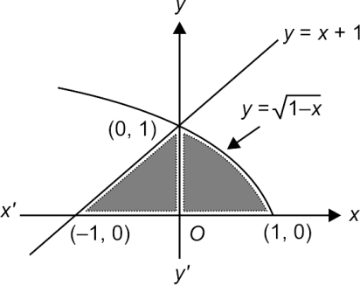

Required area = shaded region

=  (integrating along $y$-axis)

= 

= $\frac{7}{6}$ sq. units

S3. Ans. (a)

Sol.

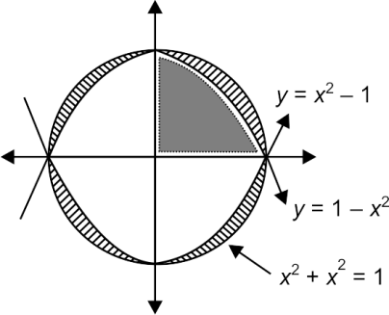

The dotted area is

$A=\int_{0}^{1}{\left(1=x^{2}\right)dx={\left(x-\frac{x^{3}}{3}\right)}_{0}^{1}=1-\frac{1}{3}=\frac{2}{3}.}$

Hence, area bounded by circle $x^{2}+y^{2}=1$ and

$\left|y\right|=1-x^{2}$

= lined area

= Area of circle – area bounded by $\left|y\right|=1-x^{2}$

= $π-4 . \left(\frac{2}{3}\right)=\frac{3π-8}{3}$ sq. units.

S4. Ans. (a)

Sol.

Curve tracing : $y=x\log_{e}{x}$

Clearly, $x>0,$

For $0<x<1, x\log_{e}{x<0}$, and for $x>1, x\log_{e}{x>0}$

Also $x\log_{e}{x=0⇒x=1.}$

Further, $\frac{dy}{dx}=0⇒1+\log_{e}{x=0⇒x=1/e,}$ which is a point of minima.

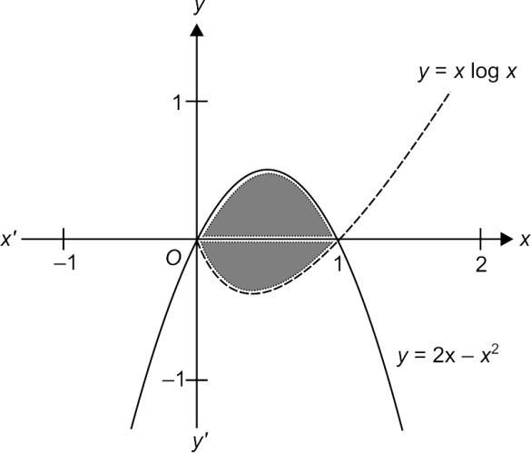

Required area

= 

= ${\left[x^{2}-\frac{2x^{3}}{3}\right]}_{0}^{1}-{\left[\frac{x^{2}}{2}\log{x-\frac{x^{2}}{4}}\right]}_{0}^{1}$

= $\left(1-\frac{2}{3}\right)-\left[0-\frac{1}{4}-\frac{1}{2}x^{2}\log{x}\right]=\frac{1}{3}+\frac{1}{4}=\frac{7}{12}.$

S5. Ans. (a)

Sol.

$y=\log_{e}\left(x+e\right), x=\log_{e}\left(\frac{1}{y}\right)⇒y=e^{-x}$.

for $y=\log_{e}{(x+e)}$ shift the graph of $y=\log_{e}{x, e}$ units left hand side.

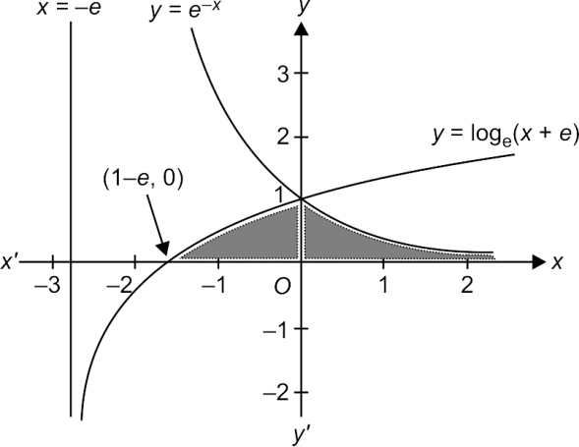

Required area =

= $|x\log_{e}\left(x+e\right)|_{1-e}^{0}-dx-|e^{-x}|_{0}^{∞}$

= $dx-e^{-∞}+e^{0}$

= $|x-e\log\left(x+e\right)|_{0}^{1-e}-0+1$

= $1-e+e\log{e+1=2}$ sq. units.

S6. Ans. (d)

Sol.

$y=\frac{1}{{\left(x-1\right)}^{2}+1}$

$y$ is maximum when ${\left(x-1\right)}^{2}=0$. Also, graph is symmetrical about line $x=1.$

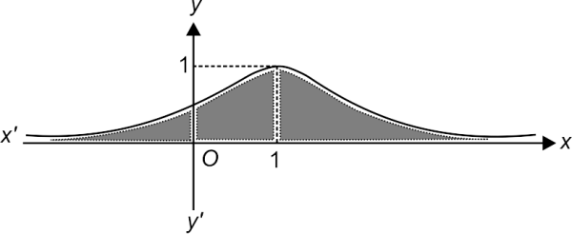

Area = $dx=2[\tan^{-1}\left(x-1\right)]_{1}^{∞}=π$ sq. units.

S7. Ans. (b)

Sol.

$xy^{2}=a^{2}(a-x)$

$⇒x=\frac{a^{3}}{y^{2}+a^{2}}$

The given curve is symmetrical about $x$-axis, and meets it at $\left(a, 0\right).$

The line $x=0,$ i.e., $y$-axis is an asymptote (tangent at infinity).

Area = $\int_{0}^{∞}{x dy=2}\int_{0}^{∞}{\frac{a^{3}}{y^{2}+a^{2}}dx}$

= $2a^{3}\frac{1}{a}{\left[\tan^{-1}{\frac{y}{a}}\right]}_{0}^{∞}=2a^{2}\frac{π}{2}=πa^{2}$ sq. units.

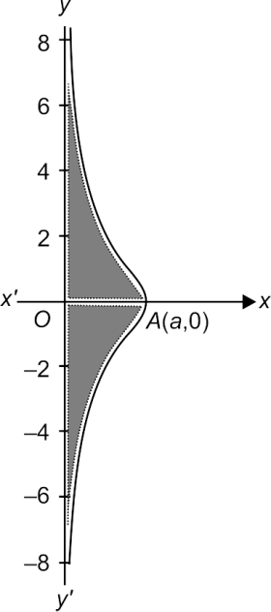

S8. Ans. (c)

Sol.

Given $y=x^{2}+x+1={\left(x+\frac{1}{2}\right)}^{2}+\frac{3}{4}⇒y-\frac{3}{4}={\left(x+\frac{1}{2}\right)}^{2}.$

This is a parabola with vertex at $\left(–\frac{1}{2},\frac{3}{4}\right)$ and the curve is concave upwards.

$y=x^{2}+x+1⇒\frac{dy}{dx}=2x+1⇒{\left(\frac{dy}{dx}\right)}_{(1, 3)}=3$

Equation of the tangent at $A(1, 3)$ is $y=3x$

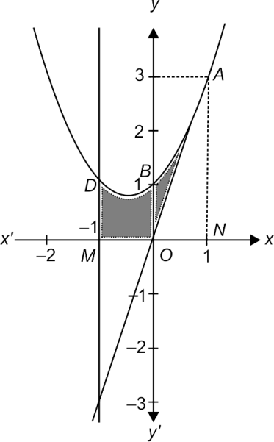

Required (shaded) area = area $ABDMN-$ area $ONA$

Now, area $ABDMN=$

= 2

Area of $ONA=\frac{1}{2}×1×3=\frac{3}{2} .$

$∴$ required area = $\frac{8}{3}-\frac{3}{2}=\frac{16-9}{6}=\frac{7}{6}$ sq. units.

S9. Ans. (a)

Sol.

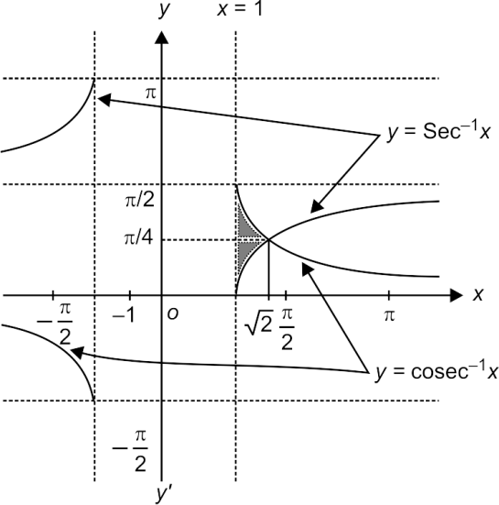

Integrating along $x$-axis, we get



$A=$

Integrating along $y$-axis, we get



$A=2$

= $2{\left[log\left|\sec{y+\tan{y}}\right|-y\right]}_{0}^{π/4}$

= $2\left[log\left|\sqrt{2}+1\right|-\frac{π}{4}\right]=\log\left(3+2\sqrt{2}\right)=\frac{π}{2}$ sq. units.

S10. Ans. (b)

Sol.

Solving $2\cos{x=3\tan{x,}}$ we get

$2-2\sin^{2}{x=3\sin{x⇒\sin{x=\frac{1}{2}⇒x=\frac{π}{6}.}}}$

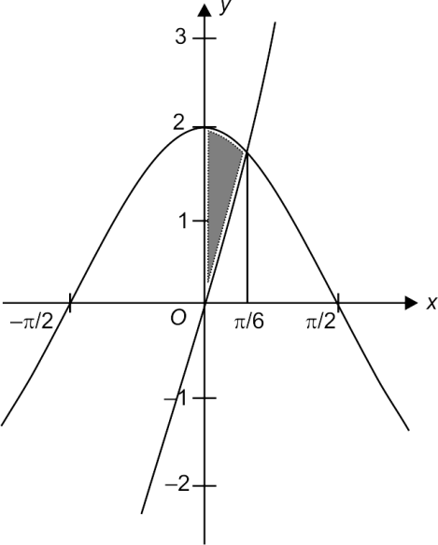

Required area =

= $2\sin{x-3\log{\sec{x}}}|_{0}^{π/6}=1-3\ln{2+\frac{3}{2}\ln{3}}$ sq. units.

**LEVEL-II**

Q1. The area between the curve $y=2x^{4}-x^{2},$ the $x$-axis and the ordinates of the two minima of the curve is

(a) 11/60 sq. units

(b) 7/120 sq. units

(c) 1/30 sq. units

(d) 7/90 sq. units

L3Difficulty3

Qtag Mathematics

Qcreator Pagemaker10

Q2. The area bounded by the curve $a^{2}y=x^{2}(x+a)$ and the $x$-axis is

(a) $a^{2}/3$ sq. units

(b) $a^{2}/4$ sq. units

(c) $3a^{2}/4$ sq. units

(d) $a^{2}/12$ sq. units

L3Difficulty3

Qtag Mathematics

Qcreator Pagemaker10

Q3. The area of the region in 1st quadrant bounded by the $y$-axis, $y=\frac{x}{4}, y=1+\sqrt{x}$ and $y=\frac{2}{\sqrt{x}}$ is

(a) 2/3 sq. units

(b) 8/3 sq. units

(c) 11/3 sq. units

(d) 13/6 sq. units

L3Difficulty3

Qtag Mathematics

Qcreator Pagemaker10

Q4. The area of the closed figure bounded by $y=\frac{x^{2}}{2}-2x+2$ and the tangents to it at (1, 1/2) and (4, 2) is

(a) 9/8 sq. units

(b) 3/8 sq. units

(c) 3/2 sq. units

(d) 9/4 sq. units

L3Difficulty3

Qtag Mathematics

Qcreator Pagemaker10

Q5. The area of the closed figure bounded by $x=-1, x=2$ and $y=\left\{\begin{matrix}-x^{2}+2, & x≤1 \\ 2x-1, & x>1\end{matrix}\right.$ and the abscissa axis is

(a) 16/3 sq. units

(b) 10/3 sq. units

(c) 13/3 sq. units

(d) 7/3 sq. units

L3Difficulty3

Qtag Mathematics

Qcreator Pagemaker10

Q6. The area of the region bounded by $x^{2}+y^{2}-2x-3=0$ and $y=\left|x\right|+1$ is

(a) $\frac{π}{2}-1$ sq. units

(b) $2π$ sq. units

(c) $4π$ sq. units

(d) $π/2$ sq. units

L3Difficulty3

Qtag Mathematics

Qcreator Pagemaker10

Q7. The value of the parameter $a$ such that the area bounded by $y=a^{2}x^{2}+ax+1$, coordinate axes and the line $x=1$ attains its least value, is equal to

(a) $-\frac{1}{4}$ sq. units

(b) $-\frac{1}{2}$ sq. units

(c) $-\frac{3}{4}$ sq. units

(d) $-1$ sq. units

L3Difficulty3

Qtag Mathematics

Qcreator Pagemaker10

Q8. The area enclosed by the curve $y=\sqrt{4-x^{2}}, y≥\sqrt{2}\sin\left(\frac{xπ}{2\sqrt{2}}\right)$ and the $x$-axis is divided by the $y$-axis in the ratio

(a) $\frac{π^{2}-8}{π^{2}+8}$

(b) $\frac{π^{2}-4}{π^{2}+4}$

(c) $\frac{π-4}{π-4}$

(d) $\frac{2π^{2}}{2π+π^{2}-8}$

L3Difficulty3

Qtag Mathematics

Qcreator Pagemaker10

Q9. The area of the region bound by $x=0, y=0, x=2, y=2, y≤e^{x}$ and $y≥\ln{x}$ is

(a) $6-4\ln{2 }$ sq. units

(b) $4\ln{2-2 }$ sq. units

(c) $2\ln{2-4}$ sq. units

(d) $6-2\ln{2 sq. units}$

L3Difficulty3

Qtag Mathematics

Qcreator Pagemaker10

Q10. The area of the loop of the curve, $ay^{2}=x^{2}\left(a-x\right)$ is

(a) $4a^{2}$ sq. units

(b) $\frac{8a^{2}}{15}$ sq. units

(c) $\frac{16a^{2}}{9}$ sq. units

(d) None of these

L3Difficulty3

Qtag Mathematics

Qcreator Pagemaker10

**Solutions**

S1. Ans. (b)

Sol.

The curve is $y=2x^{4}-x^{2}=x^{2}(2x^{2}-1)$

The curve is symmetrical about the axis of $y.$

Also, it is a polynomial of 4 degree having roots 0, 0, ± $\frac{1}{\sqrt{2}} .x=0$ is repeated root. Hence, graph touches at (0, 0).

The curve intersects the axes at $O\left(0, 0\right),A(-1/√2, 0)$ and $B(1/√2, 0).$

Thus, the graph of the curve is shown in Figure.

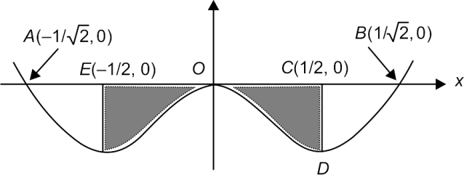

Here, $y≤0,$ as $x$ varies from $x=-1/2$ to $x=1/2$

$∴$ The required area

= 2 Area $OCDO$

= $2\left|\int_{0}^{1/2 }{ydx}\right|$

= $2\left|\int_{0}^{1/2}{\left(2x^{4}-x^{2}\right)dx}\right|$

= 7/120 sq. units

S2. Ans. (d)

Sol.

The curve is $y=\frac{x^{2}(x+a)}{a^{2}},$ which is a cubic polynomial.

Since $\frac{x^{2}(x+a)}{a^{2}}=0$ has repeated root $x=0,$ it touches $x$-axis at (0, 0) and intersects at $(-a,0)$.

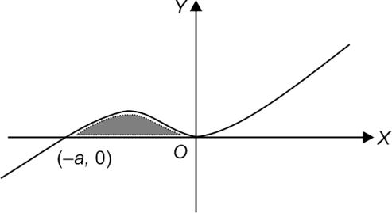

Required area = $\int_{-a}^{0}{ydx=\int_{-a}^{0}{\left[\frac{x^{2}(x+a)}{a^{2}}\right]dx=a^{2}/12}}$ sq. units.

S3. Ans. (c)

Sol.

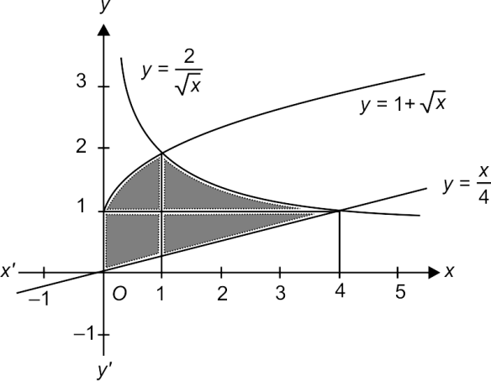

$A_{1}=$

= ${\left[x+\frac{2x^{3/2}}{3}-\frac{x^{2}}{8}\right]}_{0}^{1}=1+\frac{2}{3}-\frac{1}{8}=\frac{37}{24} .$

$A_{2}=$

= ${\left[4\sqrt{x}-\frac{x^{2}}{8}\right]}_{1}^{4}$

= $\left[8-2-4+\frac{1}{8}\right]=17/8$

$⇒A=A_{1}+A_{2}= =\frac{88}{24}=\frac{11}{3}$ sq. units

S4. Ans. (a)

Sol.

$y=\frac{x^{2}}{2}-2x+2=\frac{{\left(x-2\right)}^{2}}{2},$

$\frac{dy}{dx}=x-2, {\left(\frac{dy}{dx}\right)}_{x=1}^{ }=-1,{\left(\frac{dy}{dx}\right)}_{x=4}^{ }=2$

$⇒$ Tangent at (1, 1/2) is $y-1/2=-1(x-1)$ or $2x+2y-3=0$

Tangent at (4, 2) is $y-2=2(x-4)$ or $2x-y-6=0$

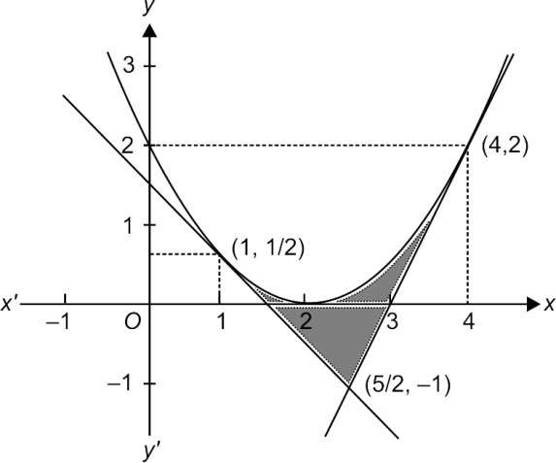

Hence, $A=$

+

= 

= ${\left(\frac{x^{3}}{6}-x^{2}+2x\right)}_{1}^{4}-\frac{1}{2}{\left(3x-x^{2}\right)}_{1}^{\frac{5}{2}}-{\left(x^{2}-6x\right)}_{5/2}^{4}$

= $\left(\frac{63}{6}-15+6\right)-\frac{1}{2}\left(3×\frac{3}{2}-\left(\frac{25}{4}-1\right)\right)$

$-\left(\left(16-\frac{25}{4}\right)-6\left(4-\frac{5}{2}\right)\right)$

= $\frac{3}{2}-\frac{1}{2}\left(\frac{9}{2}-\frac{21}{4}\right)-\left(\frac{39}{4}-6\left(\frac{3}{2}\right)\right)$

= $\frac{9}{8}$ sq. units

S5. Ans. (a)

Sol.

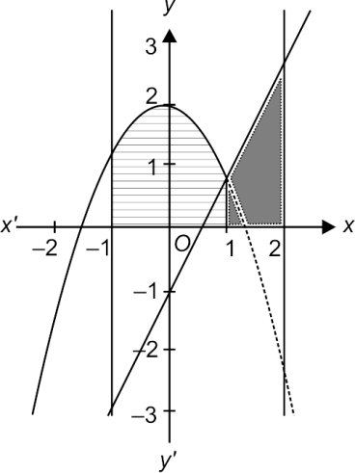



=

= sq. units

S6. Ans. (a)

Sol.

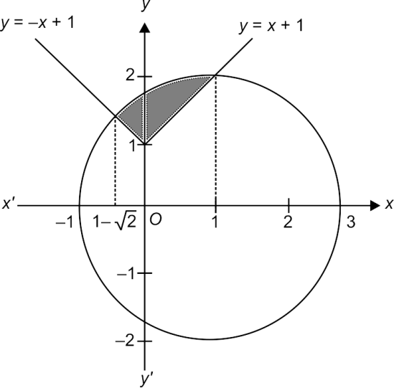



+ 

=

+

=

+

= sq. units.

S7. Ans. (c)

Sol.

$a^{2}x^{2}+ax+1$ is clearly positive for all real values of $x$. Area under consideration

$A=$

= $\frac{a^{2}}{3}+\frac{a}{2}+1$

= $\frac{1}{6}\left(2a^{2}+3a+6\right)$

= $\frac{1}{6}\left(2\left(a^{2}+\frac{3}{2}a+\frac{9}{16}\right)+6-\frac{18}{16}\right)$

= $\frac{1}{6}\left(2{\left(a+\frac{3}{4}\right)}^{2}+\frac{39}{8}\right),$ which is clearly minimum for $a=-\frac{3}{4 } .$

S8. Ans. (d)

Sol.

$y=\sqrt{4-x^{2}}, y=\sqrt{2}$ sin $\left(\frac{xπ}{2\sqrt{2}}\right)$

Intersect at $x=\sqrt{2}$

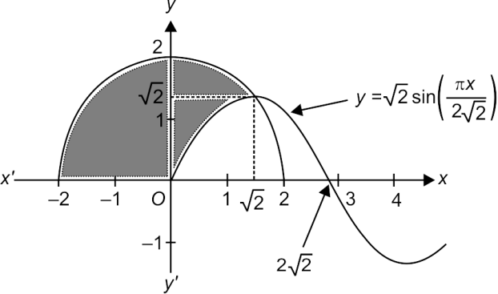

Area to the left of $y$-axis is $π$

Area to the right of $y$-axis

= 

= ${\left(\frac{x\sqrt{4-x^{2}}}{2}+\frac{4}{2}\sin^{-1}{\frac{x}{2}}\right)}_{0}^{\sqrt{2}}+{\left(\frac{4}{π}\cos{\frac{xπ}{2\sqrt{2}}}\right)}_{0}^{\sqrt{2}}$

= $\left(1+2×\frac{π}{4}\right)+\frac{4}{π}(0-1)$

= $1+\frac{π}{2}-\frac{4}{π}$

= $\frac{2π+π^{2}-8}{2π}$ sq. units.

$∴$ ratio = $\frac{2π^{2}}{2π+π^{2}-8}$.

S9. Ans. (a)

Sol.

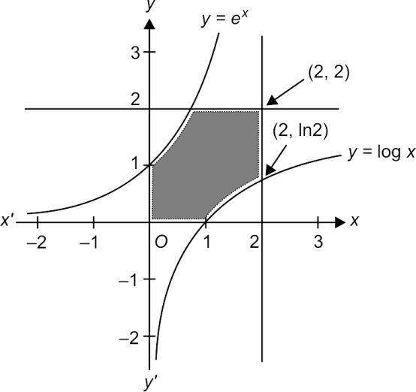

$A=$

= ${\left[x\log{x-x}\right]}_{1}^{2}$

= 2 $\log{2-1}$

$⇒$ Required area = $4-2(2\ln{2-1)=6-4\ln{2}}$ sq. units.

S10. Ans. (b)

Sol.

$ay^{2}=x^{2}\left(a-x\right)⇒y=±x\sqrt{\frac{a-x}{a}}$

Curve tracing : $y=x\sqrt{\frac{a-x}{a}}$

We must have $x≤a$

For $0<x≤a,y>0$ and for $x<0,y<0$

Also $y=0⇒x=0, a$

Curve is symmetrical about $x$-axis.

When $x→-∞, y→-∞$

Also, it can be verified that $y$ has only one point of maxima for $0<x<a.$

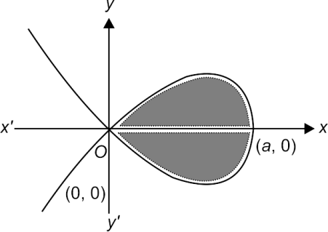

Area = $2$

$\sqrt{\frac{a-x}{a}}=t⇒1-\frac{x}{a}=t^{2}⇒x=a(1-t^{2})$

$⇒A=2$

= $4a^{2}$

= $4a^{2}{\left[\frac{t^{3}}{3}-\frac{t^{5}}{5}\right]}_{0}^{1}$

= $4a^{2}\left[\frac{1}{3}-\frac{1}{5}\right]=\frac{8a^{2}}{15}$ sq. units.

**LEVEL-III**

Q1. The area of the region enclosed between the curves $x=y^{2}-1$ and $x=|y|\sqrt{1-y^{2}}$ is

(a) 1 sq. units

(b) $4/3$ sq. units

(c) 2/3 sq. units

(d) 2 sq. units

L5Difficulty5

Qtag Mathematics

Qcreator Pagemaker10

Q2. Area bounded by the curves $y=\log_{e}{x}$ and $y=(\log_{e}{x)^{2}}$ is

(a) $e-2$ sq. units

(b) $3-e$ sq. units

(c) $e$ sq. units

(d) $e-1$ sq. units

L5Difficulty5

Qtag Mathematics

Qcreator Pagemaker10

Q3. The area of the region containing the points $(x, y)$ satisfying $4≤x^{2}+y^{2}≤2(\left|x\right|+\left|y\right|)$ is

(a) 8 sq. units

(b) 2 sq. units

(c) $4π$ sq. units

(d) $2π$ sq. units

L5Difficulty5

Qtag Mathematics

Qcreator Pagemaker10

Q4. Let $f\left(x\right)=x^{3}+3x+2$ and $g(x)$ is the inverse of it. Then the area bounded by $g\left(x\right),$ the $x$-axis and the ordinate at $x=-2$ and $x=6$ is

(a) $1/4$ sq. units

(b) 4/3 sq. units

(c) 5/4 sq. units

(d) 7/3 sq. units

L5Difficulty5

Qtag Mathematics

Qcreator Pagemaker10

Q5. The area bounded by the curve $f\left(x\right)=x+\sin{x}$ and its inverse function between the ordinates $x=0$ and $x=2π$ is

(a) 4 $π$ sq. units

(b) $8π$ sq. units

(c) 4 sq. units

(d) 8 sq. units

L5Difficulty5

Qtag Mathematics

Qcreator Pagemaker10

Q6. The area bounded by the $x$-axis, the curve $y=f(x)$ and the lines $x=1, x=b$ is equal to $\sqrt{b^{2}+1}-\sqrt{2}$ for all $b>1,$ then $f(x)$ is

(a) $\sqrt{x-1}$

(b) $\sqrt{x+1}$

(c) $\sqrt{x^{2}+1}$

(d) $\frac{x}{\sqrt{1+x^{2}}}$

L5Difficulty5

Qtag Mathematics

Qcreator Pagemaker10

Q7. Let $f(x)$ be a non-negative continuous function such that the area bounded by the curve $y=f\left(x\right), x$-axis and the ordinates $x=\frac{π}{4}$ and $x=β>\frac{π}{4}$ is $β\sin{β+\frac{π}{4}\cos{β+\sqrt{2}β.}}$ Then $f'\left(\frac{π}{2}\right)$ is

(a) $\left(\frac{π}{2}-\sqrt{2}-1\right)$

(b) $\left(\frac{π}{4}+\sqrt{2}-1\right)$

(c) $-\frac{π}{2}$

(d) $\left(1-\frac{π}{4}-\sqrt{2}\right)$

L5Difficulty5

Qtag Mathematics

Qcreator Pagemaker10

Q8. The area bounded by the curves $y=\sin^{-1}{|\sin{x|}}$ and $y=(\sin^{-1}{|\sin{x|)^{2},}}$ where $0≤x≤2π,$ is

(a) $\frac{1}{3}+\frac{π^{2}}{4}$ sq. units

(b) $\frac{1}{6}+\frac{π^{3}}{8}$ sq. units

(c) 2 sq. units

(d) None of these

L5Difficulty5

Qtag Mathematics

Qcreator Pagemaker10

Q9. Consider two curves $C_{1}: y^{2}=4\left[\sqrt{y}\right]x$ and $C_{2}:x^{2}=4\left[\sqrt{x}\right]y,$ where $\left[∙\right]$ denotes the greatest integer function. Then the area of region enclosed by these two curves within the square formed by the lines $x=1, y=1, x=4, y=4$ is

(a) 8/3 sq. units

(b) 10/3 sq. units

(c) 11/3 sq. units

(d) 11/4 sq. units

L5Difficulty5

Qtag Mathematics

Qcreator Pagemaker10

Q10. The area enclosed between the curve $y^{2}\left(2a-x\right)=x^{3}$ and the line $x=2$ above the $x$-axis is

(a) $πa^{2}$ sq. units

(b) $\frac{3π a^{2}}{2}$ sq. units

(c) 2 $πa^{2}$ sq. units

(d) $3πa^{2}$ sq. units

L5Difficulty5

Qtag Mathematics

Qcreator Pagemaker10

**Solutions**

S1. Ans. (d)

Sol.

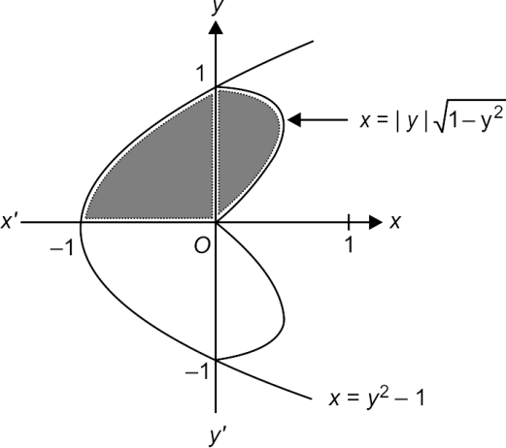

$A=2$

= 2 sq. units

S2. Ans. (b)

Sol.

Given curves are $y=\log_{e}{x}$ and $y=\log_{e}{x)^{2}}$

Solving $\log_{e}{x={\left(lo_{e}x\right)}^{2}⇒\log_{e}{x=0, 1⇒x=1}}$ and $x=e$

Also, for 1 $<x<e, 0<\log_{e}{x<1⇒\log_{e}{x>(\log_{e}{x)^{2}}}}$

For $x>e,\log_{e}{x<(\log_{e}{x)^{2}}}$

$y=(\log_{e}{x)^{2}>0}$ for all $x>0$

and when $x→0,(\log_{e}{x)^{2}→∞}$.

From these information, we can plot the graph of the functions.

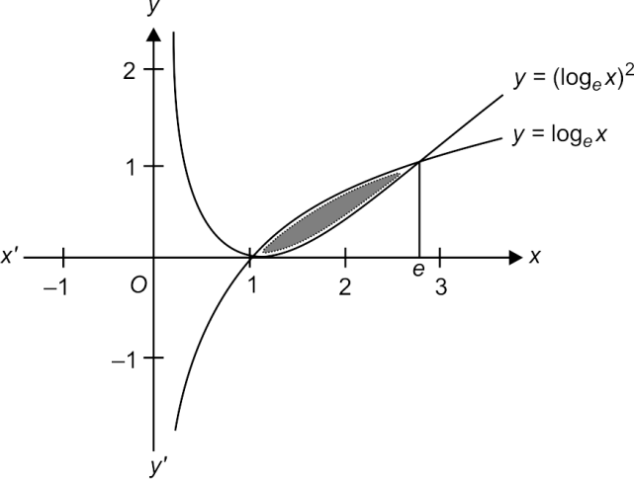

Then the required area = 

= 

= ${\left[x\log_{e}{x-x}\right]}_{1}^{e}-{\left[x(\log_{e}{x)^{2}}\right]}_{1}^{e}+$

= $1-e+2{\left[x\log_{e}{x-x}\right]}_{1}^{e}=3-e$ sq. units.

S3. Ans. (a)

Sol.

The points in the required region satisfy $4≤x^{2}+y^{2}≤2(\left|x\right|+\left|y\right|)$ (1)

Since the curve (1) is symmetrical about both the axes, the required area is 4 times the area of the region in the first quadrant. Therefore, it is sufficient to sketch the region and to find the area in the first quadrant.

In the first quadrant, the curve (1) consist of two curves

$x^{2}+y^{2}≥4,$ and $(C_{1})$

d $x^{2}+y^{2}-2x-2y≥0$ $(C_{2})$

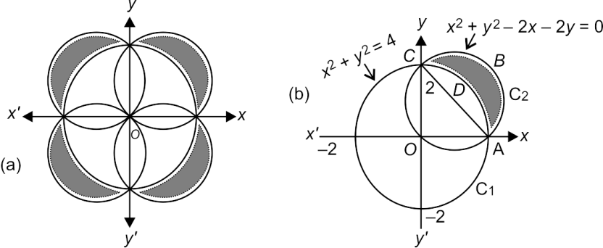

$∴$ Required area = 4 area $ABCDA$

= 4 (area of semi-circle $ABCA)-($ area of sector $ADCA)$

= 4(area of semi-circle $ABCA)-($ area of sector $OADCO-$ area of triangle $OAC)$

= $4\left\{π-(π-2\right\}=8$ sq. units.

S4. Ans. (c)

Sol.

The required area will be equal to the area enclosed by $y=f\left(x\right), y$-axis between the abscissa at $y=-2$ and $y=6$

Hence, $A=$

=  sq. units.

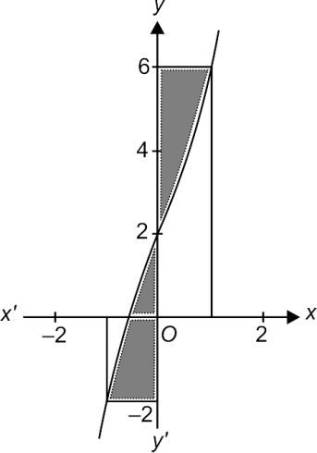

S5. Ans. (d)

Sol.

Curve tracing : $y=x+\sin{x}$

$\frac{dy}{dx}=1+\cos{x≥0∀x}$

Also $\frac{d^{2}y}{dx^{2}}=-\sin{x=0}$ when $x=nπ, n∈Z$

Hence, $x=nπ$ are points of inflection, where curve changes its concavity.

Also for $x∈\left(0, π\right),\sin{x>0⇒x+\sin{x>x.}}$

And for $x∈\left(π, 2π\right),\sin{x<0⇒x+\sin{x<x.}}$

From these information, we can plot the graph for $y=$ $f(x)$ and its inverse.

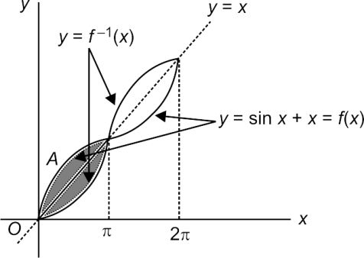

Required area = 4 $A,$ where

$A=\int_{0}^{π}{(x+\sin{x)dx-\int_{0}^{π}{xdx}}}$

= $\int_{0}^{π}{\sin{x dx=2}}$ square units.

S6. Ans. (d)

Sol.

Area = $\int_{1}^{b}{f\left(x\right)dx=\sqrt{b^{2}+1}-\sqrt{2}}$

= $\sqrt{b^{2}+1}-\sqrt{1+1}$

= ${\left|\sqrt{x^{2}+1}\right|}_{1}^{b}$

$∴f\left(x\right)=\frac{d}{dx}\left(\sqrt{x^{2}+1}\right)=\frac{1}{2}\frac{2x}{\sqrt{x^{2}+1}}=\frac{x}{\sqrt{x^{2}+1}}$.

S7. Ans. (c)

Sol.

$\int_{π/4}^{β}{f\left(x\right)dx=β\sin{β+\frac{π}{4}\cos{β+\sqrt{2} β}}}$

Differentiating both sides w.r.t. $β,$ we get

$∴$ $f\left(β\right)=β\cos{β+\sin{β-\frac{π}{4}\sin{β+\sqrt{2}}}}$

$⇒f^{'}\left(β\right)=-β\sin{β+\cos{β+\cos{β-\frac{π}{4}\cos{β}}}}$

$⇒f'\left(\frac{π}{2}\right)=-\frac{π}{2}$

S8. Ans. (d)

Sol.

$y=\sin^{-1}{|sin{x|=\left\{\begin{matrix}x, & 0≤x<\frac{π}{2} \\ π-x, & \frac{π}{2}≤x<π \\ x-π, & π≤x<\frac{3π}{2} \\ 2π-x, & \frac{3π}{2}≤x<2π\end{matrix}\right.}}$

$y={(sin}^{-1}{|sin{x|)^{2}=\left\{\begin{matrix}x^{2}, & 0≤x<\frac{π}{2} \\ {\left(π-x\right)}^{2}, & \frac{π}{2}≤x<π \\ {\left(x-π\right)}^{2}, & π≤x<\frac{3π}{2} \\ {\left(2π-x\right)}^{2}, & \frac{3π}{2}≤x<2π\end{matrix}\right.}}$ d

The required area $A$ is shown shaded in the figure.

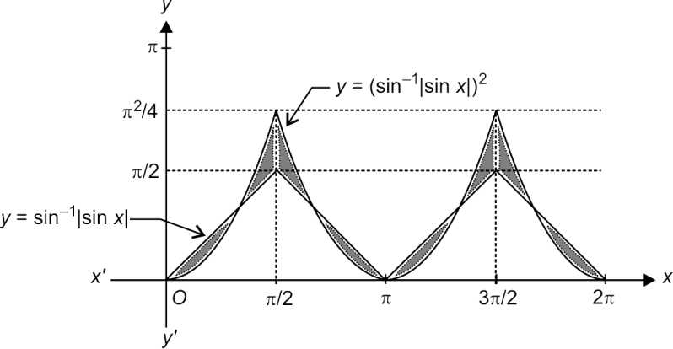

$⇒4$

= $\frac{4}{3}+π^{2}\left[\frac{π-3}{6}\right]$ sq. units.

S9. Ans. (c)

Sol.

$y^{2}=4\left[\sqrt{y}\right]x$

For $y∈\left[1, 4\right),\left[\sqrt{y}\right]=1⇒y^{2}=4x.$

Similarly, for $x∈\left[1, 4\right),\left\lfloor \sqrt{x}\right\rfloor =1$ and

$x^{2}=4\left\lfloor \sqrt{x}\right\rfloor y$ should transform into $x^{2}=4y.$

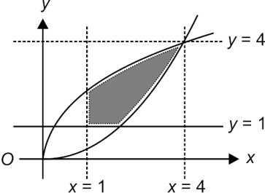

The required area is being shaded.

$A=$

= ${\left(\frac{4}{3}x^{3/2}-x\right)}_{1}^{2}+{\left(\frac{4}{3}x^{3/2}-\frac{x^{3}}{12}\right)}_{2}^{4}=\frac{11}{3}$ sq. units.

S10. Ans. (b)

Sol.

The required area $A=\int_{0}^{2a}{\sqrt{\frac{x^{3}}{2a-x}}dx}$

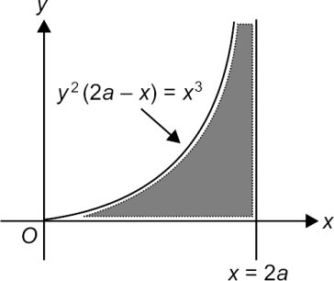

Put $x=2a\sin^{2}{θ}$

$⇒dx=2a2\sin{θ\cos{θ dθ}}$

$⇒A=8a^{2}\int_{0}^{π}{{\left(\frac{1-\cos{2θ}}{2}\right)}^{2}dθ}$

= $2a^{2}\int_{0}^{π}{(1-2\cos{2θ+\cos^{2}{2θ)dθ}}}$

= $2a^{2}\int_{0}^{π}{\left(1-2\cos{2θ+\frac{1+\cos{4θ}}{2}}\right)dθ}$

= $\frac{3πa^{2}}{2}$