MATHEMATICS

PAGEMAKER10

ELLIPSE

Q1. Distance between the directrix of the ellipse $\frac{x^{2}}{36}+\frac{y^{2}}{20}=1$ is
(a) 8
(b) 12
(c) 18
(d) 24
L1Difficulty1
Qtag Mathematics
Qcreator Pagemaker10

Q2. The distance between the foci of the ellipses 3x² + 4y² = 48 is
(a) 2
(b) 4
(c) 6
(d) 8
L1Difficulty1
Qtag Mathematics
Qcreator Pagemaker10

Q3. If the eccentricity of an ellipse be $\frac{1}{\sqrt{2}}$ , then its latus rectum is equal to
(a) minor axis
(b) semi-minor axis
(c) major-axis
(d) semi-major axis
L1Difficulty1
Qtag Mathematics
Qcreator Pagemaker10

Q4. The equation $\frac{x^{2}}{2-r}+\frac{y^{2}}{r-5}+1=0$ represent an ellipse, if
(a) r > 2
(b) 2 < r < 5
(c) r > 5
(d) none
L1Difficulty1
Qtag Mathematics
Qcreator Pagemaker10

Q5. The locus of the point which moves such that the ration of its distance from two lined point is the plane is always a constant k (< 1) is
(a) Hyperbola
(b) Ellipse
(c) Straight Line
(d) Circle
L1Difficulty1
Qtag Mathematics
Qcreator Pagemaker10

Q6. If the line y = 2x + c be a tangent to the ellipse $\frac{x^{2}}{8}+\frac{y^{2}}{4}=1$ then c is
(a) ± 4
(b) ± 6
(c) ± 1
(d) ± 8
L1Difficulty1
Qtag Mathematics
Qcreator Pagemaker10

Q7. Minimum area of the triangle by any tangent to the ellipse $\frac{x^{2}}{a^{2}}+\frac{y^{2}}{b^{2}}=1$ with the co-ordinate axes is
(a) $\frac{a^{2}+b^{2}}{2}$
(b) $\frac{(a+b)^{2}}{2}$
(c) ab
(d) $\frac{(a-b)^{2}}{2}$
L1Difficulty1
Qtag Mathematics
Qcreator Pagemaker10

Q8. If the line x Cos $α$ + y Sin $α$ = p be normal to the ellipse $\frac{x^{2}}{a^{2}}+\frac{y^{2}}{b^{2}}=1$, then
(a) p² (a²Cos²$α$ + b² Sin²$α$) = a² – b²
(b) p² (a² Cos²$α$ + b² Sin²$α$) = (a² – b²)²
(c) p² (a² + Sec²$α$ + b² Cosec²$α$) = a² – b²
(d) p² (a² Sec²$α$ + b² Cosec²$α$) = (a² – b²)²
L1Difficulty1
Qtag Mathematics
Qcreator Pagemaker10

Q9. An ellipse has OB as a semi minor axis F, F' are its foci and the angle FBF' at a right angle. The eccentricity of the ellipse is
(a) $\frac{1}{\sqrt{2}}$
(b) $\frac{1}{2}$
(c) $\frac{1}{3}$
(d) $\frac{1}{4}$
L1Difficulty1
Qtag Mathematics
Qcreator Pagemaker10

Q10. The ellipse E₁ : $\frac{x^{2}}{9}+ \frac{y^{2}}{4}=1$ is inscribed in a rectangle R whose lines are parallel to the co-ordinate axis. Another ellipse E₂ passing through the point (0, 4) circumscribes the rectangle R. The eccentricity of the ellipse E₂ is
(a) $\frac{\sqrt{2}}{2}$
(b) $\frac{\sqrt{3}}{2}$
(c) $\frac{1}{2}$
(d) $\frac{3}{4}$
L1Difficulty1
Qtag Mathematics
Qcreator Pagemaker10

Solutions

S1. Ans. (c)
Sol.
a = 6, b = 2$\sqrt{5}$
b² = a²(1 – e²)
Directrix are x = ± $\frac{a}{e}$
Distance between them $2∙\frac{6}{2/3}$
18.

S2. Ans. (b)
Sol.
a² = 16, b² = 12, e = $\sqrt{1-\frac{b^{2}}{a^{2}}}$
Distance is 2ae = 4.

S3. Ans. (d)
Sol.
e = $\frac{1}{\sqrt{2}}$
L.R. = $\frac{2b^{2}}{a}$ = $\frac{2a^{2}}{a}$ $\left(1-\frac{1}{2}\right)$ = a
semi major axis

S4. Ans. (b)
Sol.
$$\frac{x^{2}}{r-2}+\frac{y^{2}}{5-r}=1$$
r > 2 and r < 5

S5. Ans. (b)
Sol.
According to the definition.

S6. Ans. (b)
Sol.
c = $\sqrt{a^{2}m^{2}+b^{2}}$
c = $\sqrt{8×4+4}$
c = ± 6

S7. Ans. (c)
Sol.
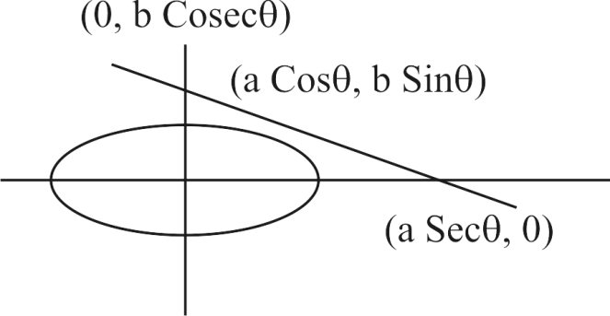
$\frac{x Cos θ}{a}+\frac{y Sin θ}{b}=1$
Area $\frac{1}{2}$ a sec $θ.b$ Cosec $θ$
$\frac{1}{2}$ × $\frac{2ab}{2 Sinθ.Cosθ}$ = $\frac{ab}{Sin2θ}$ > ab

S8. Ans. (a)
Sol.
Normal is ax sec $ϕ$ – by Cosec $ϕ$ = a² – b² straight line x Cos $α$ + y Sin$α$ = p will be normal to the ellipse $\frac{x^{2}}{a^{2}}+\frac{y^{2}}{b^{2}}=1$
$\frac{a Secϕ}{Cosα}=\frac{-b Cosecϕ}{Sinα}=\frac{a^{2}-b^{2}}{p}$
Cos $ϕ$ = $\frac{ap}{\left(a^{2}-b^{2}\right)Cosα}$
Sin $ϕ$ = $\frac{-bp}{\left(a^{2}-b^{2}\right)Sinα}$
p₂ (b² Cosec²$α$ + a²sec²$α$) = (a² – b²)²

S9. Ans. (a)
Sol.
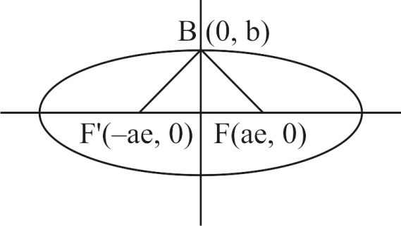
Slope of BF is $\frac{b-O}{O-ae}$
Slope of BF' is $\frac{b-O}{O+ae}$
$∠$F BF' = 90 $\frac{b}{-ae}×\frac{b}{ae}= –1$
$$e=\frac{1}{\sqrt{2}}$$

S10. Ans. (c)
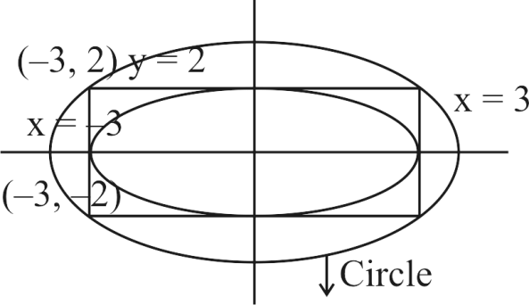
Sol.
(y + 2) (y – 2) + $λ$ (x + 3) (x – 3) = 0
it passes through (0, 4) $λ$ = $\frac{4}{3}$
$\frac{x^{2}}{12}+\frac{y^{2}}{16}=1$
e = $\frac{1}{2}$

LEVEL-II

Q1. If $2y=x$ and $3y+4x=0$ are the equations of a pair of conjugate diameters of an ellipse, then the eccentricity of the ellipse is
(a) $\sqrt{\frac{2}{3}}$
(b) $\sqrt{\frac{2}{5}}$
(c) $\sqrt{\frac{1}{3}}$
(d) $\sqrt{\frac{1}{2}}$
L3Difficulty3
Qtag Mathematics
Qcreator Pagemaker10

Q2. The distance of the point $‘θ’$ on the ellipse $\frac{x^{2}}{a^{2}}+\frac{y^{2}}{b^{2}}=1$ from a focus is
(a) $a(e+coscos θ)$
(b) $a(e-coscos θ)$
(c) $a(1+ecoscos θ)$
(d) $a(1+2ecoscos θ)$
L3Difficulty3
Qtag Mathematics
Qcreator Pagemaker10

Q3. The equation of the ellipse whose one focus is at (4, 0) and whose eccentricity is 4/5, is
(a) $\frac{x^{2}}{3^{2}}+\frac{y^{2}}{5^{2}}=1$
(b) $\frac{x^{2}}{5^{2}}+\frac{y^{2}}{3^{2}}=1$
(c) $\frac{x^{2}}{5^{2}}+\frac{y^{2}}{4^{2}}=1$
(d) $\frac{x^{2}}{4^{2}}+\frac{y^{2}}{5^{2}}=1$
L3Difficulty3
Qtag Mathematics
Qcreator Pagemaker10

Q4. The foci of $16x^{2}+25y^{2}=400$ are
(a) $(±3, 0)$
(b) $(0, ±3)$
(c) $(3, -3)$
(d) $(-3, 3)$
L3Difficulty3
Qtag Mathematics
Qcreator Pagemaker10

Q5. The line passing through the extremity $A$ of the major axis and extremity $B$ of the minor axis of the ellipse $x^{2}+9y^{2}=9$ meets its auxiliary circle at the point $M$. Then the area of the triangle with vertices at $A, M$ and the origin $O$ is
(a) $\frac{31}{10}$
(b) $\frac{29}{10}$
(c) $\frac{21}{10}$
(d) $\frac{27}{10}$
L3Difficulty3
Qtag Mathematics
Qcreator Pagemaker10

Q6. The normal at a point $P$ on the ellipse $x^{2}+4y^{2}=16$ meets the $x$-axis at $Q$. If $M$ is the mid point of the line segment $PQ$, then the locus of $M$ intersects the latus rectums of the given ellipse at the points
(a) $\left(±\frac{3\sqrt{5}}{2},±\frac{2}{7}\right)$
(b) $\left(±\frac{3\sqrt{5}}{2},±\frac{\sqrt{19}}{4}\right)$
(c) $\left(±2\sqrt{3},±\frac{1}{7}\right)$
(d) $\left(±2\sqrt{3},±\frac{4\sqrt{3}}{7}\right)$
L3Difficulty3
Qtag Mathematics
Qcreator Pagemaker10

Q7. The locus of a variable point whose distance from $(-2, 0)$ is $\frac{2}{3}$ times its distance from the line $x=-\frac{9}{2}$ , is
(a) Ellipse
(b) Parabola
(c) Hyperbola
(d) None of these
L3Difficulty3
Qtag Mathematics
Qcreator Pagemaker10

Q8. The equation of the tangent to the ellipse $x^{2}+16y^{2}=16$ making an angle of $60°$ with $x$-axis is
(a) $\sqrt{3}x-y+7=0$
(b) $\sqrt{3}x-y-7=0$
(c) $\sqrt{3}x-y±7=0$
(d) None of these
L3Difficulty3
Qtag Mathematics
Qcreator Pagemaker10

Q9. The position of the point (1, 3) with respect to the ellipse $4x^{2}+9y^{2}-16x-54y+61=0$
(a) Outside the ellipse
(b) On the ellipse
(c) On the major axis
(d) On the minor axis
L3Difficulty3
Qtag Mathematics
Qcreator Pagemaker10

Q10. The line $lx+my-n=0$ will be tangent to the ellipse $\frac{x^{2}}{a^{2}}+\frac{y^{2}}{b^{2}}=1,$ if
(a) $a^{2}l^{2}+b^{2}m^{2}=n^{2}$
(b) $al^{2}+bm^{2}=n^{2}$
(c) $a^{2}l+b^{2}m=n$
(d) None of these
L3Difficulty3
Qtag Mathematics
Qcreator Pagemaker10

Solutions

S1. Ans. (c)
Sol.
$2y=x;3y+4x=0$ [Conjugate diameters]
$∴y=\frac{1}{2}x; y=\frac{-4}{3}x$
$∴\frac{-b^{2}}{a^{2}}=m_{1}m_{2}⇒\frac{-b^{2}}{a^{2}}=\frac{1}{2}\left(\frac{-4}{3}\right)=\frac{-2}{3}$
$∴e=\sqrt{1-\frac{b^{2}}{a^{2}}}=\sqrt{1-\frac{2}{3}}=\sqrt{\frac{1}{3}} .$

S2. Ans. (c)
Sol.
Focal distance of any point $P(x, y)$ on the ellipse is equal to $SP=a+ex.$ Here $x=acoscos θ$
Here, $SP=a+aecoscos θ=a(1+ecoscos θ).$

S3. Ans. (b)
Sol.
Here, $ae=4$ and $e=\frac{4}{5}⇒a=5$
Now $b^{2}=a^{2}\left(1-e^{2}\right)⇒b^{2}=25\left(1-\frac{16}{25}\right)=9$
Hence, equation of the ellipse is $\frac{x^{2}}{25}+\frac{y^{2}}{9}=1$.

S4. Ans. (a)
Sol.
The equation of the ellipse is $16x^{2}+25y^{2}=400$ or $\frac{x^{2}}{25}+\frac{y^{2}}{16}=1.$
Here, $a^{2}=25, b^{2}=16⇒e=\frac{3}{5} .$

S5. Ans. (d)
Sol.
Equation of auxiliary circle is $x^{2}+y^{2}=9$ ….(i)
Equation of $AM$ is $\frac{x}{3}+\frac{y}{1}=1$ ….(ii)
On solving (i) and (ii), we get $M\left(-\frac{12}{5},\frac{9}{5}\right)$
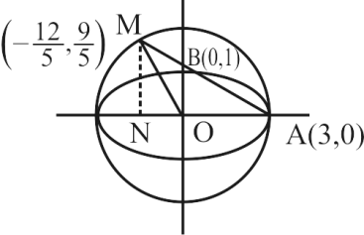
Now, area of $∆AOM=\frac{1}{2} .OA×MN=\frac{27}{10}$ $square unit.$

S6. Ans. (c)
Sol.
$\frac{x^{2}}{16}+\frac{y^{2}}{4}=1, a=4, b=2$
Equation of normal $4xsecsec θ-2y cosec θ=12$
$M\left(\frac{7coscos θ }{2},sinsin θ \right)=(h, k)$ (say)
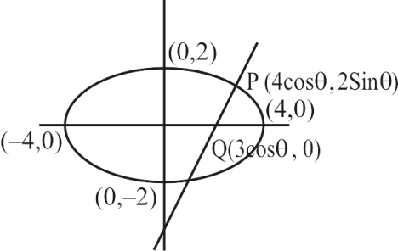
$h=\frac{7coscos θ }{2}$
$⇒cosθ=\frac{2h}{7}$
and $k=sinsin θ$
$\frac{4h^{2}}{49}+k^{2}=1$
Locus $\frac{4x^{2}}{49}+y^{2}=1$ ….(i)
For given ellipse $e^{2}=1-\frac{4}{16}=\frac{3}{4}⇒e=\frac{\sqrt{3}}{2}$
$x=±4×\frac{\sqrt{3}}{2}=±2\sqrt{3}$ ….(ii)
Solving (i) and (ii), we get
$\frac{4}{49}×12+y^{2}=1⇒y^{2}=1-\frac{48}{49}⇒y=±\frac{1}{7}$
$∴$Required points $\left(±2\sqrt{3},±\frac{1}{7}\right).$

S7. Ans. (a)
Sol.
Let point $P\left(x_{1}, y_{1}\right)$
So, $\sqrt{{\left(x_{1}+2\right)}^{2}+y_{1}^{2}}=\frac{2}{3}\left(x_{1}+\frac{9}{2}\right)$
$⇒{\left(x_{1}+2\right)}^{2}+y_{1}^{2}=\frac{4}{9}{\left(x_{1}+\frac{9}{2}\right)}^{2}$
$⇒9\left[x_{1}^{2}+y_{1}^{2}+4x_{1}+4\right]=4\left(x_{1}^{2}+\frac{81}{4}+9x_{1}\right)$
$⇒5x_{1}^{2}+9y_{1}^{2}=45⇒\frac{x_{1}^{2}}{9}+\frac{y_{1}^{2}}{5}=1,$
Locus of $(x_{1}, y_{1})$ is $\frac{x^{2}}{9}+\frac{y^{2}}{5}=1,$ which is equation of an ellipse.
Trick : The ratio $e=\frac{2}{3}<1.$ So, it is ellipse (fundamental concept).

S8. Ans. (c)
Sol.
$m=tantan 60°=\sqrt{3}.$ Therefore, equation of tangent is $y=\sqrt{3}x±\sqrt{1+3.16}⇒y=\sqrt{3}x±7.$

S9. Ans. (c)
Sol.
$E≡4+9{\left(3\right)}^{2}-16\left(1\right)-54\left(3\right)+61<0$
Therefore, the point is inside the ellipse.
$\frac{4{\left(x-2\right)}^{2}}{36}+\frac{9{\left(y-3\right)}^{2}}{36}=1$
Equation of major axis is $y-3=0$ and point (1, 3) lies on it.

S10. Ans. (a)
Sol.
$y=\frac{-1}{m}x+\frac{n}{m}$ is tangent to $\frac{x^{2}}{a^{2}}+\frac{y^{2}}{b^{2}}=1,$ if
$\frac{n}{m}=±\sqrt{b^{2}+a^{2}{\left(\frac{1}{m}\right)}^{2}}$ or $n^{2}=m^{2}b^{2}+l^{2}a^{2}.$

LEVEL-III

Q1. The locus of the point of intersection of mutually perpendicular tangent to the ellipse $\frac{x^{2}}{a^{2}}+\frac{y^{2}}{b^{2}}=1,$ is
(a) A straight line
(b) A parabola
(c) A circle
(d) None of these
L5Difficulty5
Qtag Mathematics
Qcreator Pagemaker10

Q2. The equation of the tangent at the point $(1/4, 1/4 )$ of the ellipse $\frac{x^{2}}{4}+\frac{y^{2}}{12}=1$ is
(a) $3x+y=48$
(b) $3x+y=3$
(c) $3x+y=16$
(d) None of these
L5Difficulty5
Qtag Mathematics
Qcreator Pagemaker10

Q3. The angle between the pair of tangents drawn to the ellipse $3x^{2}+2y^{2}=5$ from the point (1, 2) is
(a) $\left(\frac{12}{5}\right)$
(b) $(6\sqrt{5})$
(c) $\left(\frac{12}{\sqrt{5}}\right)$
(d) $(12\sqrt{5})$
L5Difficulty5
Qtag Mathematics
Qcreator Pagemaker10

Q4. The equations of the tangents of the ellipse $9x^{2}+16y^{2}=144$ which passes through the point (2, 3) is
(a) $y=3, x+y=5$
(b) $y=-3, x-y=5$
(c) $y=4, x+y=3$
(d) $y=-4, x-y=3$
L5Difficulty5
Qtag Mathematics
Qcreator Pagemaker10

Q5. If any tangent to the ellipse $\frac{x^{2}}{a^{2}}+\frac{y^{2}}{b^{2}}=1$ cuts off intercepts of length $h$ and $k$ on the axes, then $\frac{a^{2}}{h^{2}}+\frac{b^{2}}{k^{2}}=$
(a) 0
(b) 1
(c) $-1$
(d) None of these
L5Difficulty5
Qtag Mathematics
Qcreator Pagemaker10

Q6. The value of $λ,$ for which the line $2x-\frac{8}{3}λy=-3$ is a normal to the conic $x^{2}+\frac{y^{2}}{4}=1$ is
(a) $\frac{\sqrt{3}}{2}$
(b) $\frac{1}{2}$
(c) $-\frac{\sqrt{3}}{2}$
(d) $\frac{3}{8}$
L5Difficulty5
Qtag Mathematics
Qcreator Pagemaker10

Q7. The pole of the straight line $x+4y=4$ with respect to ellipse $x^{2}+4y^{2}=4$ is
(a) $(1, 4)$
(b) $(1, 1)$
(c) $(4, 1)$
(d) $(4, 4)$
L5Difficulty5
Qtag Mathematics
Qcreator Pagemaker10

Q8. The sum of focal distances of any point on the ellipse with major and minor axes as $2a$ and $2b$ respectively, is equal to
(a) $2a$
(b) $\frac{2a}{b}$
(c) $\frac{2b}{a}$
(d) $\frac{b^{2}}{a}$
L5Difficulty5
Qtag Mathematics
Qcreator Pagemaker10

Q9. The equation of ellipse whose distance between the foci is equal to 8 and distance between the directrix is 18, is
(a) $5x^{2}-9y^{2}=180$
(b) $9x^{2}+5y^{2}=180$
(c) $x^{2}+9y^{2}=180$
(d) $5x^{2}+9y^{2}=180$
L5Difficulty5
Qtag Mathematics
Qcreator Pagemaker10

Q10. In an ellipse the distance between its foci is 6 and its minor axis is 8. Then its eccentricity is
(a) $\frac{4}{5}$
(b) $\frac{1}{\sqrt{52}}$
(c) $\frac{3}{5}$
(d) $\frac{1}{2}$
L5Difficulty5
Qtag Mathematics
Qcreator Pagemaker10

Solutions

S1. Ans. (c)
Sol.
It is a fundamental concept.

S2. Ans. (d)
Sol.
The point does not lie on ellipse.

S3. Ans. (c)
Sol.
$SS_{1}=T^{2}$
$tantan θ=2\frac{\sqrt{h^{2}-ab}}{a+b},a=9, b=-4$ and $h=-12.$

S4. Ans. (a)
Sol.
The tangent will be $y-3=m\left(x-2\right)⇒y-mx=3-2m.$ But it is tangent to the given ellipse, therefore $m=0, -1.$ Hence tangents are $y=3$ and $x+y=5.$
Trick : Only answer (a) satisfy the point (2, 3).

S5. Ans. (b)
Sol.
The tangent at $(acoscos θ, bsinsin θ)$ to the ellipse is
$\frac{(acoscos θ)x }{a^{2}}+\frac{(bsinsin θ)y }{b^{2}}=1$ or $\frac{x}{(a/coscos θ) }+\frac{y}{(b/sinsin θ) }=1$
$∴$ Intercepts are, $h=\frac{a}{coscos θ }, k=\frac{b}{sinsin θ }⇒\frac{a^{2}}{h^{2}}+\frac{b^{2}}{k^{2}}=1.$

S6. Ans. (d)
Sol.
We know that the equation of the normal at point $(acoscos θ, bsinsin θ)$ on the curve $x^{2}+\frac{y^{2}}{4}=1$ is given by
$axsecsec θ-by cosec θ=a^{2}-b^{2}$ ….(i)
Comparing equation (i) with $2x-\frac{8}{3}λy=-3,$ we get
$asecsec θ=2, b cosec θ=\frac{8}{3}λ$ or $ab=\frac{16}{3}λ$ ….(ii)
$∴a=1, b=2;$
$∴2=\frac{16}{3}λ$ or $λ=3/8$

S7. Ans. (b)
Sol.
We know that equation of polar at point $(h, k)$ is
$\frac{hx}{a^{2}}+\frac{ky}{b^{2}}=1⇒\frac{hx}{4}+\frac{ky}{1}=1⇒hx+4ky=4$ ….(i)
Which is similar to given straight line $x+4y=4$ ….(ii)
Comparing (i) and (ii), we get $h=1, k=1.$
Hence the point is $\left(1, 1\right).$

S8. Ans. (a)
Sol.
Sum of focal distances of a point in an ellipse is always equal to length of major axis of that ellipse. It is a property of ellipse.

S9. Ans. (d)
Sol.
$2ae=8,\frac{2a}{e}=18⇒a=\sqrt{4×9}=6$
$e=\frac{2}{3}, b=6\sqrt{1-\frac{4}{9}}=\frac{6}{3}\sqrt{5}=2\sqrt{5}$
Hence, the required equation is $\frac{x^{2}}{36}+\frac{y^{2}}{20}=1$
$i.e.,$ $5x^{2}+9y^{2}=180.$

S10. Ans. (c)
Sol.
Distance between foci = 6$⇒ae=3.$
Minor axis = 8$⇒2b=8⇒b=4⇒b^{2}=16$
$⇒a^{2}\left(1-e^{2}\right)=16⇒a^{2}-a^{2}e^{2}=16⇒a^{2}-9=16⇒a=5$
Hence, $ae=3⇒e=\frac{3}{5} .$

