MATHEMATICS

PAGEMAKER10

A.O.D.

Q1. A function is matched below against an interval where it is supposed to be increasing. Which of the following parts is incorrectly matched?
Interval Function
(a) $\left[2, ∞\right]$ $2x^{3}-3x^{2}-12x+6$
(b) $(-∞, ∞)$ $x^{3}-3x^{2}+3x+3$
(c) $(-∞, -4]$ $x^{3}+6x^{2}+6$
(d) $\left(-∞,\frac{1}{3}\right)$ $3x^{2}-2x+1$
L1Difficulty1
Qtag Mathematics
Qcreator Pagemaker10

Q2. The function $f\left(x\right)=\tan^{-1}{(\sin{x+\cos{x)}}}$ is an increasing function in
(a) $\left(-\frac{π}{2},\frac{π}{4}\right)$
(b) $\left(0,\frac{π}{2}\right)$
(c) $\left(–\frac{π}{2},\frac{π}{2}\right)$
(d) $\left(\frac{π}{4},\frac{π}{2}\right)$
L1Difficulty1
Qtag Mathematics
Qcreator Pagemaker10

Q3. The function $x^{2}$ decreases in the interval
(a) $(0, e)$
(b) $(0, 1)$
(c) $\left(0,\frac{1}{e}\right)$
(d) None of these
L1Difficulty1
Qtag Mathematics
Qcreator Pagemaker10

Q4. The function $f\left(x\right)={\left(x-K\right)}^{2}$ assumes the minimum value of $x$ given by
(a) 5
(b) $\frac{5}{2}$
(c) 3
(d) 2
L1Difficulty1
Qtag Mathematics
Qcreator Pagemaker10

Q5. Which of the following statements is always true?
(a) If $f(x)$ is increasing, then $f^{-1}(x)$ is decreasing.
(b) If $f(x)$ is increasing, then $\frac{1}{f(x)}$ is also increasing.
(c) If $f$ and $g$ are positive function and $f$ is increasing and $g$ is decreasing, then $f/g$ is a decreasing function.
(d) If $f$ and $g$ are positive function and $f$ is decreasing and $g$ is increasing, then $f/g$ is a decreasing function.
L1Difficulty1
Qtag Mathematics
Qcreator Pagemaker10

Q6. Let $f:R→R$ be a differentiable function for all values of $x$ and has the property that $f(x)$ and $f^{'}(x)$ have opposite signs for all values of $x.$ Then,
(a) $f(x)$ is an increasing function
(b) $f(x)$ is a decreasing function
(c) $f^{2}(x)$ is a decreasing function
(d) $|f\left(x\right)|$ is an increasing function
L1Difficulty1
Qtag Mathematics
Qcreator Pagemaker10

Q7. Let $f\left(x\right)=x\sqrt{4ax-x^{2}}, \left(a>0\right).$ Then $f(x)$ is
(a) increasing in $\left(0, 3a\right),$ decreasing in $(3a, 4a)$
(b) increasing in $\left(a, 4a\right),$decreasing in $(5a, ∞)$
(c) increasing in $(0, 4a)$
(d) None of these
L1Difficulty1
Qtag Mathematics
Qcreator Pagemaker10

Q8. Let $f:R→R$ be a differentiable function $∀x∈R.$ If the tangent drawn to the curve at any point $x∈(a, b)$ always lies below the curve, then
(a) $f^{'}\left(x\right)>0, f"(x)<0 ∀ x∈(a,b)$
(b) $f^{'}\left(x\right)<0, f"(x)<0 ∀ x∈(a,b)$
(c) $f^{'}\left(x\right)>0, f"(x)>0 ∀ x∈(a,b)$
(d) None of these
L1Difficulty1
Qtag Mathematics
Qcreator Pagemaker10

Q9. If $f^{'}\left(x\right)=\left|x\right|-\{x\}$ where $\{x\}$ denotes the fractional part of $x$, then $f(x)$ is decreasing in
(a) $\left(-\frac{1}{2}, 0\right)$
(b) $\left(-\frac{1}{2}, 2\right)$
(c) $\left(-\frac{1}{2},2\right)$
(d) $\left(\frac{1}{2},∞\right)$
L1Difficulty1
Qtag Mathematics
Qcreator Pagemaker10

Q10. Function $f\left(x\right)=\left|x\right|-|x-1|$ is monotonically increasing when
(a) $x<0$
(b) $x>1$
(c) $x<1$
(d) $0<x<1$
L1Difficulty1
Qtag Mathematics
Qcreator Pagemaker10

Q11. Let $f$ be continuous and differentiable function such that $f(x)$ and $f^{'}(x)$ have opposite signs everywhere. Then
(a) $f$ is increasing
(b) $f$ is decreasing
(c) $|f|$ is non-monotonic
(d) $|f|$ is decreasing
L1Difficulty1
Qtag Mathematics
Qcreator Pagemaker10

Q12. If the function $f(x)$ increases in the interval $a, b),$ and $∅\left(x\right)={\left[f\left(x\right)\right]}^{2},$ then
(a) $∅(x)$ increases in $(a, b)$
(b) $∅(x)$ decreases in $(a, b)$
(c) We cannot say that $∅(x)$ increases or decreases in $(a, b)$
(d) None of these
L1Difficulty1
Qtag Mathematics
Qcreator Pagemaker10

Q13. If $∅(x)$ is a polynomial function and $∅^{'}\left(x\right)>∅\left(x\right), ∀ x≥1$ and $∅\left(1\right)=0,$ then
(a) $∅\left(x\right)≥0,∀ x≥1$
(b) $∅\left(x\right)<0, ∀ x≥1$
(c) $∅\left(x\right)=0, ∀ x≥1$
(d) None of these
L1Difficulty1
Qtag Mathematics
Qcreator Pagemaker10

Q14. Which of the following statements is true for the function
$f\left(x\right)=\left[\begin{matrix}\sqrt{x,} & x≥1 \\ x^{3}, & 0≤x≤1 \\ \frac{x^{3}}{3}-4x, & x<0\end{matrix}\right.$
(a) It is monotonic increasing $∀x∈R.$
(b) $f^{'}(x)$ fails to exist for three distinct real values of $x.$
(c) $f^{'}(x)$ changes its sign twice as $x$ varies from $-∞$to$∞$.
(d) The function attains its extreme values at $x_{1}$ and $x_{2},$ such that $x_{1}x_{2}>0.$
L1Difficulty1
Qtag Mathematics
Qcreator Pagemaker10

Q15. If $f"(x)>0, ∀ x∈R,f'(3)=0$ and $g\left(x\right)=f(\tan^{2}{x-2\tan{x+4), 0<x<\frac{π}{2},}}$ then $g(x)$ is increasing in
(a) $\left(0,\frac{π}{4}\right)$
(b) $\left(\frac{π}{6, },\frac{π}{3}\right)$
(c) $\left(0,\frac{π}{3}\right)$
(d) $\left(\frac{π}{4},\frac{π}{2}\right)$
L1Difficulty1
Qtag Mathematics
Qcreator Pagemaker10

Solutions

S1. Ans. (d)
Sol.
When $f\left(x\right)=3x^{2}-2x+1$
$∴f^{'}\left(x\right)=6x-2$
$f$ is increasing $⇒f^{'}(x)≥0$
$⇒6x-2≥0⇒x≥\frac{1}{3}$

S2. Ans. (a)
Sol.
Here $f\left(x\right)=\tan^{-1}{(\sin{x+\cos{x)}}}$
$∴f^{'}\left(x\right)=\frac{1}{1+(\sin{x+\cos{x)^{2}}}}(\cos{x-\sin{x)}}$
$=\frac{\cos{x - \sin{x}}}{2 + \sin{2x}}$
For $-\frac{π}{2}<x<\frac{π}{4},\cos{x>\sin{x}}$
Hence, $y=f(x)$ is increasing in $\left(-\frac{π}{2},\frac{π}{4}\right)$.

S3. Ans. (c)
Sol.
$∵f^{'}\left(x\right)=x^{x}[1+\log{x]=x^{x}log⁡(ex)}$
$f^{'}\left(x\right)<0$
$⇒\log\left(ex\right)<0$
$⇒0<ex<1$
$⇒0<x<1/e$

S4. Ans. (c)
Sol.
$f\left(x\right)={\left(x-1\right)}^{2}+{\left(x-2\right)}^{2}+{\left(x-3\right)}^{2}+{\left(x-4\right)}^{2}+{\left(x-5\right)}^{2}$
$f^{'}\left(x\right)=2\left[x-1+x-2+x-3+x-4+x-5\right]=2[5x-15]$
$f^{'}\left(x\right)=0$ gives $x=3$ and $f"(x)>0$ for all $x$
$∴f(x)$ is minimum for $x=3.$

S5. Ans. (d)
Sol.
If $f(x)$ increases then $f^{-1}(x)$ increases.
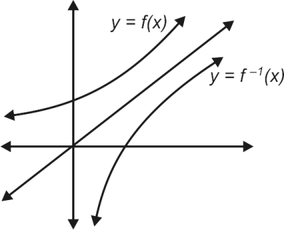
If $f\left(x\right)$ increases, then $f^{'}\left(x\right)>0$
$⇒\frac{d}{dx}\left(\frac{1}{f(x)}\right)=-\frac{f^{'}(x)}{f^{2}(x)}<0⇒\frac{1}{f(x)}$ decreases
$\frac{d}{dx}\left(\frac{f}{g}\right)=\frac{f^{'}g-fg'}{g^{2}}$
If $g$ and $g$ are $+$ ve functions and $f^{'}<0$ and $g^{'}>0,$ then
$\frac{d}{dx}\left(\frac{f}{g}\right)<0.$

S6. Ans. (c)
Sol.
$f\left(x\right)f^{'}\left(x\right)<0 ∀x∈R$
$⇒\frac{1}{2}\frac{d}{dx}\left(f^{2}\left(x\right)\right)<0$
$⇒\frac{d}{dx}\left(f^{2}\left(x\right)\right)<0$
$⇒f^{2}(x)$ is a decreasing function.

S7. Ans. (a)
Sol.
$f\left(x\right)=x\sqrt{4ax-x^{2}}$ (domain is $[0, 4a]$
$⇒f^{'}\left(x\right)=\sqrt{4ax-x^{2}}+\frac{x(4a-2x)}{2\sqrt{4ax-x^{2}}}$
$=\frac{2x(3a-x)}{\sqrt{4ax-x^{2}}}$
Now if $f^{'}\left(x\right)>0$
$⇒2x\left(3a-x\right)>0$
$⇒2x\left(x-3a\right)<0$
$⇒x∈(0, 3a)$
Thus, $f(x)$ increases in $(0, 3a)$ and decreases in $(3a, 4a)$.

S8. Ans. (c)
Sol.
$f^{'}\left(x\right)<0,f"(x)<0$
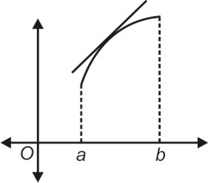
(a) : $f^{'}\left(x\right)>0,f"(x)<0$
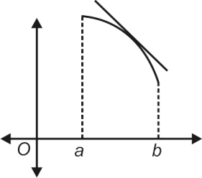
(b) : $f^{'}\left(x\right)<0,f"(x)<0$
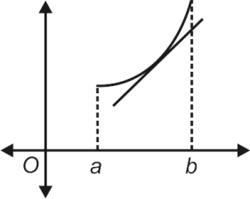
(c) : $f^{'}\left(x\right)>0,f"(x)>0$
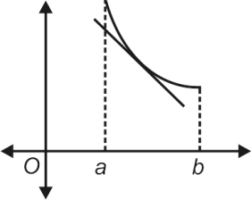
(d) : $f^{'}\left(x\right)<0,f"(x)>0$
Clearly for $f^{'}\left(x\right)>0,f"(x)>0$ [in Fig. (6.66(c)] tangent always lies below the graph.
Or $f^{'}\left(x\right)<0,f"(x)>0$ (in Fig. 6.66(d)) tangent always lies below the graph.

S9. Ans. (a)
Sol.
$f^{'}\left(x\right)=\left|x\right|-\left\{x\right\}=\left|x\right|-\left(x-\left[x\right]\right)=\left|x\right|-x+[x]$
For $x∈(-1/2, 0),$
$f^{'}\left(x\right)=-x-x-1=-2x-1$
Also, for $-\frac{1}{2}<x<0⇒0<-2x<1⇒-1<-2x-1<0$
$⇒f^{'}\left(x\right)<0⇒f\left(x\right)$ decreases in $\left(-\frac{1}{2}, 0\right).$
Similarly, we can check for other given options say for $x∈(-1/2, 2)$,
$f^{'}\left(x\right)=\left\{\begin{matrix}\left(-x\right)-x-1, & -\frac{1}{2}<x<0 \\ x-x+0, & 0≤x<1 \\ x-x+1, & 1≤x<2 \\ ⋮ & \end{matrix}\right.$
Here $f(x)$ decreases only in $(-1/2, 0),$otherwise $f(x)$ in other intervals is constant.

S10. Ans. (d)
Sol.
$f\left(x\right)=\left|x\right|-|x-1|$
$=\left\{\begin{matrix}-x-\left(1-x\right), & x<0 \\ x-\left(1-x\right), & 0≤x<1 \\ x-\left(x-1\right), & x≥0\end{matrix}\right.$
$=\left\{\begin{matrix}-1 & x<0 \\ 2x-1, & 0≤x<1 \\ 1, & x≤1\end{matrix}\right.$
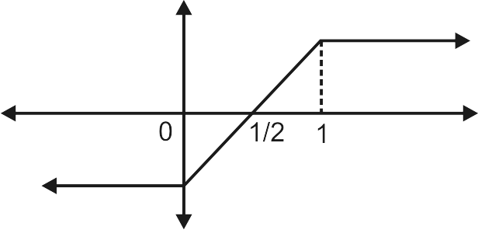
Graph of the function is that $f(x$) clearly increases in $\left(0, 1\right).$

S11. Ans. (d)
Sol.
$|f\left(x\right)|=\left\{\begin{matrix}f\left(x\right), & f(x)≥0 \\ -f\left(x\right), & f\left(x\right)<0\end{matrix}\right.$
$⇒\frac{d}{dx}\left|f\left(x\right)\right|=\left\{\begin{matrix}f^{'}\left(x\right), & f\left(x\right)>0 \\ -f^{'}\left(x\right), & f\left(x\right)<0\end{matrix}\right.$
Now as $f(x)$ and $f^{'}(x)$ keep opposite sign, then
$\frac{d}{dx}\left|f\left(x\right)\right|<0$.
Hence $|f|$ is decreasing.

S12. Ans. (c)
Sol.
$ϕ^{'}\left(x\right)=2f\left(x\right)f^{'}(x)$
We do not know the sign of $f(x)$ in $(a, b)$, so we cannot say about the sign of $ϕ^{'}\left(x\right).$

S13. Ans. (a)
Sol.
Given $ϕ^{'}\left(x\right)-ϕ\left(x\right)>0 ∀x≥1$
$⇒e^{-x}\left\{ϕ^{'}\left(x\right)-ϕ\left(x\right)\right\}>0 ∀x≥1$
$⇒\frac{d}{dx}e^{-x}ϕ\left(x\right)>0 ∀x≥1$
$∴e^{-x}ϕ(x)$ is an increasing function $∀x≥1$
Since $ϕ(x)$ is a polynomial.
$⇒e^{-x}ϕ\left(x\right)>e^{-1}ϕ\left(1\right)⇒e^{-x}ϕ\left(x\right)>0$ $[∵ϕ\left(1\right)=0]$
$⇒ϕ\left(x\right)>0.$

S14. Ans. (c)
Sol.
Function is increasing in $\left(-∞, -2\right)∪\left(0, ∞\right),$ function is decreasing in $\left(-2, 0\right).$
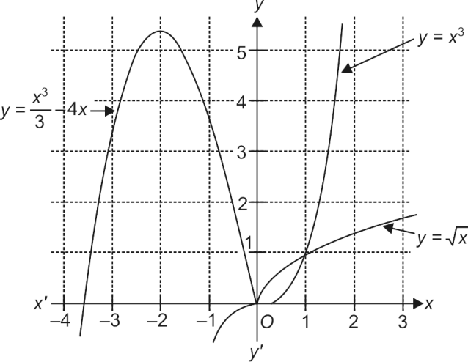
$x=-2$ is local maxima, $x=0→$ local minima
Derivable $∀x∈R-\left\{0, 1\right\}$
Continuous $∀ x∈R.$

S15. Ans. (d)
Sol.
$g^{'}\left(x\right)=(f^{'}((\tan{x-1)^{2}+3)) 2(\tan{x-1)}sec^{2}x}$
Since $f"(x)>0⇒f'(x)$ is increasing
So, $f^{'}((\tan{x-1)^{2}+3)>f^{'}\left(3\right)=0 ∀x∈\left(0, \frac{π}{4}\right)∪\left(\frac{π}{4},\frac{π}{2}\right)}$
Also, $(\tan{x-1)>0 x∈\left(\frac{π}{4},\frac{π}{2}\right).}$
So, $g(x)$ is increasing in $\left(\frac{π}{4},\frac{π}{2}\right)$.

LEVEL-II

Q1. Let $f(x)$ be a function such that $f^{'}\left(x\right)=\log_{1/3}{[\log_{3}{(\sin{x+a)].}}}$ If $f(x)$ is decreasing for all real values of $x$, then
(a) $a∈(1, 4)$
(b) $a∈(4, ∞)$
(c) $a∈(2, 3)$
(d) $a∈(2, ∞)$
L3Difficulty3
Qtag Mathematics
Qcreator Pagemaker10

Q2. If $f\left(x\right)=x+\sin{x;g\left(x\right)=e^{-x};u=\sqrt{c+1}-\sqrt{c}; v=\sqrt{c}-\sqrt{c-1};\left(c>1\right),}$ then
(a) $fog\left(u\right)<fog(v)$
(b) $gof\left(u\right)<gof(v)$
(c) $gof\left(u\right)>gof(v)$
(d) $fog\left(u\right)<fog(v)$
L3Difficulty3
Qtag Mathematics
Qcreator Pagemaker10

Q3. The length of the largest continuous interval in which the function $f\left(x\right)=4x-\tan{2x}$ is monotonic is
(a) $π/2$
(b) $π/4$
(c) $π/8$
(d) $π/16$
L3Difficulty3
Qtag Mathematics
Qcreator Pagemaker10

Q4. $f\left(x\right)=\left(x-1\right)\left|\left(x-2\right)\left(x-3\right)\right|,$ then $'f'$ decreases in
(a) $\left(2-\frac{1}{\sqrt{3}},2\right)$
(b) $\left(2, 2+\frac{1}{\sqrt{3}}\right)$
(c) $\left(2+\frac{1}{\sqrt{3}},4\right)$
(d) $(3, ∞)$
L3Difficulty3
Qtag Mathematics
Qcreator Pagemaker10

Q5. The number of solutions of the equations $x^{3}+2x^{2}+5x+2\cos{x=0}$ in $[0, 2π]$ is
(a) one
(b) two
(c) three
(d) zero
L3Difficulty3
Qtag Mathematics
Qcreator Pagemaker10

Q6. $f\left(x\right)=\left(x-2\right)|x-3|$ is monotonically increasing in
(a) $\left(-∞,\frac{5}{2}\right)∪(3, ∞)$
(b) $(5/2, ∞)$
(c) $(2, ∞)$
(d) $(-∞, 3)$
L3Difficulty3
Qtag Mathematics
Qcreator Pagemaker10

Q7. $f\left(x\right)={\left(x-8\right)}^{4}{\left(x-9\right)}^{5}, 0≤x≤10,$ monotonically decreases in
(a)
(b) $\left(8,\frac{76}{9}\right)$
(c) $[0, 8)$
(d)
L3Difficulty3
Qtag Mathematics
Qcreator Pagemaker10

Q8. If $f\left(x\right)=x^{3}+4x^{2}+λx+1$ is a monotonically decreasing function of $x$ in the largest possible interval $(-2, -2/3)$, then
(a) $λ=4$
(b) $λ=2$
(c) $λ=-1$
(d) $λ$ has no real value
L3Difficulty3
Qtag Mathematics
Qcreator Pagemaker10

Q9. $f\left(x\right)=|xlog_{e}x$| monotonically decreases in
(a) $(0, 1/e)$
(b) $(1/e,1)$
(c) $(1, ∞)$
(d) $(1/e,∞)$
L3Difficulty3
Qtag Mathematics
Qcreator Pagemaker10

Q10. Given that $f^{'}\left(x\right)>g^{'}(x)$ for all real $x$, and $f\left(0\right)=g\left(0\right),$ then $f\left(x\right)<g(x)$ for all $x$ belongs to
(a) $(0, ∞)$
(b) $(-∞, 0)$
(c) $(-∞, ∞)$
(d) None of these
L3Difficulty3
Qtag Mathematics
Qcreator Pagemaker10

Q11. A function $g(x)$ is defined as $g\left(x\right)=\frac{1}{4}f\left(2x^{2}-1\right)+\frac{1}{2}f(1-x^{2})$ and $f^{'}(x)$ is an increasing function, then $g(x)$ is increasing in the interval
(a) $(-1, 1)$
(b) $\left(-\sqrt{\frac{2}{3}}, 0\right)∪\left(\sqrt{\frac{2}{3}}, ∞\right)$
(c) $\left(-\sqrt{\frac{2}{3},}\sqrt{\frac{2}{3}}\right)$
(d) None of these
L3Difficulty3
Qtag Mathematics
Qcreator Pagemaker10

Q12. Let $f(x)$ be a function defined as below:
d$f\left(x\right)=\sin\left(x^{2}-3x\right), x≤0;$ and $6x+5x^{2}, x>0$ Then at $x=0, f(x)$
(a) has a local maximum
(b) has a local minimum
(c) is discontinuous
(d) None of these
L3Difficulty3
Qtag Mathematics
Qcreator Pagemaker10

Q13. The greatest value of $f\left(x\right)=\cos\left(xe^{\left[x\right]}+7x^{2}-3x\right), x∈[-1, ∞)$ is (where $[∙]$ represents the greatest integer function)
(a) $-1$
(b) $1$
(c) $0$
(d) None of these
L3Difficulty3
Qtag Mathematics
Qcreator Pagemaker10

Q14. The maximum value of the function $f\left(x\right)=sin\left(x+\frac{π}{6}\right)+cos\left(x+\frac{π}{6}\right)$ in the interval $\left(0,\frac{π}{2}\right)$ occurs at
(a) $\frac{π}{12}$
(b) $\frac{π}{6}$
(c) $\frac{π}{4}$
(d) $\frac{π}{3}$
L3Difficulty3
Qtag Mathematics
Qcreator Pagemaker10

Q15. Let $f\left(x\right)=\left\{\begin{matrix}x+2, & -1≤x<0 \\ 1, & x=0 \\ \frac{x}{2}, & 0<x≤1\end{matrix}\right.$
Then on $\left[-1, 1\right],$this function has
(a) a minimum
(b) a maximum
(c) either a maximum or a minimum
(d) neither a maximum nor a minimum
L3Difficulty3
Qtag Mathematics
Qcreator Pagemaker10

Solutions

S1. Ans. (b)
Sol.
We must have $\log_{1/3}{(\log_{3}{(\sin{x+a))<0 ∀x∈R}}}$
$⇒\log_{3}{(\sin{x+a)>1 ∀x∈R}}$
$⇒\sin{x+a>3 ∀x∈R}$
$⇒a>3-\sin{x ∀x∈R}$
$⇒a>4$

S2. Ans. (c)
Sol.
$u=\sqrt{c+1}-\sqrt{c}$
$u=\frac{1}{\sqrt{c+1}+\sqrt{c}}$ and $v=\frac{1}{\sqrt{c-1}+\sqrt{c}}$
Clearly $u<v$
Also, $f$ is increasing whereas $g$ is decreasing.
Thus $u<v$
$⇒f\left(u\right)<f(v)$
$⇒gof\left(u\right)>gof(v)$

S3. Ans. (b)
Sol.
$f^{'}\left(x\right)=4-2\sec^{2}{2x=2(1-\tan^{2}{2x)}}$
For the continuous domain $\left(-\frac{π}{4},\frac{π}{4}\right),f^{'}(x)≥0$ in $\left[-\frac{π}{8},\frac{π}{8}\right]$
and $f^{'}(x)≤0$ in $\left(-\frac{π}{4},\frac{π}{8}\right)∪\left[\frac{π}{8},\frac{π}{4}\right]$
So the required largest continuous interval is $\left[-\frac{π}{8},\frac{π}{8}\right],$ length = $\frac{π}{4} .$

S4. Ans. (a)
Sol.
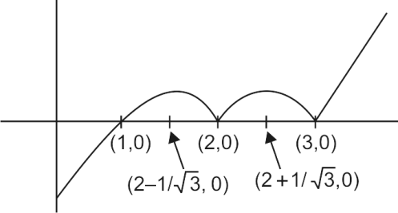
$f\left(x\right)=\left(x-1\right)|\left(x-2\right)\left(x-3\right)|$
let $g\left(x\right)=\left(x-1\right)\left(x-2\right)\left(x-3\right)$
$=x^{3}-6x^{2}+11x-6$
$⇒g^{'}\left(x\right)=3x^{2}-12x+11$
$g^{'}\left(x\right)=0⇒x=\frac{12±\sqrt{144-132}}{6}=\frac{12±\sqrt{12}}{6}=2±\frac{1}{\sqrt{3}}$
Hence, $f(x)$ decreases in $\left(2-\frac{1}{\sqrt{3}}, 2\right)∪\left(2+\frac{1}{\sqrt{3}},3\right).$

S5. Ans. (d)
Sol.
Let $f\left(x\right)=x^{3}+2x^{2}+5x+2\cos{x}$
$⇒f^{'}\left(x\right)=3x^{2}+4x+5-2\sin{x}$
Now the least value of $3x^{2}+4x+5$ is
$-\frac{D}{4a}=-\frac{{\left(4\right)}^{2}-4\left(3\right)(5)}{4(3)}=\frac{11}{3}$
and the greatest value of $2\sin{x=2}$
$⇒3x^{2}+4x+5>2\sin{x ∀x∈R}$
$⇒f^{'}\left(x\right)=3x^{2}+4x+5-2\sin{x>0 ∀x∈R}$
$⇒f(x)$ is strictly an increasing function
also $f\left(0\right)=2$ and $f\left(2π\right)>0.$
Thus, for the given interval, $f\left(x\right)$ never becomes zero.
Hence, the number of roots is zero.

S6. Ans. (a)
Sol.
d$f\left(x\right)=\left(x-2\right)|x-3|$
For, $f\left(x\right)=\left(x-2\right)\left(x-3\right)=x^{2}-5x+6$
$f^{'}\left(x\right)=2x-5=0⇒x=5/2$
Now, the graph of $f\left(x\right)=\left(x-2\right)|x-3|$ is
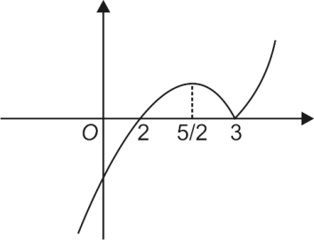
Clearly from the graph, $f(x)$ increases in $(-∞, 5/2)∪(3,∞).$

S7. Ans. (b)
Sol.
$f\left(x\right)={\left(x-8\right)}^{4}{\left(x-9\right)}^{5},0≤x≤10$
$⇒f^{'}\left(x\right)=4{\left(x-8\right)}^{3}{\left(x-9\right)}^{5}+5{\left(x-9\right)}^{4}{\left(x-8\right)}^{4}$
${=\left(x-8\right)}^{3}{\left(x-9\right)}^{4}[4\left(x-9\right)+5\left(x-8\right)]$
$=9{\left(x-8\right)}^{3}{\left(x-9\right)}^{4}\left(x-\frac{76}{9}\right).$
Sign scheme of $f^{'}(x)$
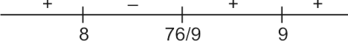
$f^{'}\left(x\right)<0,$ if $x∈\left(8,\frac{76}{9}\right)⇒f(x)$ decreases if $x∈\left(8,\frac{76}{9}\right).$

S8. Ans. (a)
Sol.
Here $f^{'}\left(x\right)≤0$
$⇒3x^{2}+8x+λ≤0∀x∈\left(-2, -\frac{2}{3}\right)$
Then situations for $f^{'}(x)$ is as follow:
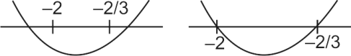
Given that $f(x)$ decreases in the largest possible interval
$\left(-2, -\frac{2}{3}\right),$ then $f^{'}\left(x\right)=0$ must have roots $-2$and $-2/3.$
$⇒$ Product of roots is $\left(-2\right)\left(-\frac{2}{3}\right)=\frac{λ}{3}⇒λ=4.$

S9. Ans. (b)
Sol.
$f\left(x\right)=|x\log_{c}{x|}$
For $g\left(x\right)=x\log_{e}{x,}$
$g^{'}\left(x\right)=x\frac{1}{x}+\log_{e}{x=1+\log_{e}{x}}$
$⇒g(x)$ increases for $\left(\frac{1}{e},∞\right)$ and decreases for $\left(0,\frac{1}{e}\right).$
Graph of $y=g\left(x\right)=x\log_{e}{x}$
(a) | 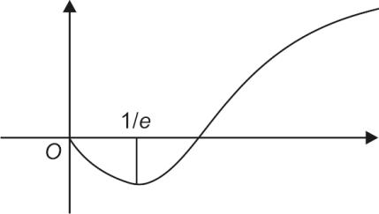
Graph of $y=f\left(x\right)=|x\log_{e}{x|}$
(b) | 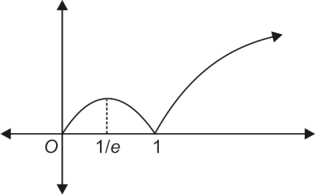
From the graph, $f\left(x\right)=|x\log_{e}{x|}$ decreases in $\left(\frac{1}{e},1\right).$

S10. Ans. (b)
Sol.
Let $h\left(x\right)=f\left(x\right)-g\left(x\right)$
$h^{'}\left(x\right)=f^{'}\left(x\right)-g^{'}\left(x\right)>0 ∀x∈R$
$⇒h(x)$ is an increasing function and
$h\left(0\right)=f\left(0\right)-g\left(0\right)=0$
Therefore, $h\left(x\right)>0 ∀ x∈(0,∞)$ and $h\left(x\right)<0 ∀ x∈\left(-∞, 0\right).$

S11. Ans. (b)
Sol.
$g^{'}\left(x\right)=xf^{'}\left(2x^{2}-1\right)-xf^{'}\left(1-x^{2}\right)=x(f^{'}\left(2x^{2}-1\right)-f^{'}\left(1-x^{2}\right))$
$g^{'}\left(x\right)>0$
if $x>0$,$2x^{2}-1>1-x^{2}$ (as $f'$ is an increasing function)
$⇒3x^{2}>2⇒x∈\left(-∞,-\sqrt{\frac{2}{3}}\right)∪\left(\sqrt{\frac{2}{3}},∞\right)$
$⇒x∈\left(\sqrt{\frac{2}{3}},∞\right)$
If $x<0, 2x^{2}-1<1-x^{2}$
$⇒3x^{2}<2⇒x∈\left(-\sqrt{\frac{2}{3}},\sqrt{\frac{2}{3}}\right)⇒x∈\left(-\sqrt{\frac{2}{3}},0\right).$

S12. Ans. (b)
Sol.
$f\left(0\right)=\sin{0=0}$
$f(0^{+})→0^{+}$
$f\left(0^{-}\right)=$ $\sin\left(x^{2}-3x\right)=$ $sin⁡(h^{2}+3h)→0^{+}$
Thus, $f\left(0^{+}\right)>f(0)$ and $f\left(0^{-}\right)>f(0)$
Hence, $x=0$ is a point of minima.

S13. Ans. (b)
Sol.
Since $\cos{θ≤1}$ for all $θ.$ Therefore, $f(x)≤1$ for all $x.$

S14. Ans. (a)
Sol.
D$f\left(x\right)=sin\left(x+\frac{π}{6}\right)+cos\left(x+\frac{π}{6}\right)$
$=\sqrt{2} sin\left(x+\frac{π}{6}+\frac{π}{4}\right)$
$=\sqrt{2} sin\left(x+\frac{5π}{12}\right)$
Its maximum value = $\sqrt{2}$ when $x+\frac{5x}{12}=\frac{π}{2}$
$i.e.,$ when $x=\frac{π}{2}-\frac{5x}{12}=\frac{6π-5π}{12}=\frac{π}{12} .$

S15. Ans. (d)
Sol.
$f\left(0\right)>f(0^{+})$ and $f\left(0\right)<f\left(0^{-}\right),$ hence $x=0$ is neither a maximum nor a minimum.

LEVEL-III

Q1. The maximum value of $f\left(x\right)=\frac{x}{1+4x+x^{2}}$ is
(a) $-\frac{1}{4}$
(b) $-\frac{1}{3}$
(c) $\frac{1}{6}$
(d) $\frac{1}{5}$
L5Difficulty5
Qtag Mathematics
Qcreator Pagemaker10

Q2. The maximum slope of the curve $y=-x^{3}+3x^{2}+9x-27$ is
(a) 0
(b) 12
(c) 16
(d) 32
L5Difficulty5
Qtag Mathematics
Qcreator Pagemaker10

Q3. Let $f\left(x\right)=\cos{πx+10x+3x^{2}+x^{3},-2≤x≤3.}$ The absolute minimum value of $f(x)$ is
(a) 0
(b) $-15$
(c) $3-2π$
(d) None of these
L5Difficulty5
Qtag Mathematics
Qcreator Pagemaker10

Q4. The minimum value of $e^{\left(2x^{2}-2x+1\right)\sin^{2}{x}}$ is
(a) $e$
(b) $1/e$
(c) $1$
(d) $0$
L5Difficulty5
Qtag Mathematics
Qcreator Pagemaker10

Q5. The maximum value of $x^{4}e^{-x^{2}}$ is
(a) $e^{2}$
(b) $e^{-2}$
(c) $12e^{-2}$
(d) $4e^{-2}$
L5Difficulty5
Qtag Mathematics
Qcreator Pagemaker10

Q6. If $a^{2}x^{4}+b^{2}y^{4}=c^{6},$ then the maximum value of $xy$ is
(a) $\frac{c^{2}}{\sqrt{ab}}$
(b) $\frac{c^{3}}{ab}$
(c) $\frac{c^{3}}{\sqrt{2ab}}$
(d) $\frac{c^{3}}{2ab}$
L5Difficulty5
Qtag Mathematics
Qcreator Pagemaker10

Q7. The global maximum value of $f\left(x\right)=\log_{10}\left(4x^{3}-12x^{2}+11x-3\right), x∈\left[2, 3\right]$ is
(a) $-\frac{3}{2}log_{10}3$
(b) $1+log_{10}3$
(c) $log_{10}3$
(d) $\frac{3}{2}log_{10}3$
L5Difficulty5
Qtag Mathematics
Qcreator Pagemaker10

Q8. The least natural number $a$ for which $x+ax^{-2}>2, ∀∈(0, ∞)$ is
(a) 1
(b) 2
(c) 5
(d) None of these
L5Difficulty5
Qtag Mathematics
Qcreator Pagemaker10

Q9. A function $f$ is defined by $f\left(x\right)={\left|x\right|}^{m}{\left|x-1\right|}^{n}, ∀x∈R.$ The local maximum value of the function is $(m, n∈N)$
(a) 1
(b) $m^{n}n^{m}$
(c) $\frac{m^{m}n^{n}}{(m+n)^{m+n}}$
(d) $\frac{(mn)^{mn}}{(m+n)^{m+n}}$
L5Difficulty5
Qtag Mathematics
Qcreator Pagemaker10

Q10. $f\left(x\right)=\left\{\begin{matrix}4x-x^{3}+\ln\left(a^{2}-3a+3\right), & 0≤x<3 \\ x-18, & x≥3\end{matrix}\right.$
Complete set of values of $a$ such that $f(x)$ as a local minima at $x=3$ is
(a) $[-1, 2]$
(b) $\left(-∞, 1\right)∪(2, ∞)$
(c) $[1, 2]$
(d) $\left(-∞, -1\right)∪(2, ∞)$
L5Difficulty5
Qtag Mathematics
Qcreator Pagemaker10

Q11. Let the function $f(x)$ be defined as follows
$f\left(x\right)=\left\{\begin{matrix}x^{3}+x^{2}-10x, & -1≤x<0 \\ \cos{x,} & 0≤x<π/2 \\ 1+\sin{x,} & π/2≤x≤π\end{matrix}\right.$
Then $f(x)$ has
(a) a local minimum at $x=π/2$
(b) a global maximum at $x=π/2$
(c) an absolute minimum at $x=-1$
(d) an absolute maximum at $x=π$
L5Difficulty5
Qtag Mathematics
Qcreator Pagemaker10

Q12. A differentiable function $f(x)$ has a relative minimum at $x=0,$ then the function $y=f\left(x\right)+ax+b$ has a relative minimum at $x=0$ for
(a) all $a$ and all $b$
(b) all $b$ if $a=0$
(c) all $b>0$
(d) all $a>0$
L5Difficulty5
Qtag Mathematics
Qcreator Pagemaker10

Q13. If $f\left(x\right)=4x^{3}-x^{2}-2x+1$ and
$g\left(x\right)=\left[\begin{matrix}\min{ \left\{f\left(t\right):0≤t≤x\right\};} & 0≤x≤1 \\ 3-x; & 1<x≤2\end{matrix}\right.$
then $g\left(\frac{1}{4}\right)+g\left(\frac{3}{4}\right)+g\left(\frac{5}{4}\right)$has the value equal to
(a) $7/4$
(b) 9/4
(c) 13/4
(d) 5/2
L5Difficulty5
Qtag Mathematics
Qcreator Pagemaker10

Q14. The set of value(s) of $a$ for which the function
$f\left(x\right)=\frac{ax^{3}}{3}+\left(a+2\right)x^{2}+\left(a-1\right)x+2$ possesses a negative point of inflection is
(a) $\left(-∞, -2\right)∪(0, ∞)$
(b) $\{-4/5\}$
(c) $(-2, 0)$
(d) empty set
L5Difficulty5
Qtag Mathematics
Qcreator Pagemaker10

Q15. Suppose that $f$ is a polynomial of degree 3 and that $f"(x)≠0$ at any of the stationary point. Then
(a) $f$ has exactly one stationary point
(b) $f$ must have no stationary point
(c) $f$ must have exactly two stationary points
(d) $f$ has either zero or two stationary point
L5Difficulty5
Qtag Mathematics
Qcreator Pagemaker10

Solutions

S1. Ans. (c)
Sol.
$f^{'}\left(x\right)=\frac{\left(1+4x+x^{2}\right)1-x(4+2x)}{{\left(1+4x+x^{2}\right)}^{2}}=\frac{1-x^{2}}{{\left(1+4x+x^{2}\right)}^{2}}$
For maximum or minimum $f^{'}\left(x\right)=0⇒x=±1$
For $x=1,f^{'}(x)$ changes sign from positive to negative as $x$ passes through 1.
Therefore, $f(x)$ is maximum for $x=1,$ and maximum value
= $\frac{1}{1+4+1}=\frac{1}{6}$ .

S2. Ans. (b)
Sol.
$y=-x^{3}+3x^{2}+9x-27$
$∴\frac{dy}{dx}=-3x^{2}+6x+9$
Let the slope of tangent to the curve at any point be $m$ (say)
$⇒m=-3x^{2}+6x+9 ⇒\frac{dm}{dx}=-6x+6$
$\frac{d^{2}m}{dx^{2}}=-6<0$ for all $x$
Therefore, $m$ is maximum when $\frac{dm}{dx}=0,$ i.e., when $x=1$
Therefore, maximum slope = $-3+6+9=12.$

S3. Ans. (b)
Sol.
$f^{'}\left(x\right)=-π\sin{πx+10+6x+3x^{2}}$
$=3{\left(x+1\right)}^{2}+7-π\sin{πx>0}$ for all $x$.
$∴ f(x)$ is increasing in $-2≤x≤3.$
So, the absolute minimum = $f\left(-2\right)=1-20+12-8.$

S4. Ans. (c)
Sol.
Given $y=e^{\left(2x^{2}-2x+1\right)\sin^{2}{x}}=e^{2\left[{\left(x-\frac{1}{2}\right)}^{2}+\frac{1}{4}\right]\sin^{2}{x}}$
Clearly, the minimum value occurs when $\sin^{2}{x=0}$ as
$\left[{\left(x-\frac{1}{2}\right)}^{2}+\frac{1}{4}\right]≥1/4 .$

S5. Ans. (d)
Sol.
$f\left(x\right)=x^{4}e^{-x^{2}}⇒f^{'}\left(x\right)=4x^{3}e^{-x^{2}}+x^{4}e^{-x^{2}}\left(-2x\right)$
$=2x^{3}e^{-x^{2}}(z-x^{2})$
Sign scheme of $f^{'}(x)$
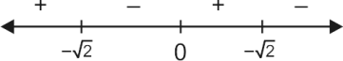
Hence, $f(x)$ is maximum at $x=\sqrt{2}⇒$ Maximum value = $4e^{-2}$

S6. Ans. (c)
Sol.
Since A.M. $≥$ G.M.
$\frac{a^{2}x^{4}+b^{2}y^{4}}{2}≥\sqrt{a^{2}x^{4}b^{2}y^{4}}$
$⇒abx^{2}y^{2}≤\frac{c^{6}}{2}$
$⇒xy≤\frac{c^{3}}{\sqrt{2ab}}$
Hence, maximum value of $xy$ is $\frac{c^{3}}{\sqrt{2ab}}$ .

S7. Ans. (b)
Sol.
Let $g\left(x\right)=4x^{3}-12x^{2}+11x-3$
$⇒g^{'}\left(x\right)=12x^{2}-24x+11$
$=12{\left(x-1\right)}^{2}-1$
$⇒g^{'}\left(x\right)>0$ for $x∈[2, 3]$
$⇒g(x)$ is increasing in $[2, 3]$
$f(x)_{max}=f\left(3\right)=\log_{10}{(4.27-12.9+11.3-3)}$
$=\log_{10}{(30}$
$=1+\log_{10}{3.}$

S8. Ans. (b)
Sol.
Let $f\left(x\right)=x+ax^{-2}-2$
$⇒f^{'}\left(x\right)=1-2ax^{-3}=0⇒x={\left(2a\right)}^{1/3}$
Also $f"(x)=6ax^{-4}⇒f"\left({\left(2a\right)}^{-1/3}\right)>0$
d$⇒x={\left(2a\right)}^{1/3}$ is the point of minima.
For $x+ax^{-2}-2>0 ∀x$ are must have $f\left({\left(2a\right)}^{\frac{1}{3}}\right)>0$
$⇒{\left(2a\right)}^{1/3}+a{\left(2a\right)}^{-2/3}-2>0$
$⇒2a+a-2{\left(2a\right)}^{2/3}>0$
$⇒3a>2{\left(2a\right)}^{2/3}$
$⇒27a^{3}>32a^{2}$
$⇒a>32/27$
Hence, the least value of $a$ is 2.

S9. Ans. (c)
Sol.
We have $f\left(x\right)=\left\{\begin{matrix}{\left(-1\right)}^{m+n}x^{m}{\left(x-1\right)}^{n}, & if x<0 \\ {\left(-1\right)}^{n}{ x}^{m}{\left(x-1\right)}^{n}, & if 0≤x<1 \\ x^{m}{\left(x-1\right)}^{n}, & if x≥1\end{matrix}\right.$
Let $g\left(x\right)=x^{m}{\left(x-1\right)}^{n},$ then
$g^{'}\left(x\right)=mx^{m-1}{\left(x-1\right)}^{n}+nx^{m}{\left(x-1\right)}^{n-1}$
$=x^{m-1}{\left(x-1\right)}^{n-1} \{mx-m+nx\}$
Now $f^{'}\left(x\right)=0⇒g^{'}\left(x\right)=0⇒x=0, 1$ or $\frac{m}{m+n}$
$f\left(\frac{m}{m+n}\right)={\left(-1\right)}^{n}\frac{m^{m}n^{n}{\left(-1\right)}^{n}}{{\left(m+n\right)}^{m+n}}$
$=\frac{m^{m}n^{n}}{m+n^{m+n}}>0$
$∴$ the maximum value = $\frac{m^{m}n^{n}}{{\left(m+n\right)}^{m+n}}$

S10. Ans. (b)
Sol.
Clearly, $f(x)$ in decreasing just before $x=3$ and increasing after $x=3.$ For $x=3$ to be the point of local minima, $f(3)≤f(3^{-})$.
$⇒-15≤12-27+ln⁡(a^{2}-3a+3)$ d
$⇒a^{2}-3a+3≥1$
$⇒a∈\left(-∞,1\right)∪\left(2,∞\right).$

S11. Ans. (c)
Sol.
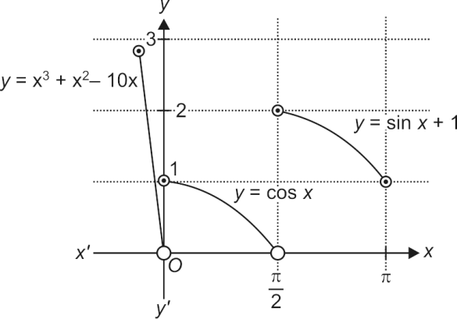

S12. Ans. (b)
Sol.
Since $f(x)$ has a relative minimum at $x=0,$ therefore $f^{'}\left(0\right)=0$ and $f"(0)>0.$
If the function $y=f\left(x\right)+ax+b$ has a relative minimum at $x=0,$ then
$\frac{dy}{dx}=0$ at $x=0⇒f^{'}\left(x\right)+a=0$ for $x=0$
$⇒f^{'}\left(0\right)+a=0⇒0+a=0$ $\left[∵f^{'}\left(0\right)=0\right]⇒a=0$
Now, $\frac{d^{2}y}{dx^{2}}=f\text{(x)⇒}{\left(\frac{{\text{d}}^{\text{2}}\text{y}}{\text{d}{\text{x}}^{\text{2}}}\right)}_{\text{x=0}}=f"(0)>0$
$[∵f"(0)>0]$
Hence, $y$ has a relative minimum at $x=0$ if $a=0$ and $b$ can attain any real value.

S13. Ans. (d)
Sol.
$f^{'}\left(x\right)=12x^{2}-2x-2=2\left[6x^{2}-x-1\right]=2\left(3x+1\right)(2x-1)$
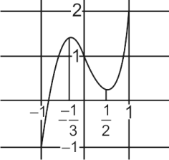
Hence $g\left(x\right)=\left[\begin{matrix}f\left(x\right), & if & 0≤x<\frac{1}{2} \\ f\left(\frac{1}{2}\right), & if & \frac{1}{2}≤x≤1 \\ 3-x & if & 1<x≤2\end{matrix}\right.$
$⇒g\left(\frac{1}{4}\right)+g\left(\frac{3}{4}\right)+g\left(\frac{5}{4}\right)=f\left(\frac{1}{4}\right)+f\left(\frac{1}{2}\right)+g\left(\frac{5}{4}\right)$
$=\frac{5}{2}$

S14. Ans. (a)
Sol.
$f^{'}\left(x\right)=ax^{2}+2\left(a+2\right)x+\left(a-1\right),$
$f"(x)=2ax+2(a+2)=0$
$⇒x=-\frac{a+2}{a}$ which is the point of inflection
Given that, we must have $–\frac{a+2}{a}<0$
$⇒\left(-∞,-2\right)∪\left(0,∞\right).$

S15. Ans. (d)
Sol.
The derivative of a degree 3 polynomial is quadratic. This must have either 0, 1 or 2 roots. If this has precisely one root, then this must be repeated. Hence, we have $f^{'}\left(x\right)=m{\left(x-α\right)}^{2},$ where $α$ is the repeated root and $m∈R.$ So, our original function $f$ has a critical point at $x=α.$
Also, $f"(x)=2m(x-α),$ in which case $f"(α)=0$. But we are told that the 2nd derivative is non-zero at critical point. Hence, there must be either 0 or 2 critical points.

