MATH

PAGEMAKER10

Function

Q1. Solve (2x+1)(x–3)(x+7) < 0
(a) (–$∞$, –6)
(b) (1, 4)
(c) (10, 12)
(d) ($-∞, -7) ∪$ $\left(-\frac{1}{2}, 3\right)$
L1Difficulty1
Qtag Mathematics
Qcreator Pagemaker10

Q2. Solve $\frac{2}{x}$ < 3
(a) ($-∞, 0) ∪$ $\left(\frac{2}{3}, ∞\right)$
(b) ($-2, 1)$
(c) (0, 1)
(d) none
L1Difficulty1
Qtag Mathematics
Qcreator Pagemaker10

Q3. Find the domain of $f\left(x\right)= \sqrt{1-\sqrt{1-\sqrt{1-x^{2}}}}$
(a) [$-1, 1]$
(b) (1, $∞$)
(c) ($-∞, 0)$
(d) none
L1Difficulty1
Qtag Mathematics
Qcreator Pagemaker10

Q4. Find the range of $f\left(x\right)=x^{2}-x-3$
(a) [1, 3)
(b) (3, 10)
(c) [$-\frac{13}{4}$, $∞)$
(d) none of these
L1Difficulty1
Qtag Mathematics
Qcreator Pagemaker10

Q5. Solve $\left| \left|x-1\right|-5 \right|$ $≥$ 2
(a) ($-∞, -6] ∪$ [$-2, 4] ∪[8, ∞]$
(b) ($-∞, 1)$
(c) ($-2, 5)$
(d) none
L1Difficulty1
Qtag Mathematics
Qcreator Pagemaker10

Q6. Find the number of solution of the equation sin x = $x^{2}+x+1$
(a) 0
(b) 1
(c) 2
(d) 3
L1Difficulty1
Qtag Mathematics
Qcreator Pagemaker10

Q7. Find the range of $f\left(x\right)=\left|\sin{x}\right|+|\cos{x|;x}∈R$
(a) [1, $\sqrt{2}]$
(b) [2, 4]
(c) [5, 6]
(d) none
L1Difficulty1
Qtag Mathematics
Qcreator Pagemaker10

Q8. Which of the following even function
(a) x² sin x
(b) $f\left(x\right)=log\left(\frac{1-x}{1+x}\right)$
(c) $f\left(x\right)=\sin{x-\cos{x}}$
(d) $f\left(x\right)=\frac{e^{x}+e^{-x}}{2}$
L1Difficulty1
Qtag Mathematics
Qcreator Pagemaker10

Q9. Period of cos(cos x) + cos(sin x)
(a) $\frac{π}{2}$
(b) 0
(c) $\frac{π}{4}$
(d) none
L1Difficulty1
Qtag Mathematics
Qcreator Pagemaker10

Q10. $f\left(x\right)=\sin{\frac{πx}{2}}$ is one-one or onto
(a) bijective
(b) only one-one
(c) only onto
(d) neither one-one nor onto
L1Difficulty1
Qtag Mathematics
Qcreator Pagemaker10

Solutions

S1. Ans. (d)
Sol.
– + – +
–7 $-\frac{1}{2}$ 3
(–$∞$, –7) $∪$ ($-\frac{1}{2}$, 3)

S2. Ans. (a)
Sol.
$\frac{2}{x}$ < 3
$\frac{2}{x}$ – 3 < 0
$\frac{2-3x}{x}$ < 0
$\frac{x-\frac{2}{3}}{x}$ > 0 | + – +  0 $\frac{2}{3}$
(–$∞$, 0) $∪$ ($\frac{2}{3}$, $∞$)

S3. Ans. (a)
Sol.
f(x) = $\sqrt{1-\sqrt{1-\sqrt{1-x^{2}}}}$
1–$\sqrt{1-\sqrt{1-x^{2}}}$ $≥$ 0
$\sqrt{1-\sqrt{1-x^{2}}}$ $≤$ 1
1 – $\sqrt{1-x^{2}}$ $≥$ 0
1 – x² $≥$ 0
x² $– 1$ $≤0$
(x – 1)(x + 1) $≤$ 0
[–1, 1]

S4. Ans. (c)
Sol.
f(x) = x² – x – 3
f(x) = (x – $\frac{1}{2}$)² $\frac{-13}{4}$ $≥$ $\frac{-13}{4}$
[$\frac{-13}{4}$, $∞$]

S5. Ans. (a)
Sol.
||x – 1| – 5| $≥$ 2
|x – 1| – 5 $≤$ –2 or |x – 1| – 5 $≥$ 2
|x – 1| $≤$ 3 or |x – 1| $≥$ 7
–3 $≤$ x – 1 $≤$ 3 or x – 1 $≤$ 7 or x – 1
–2 $≤$ x $≤$ 4 or x $≤$ –6 or x – 1

S6. Ans. (a)
Sol.
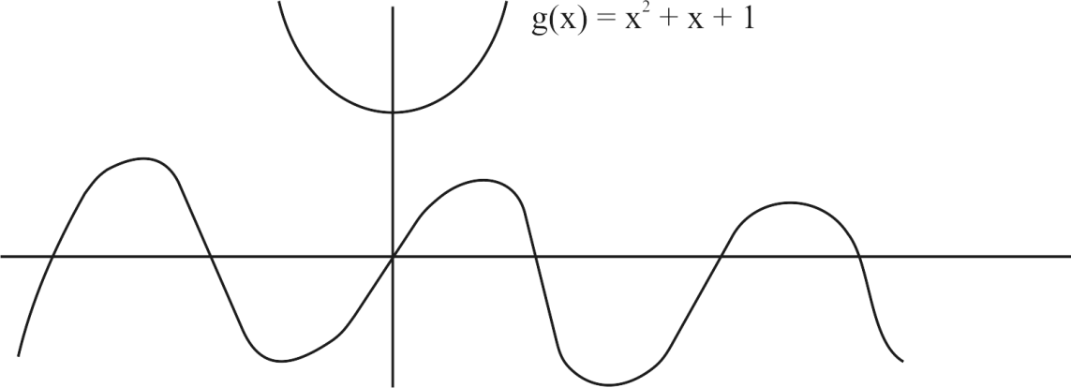
g(x) = x² + x + 1 = (x + $\frac{1}{2}$)² + $\frac{3}{4}$
no intersect so no-solution.

S7. Ans. (a)
Sol.
f²(x) = sin²x + cos²x + |2 sin x cos x|
f²(x) = 1 + |sin$2$x|
[1, $\sqrt{2}]$

S8. Ans. (d)
Sol.
f(x) = f(–x) even only (d) option is correct.

S9. Ans. (a)
Sol.
cos(cos($\frac{π}{2}+x)$ $+$ cos(sin($\frac{π}{2}-x)$
cos sin x + cos cos x
f(x + T) = f(x)

S10. Ans. (a)
Sol.
f(x) = sin $\frac{πx}{2}$
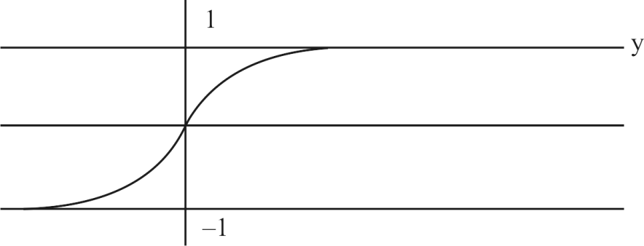
graph shows f(x) is one-one and onto as range = co-domain.

Level 2

Q1. $Domain of f\left(x\right)=\sqrt{x-4-2\sqrt{x-5}}-\sqrt{x-4+2\sqrt{x-5}}$
(a) (5, $∞$)
(b) [$5, ∞)$
(c) [$-5, 0]$
(d) [$-6, -5)$
L3Difficulty3
Qtag Mathematics
Qcreator Pagemaker10

Q2. Solve $log_{x}$(x²$-1)≤0$
(a) (1, $\sqrt{2}]$
(b) (1, $\sqrt{2})$
(c) [1, $\sqrt{2})$
(d) none
L3Difficulty3
Qtag Mathematics
Qcreator Pagemaker10

Q3. The range of the function $f\left(x\right)=$ $6^{x}+3^{x}+6^{-x}+3^{-x}+2$
(a) [6, $∞$)
(b) ($5, 1)$
(c) ($-4, 4)$
(d) (0, 1)
L3Difficulty3
Qtag Mathematics
Qcreator Pagemaker10

Q4. Find the range of $f\left(x\right)=\sqrt{x-1}+\sqrt{5-1}$
(a) [1, 5)
(b) [2, 6]
(c) (1, 5)
(d) [2, 2$\sqrt{2})$
L3Difficulty3
Qtag Mathematics
Qcreator Pagemaker10

Q5. Find the No. of solution sin x = $\frac{x}{10}$
(a) 7
(b) 8
(c) 9
(d) 10
L3Difficulty3
Qtag Mathematics
Qcreator Pagemaker10

Q6. Find the domain of $f\left(x\right)=\sqrt{\left[x\right]-1}+\sqrt{4-[x]}$ [x}, is greatest integer
(a) [2, 10]
(b) [1, 5)
(c) ($-∞, 1]$
(d) none
L3Difficulty3
Qtag Mathematics
Qcreator Pagemaker10

Q7. $f(x)$ = log(x+$\sqrt{1+x^{2}})$ is which type of function
(a) odd function
(b) even function
(c) neither even nor odd
(d) none
L3Difficulty3
Qtag Mathematics
Qcreator Pagemaker10

Q8. Period of $f\left(x\right)=tan\frac{π}{2}[x]$
(a) 1
(b) 3
(c) 2
(d) 4
L3Difficulty3
Qtag Mathematics
Qcreator Pagemaker10

Q9. If $f\left(x\right)=$ 3x$-2$ and (gof$)^{-1}$x = x – 2 then g(x) is
(a) $\frac{x+8}{3}$
(b) $\frac{x+7}{3}$
(c) $\frac{x+6}{3}$
(d) none
L3Difficulty3
Qtag Mathematics
Qcreator Pagemaker10

Q10. Period of $f\left(x\right)=\sin{x+}\{x\}$ is
(a) not periodic
(b) 1
(c) 2
(d) 4
L3Difficulty3
Qtag Mathematics
Qcreator Pagemaker10

Solutions

S1. Ans. (b)
Sol.
f(x) = $\sqrt{x-5-2\sqrt{x-5}+1}$
$-\sqrt{x-4+2\sqrt{x-5}+1}$
f(x) = $\sqrt{(\sqrt{x-5}-1)^{2}}-$ $\sqrt{(\sqrt{x-5}+1)^{2}}$
= |$\sqrt{x-5}-1|-$ |$\sqrt{x-5}+1|$

S2. Ans. (a)
Sol.
lo$g_{x}($x²$-1)≤$ 0
if x > 1, then
0 < x² – 1 < 1
1 < x² $≤$ 2
[–$\sqrt{2}, -1)$ $∪$ (1, $\sqrt{2}$]
(1, $\sqrt{2}$]
0 < x < 1 $⇒$ x² – 1 $≥$ 1 $⇒$ x² $≥$ 2
x $∈$ ($-∞$, $-\sqrt{2}]$ $∪$ [$\sqrt{2}$, $∞$)
x $∈$ $ϕ$
x $∈$ (1, $\sqrt{2}$]

S3. Ans. (a)
Sol.
$f\left(x\right)=$ $6^{x}+3^{x}+6^{-x}+3^{-x}+2$
= ($\sqrt{6^{x}}-\sqrt{6^{-x}})^{2}$ + ($\sqrt{3^{x}}-\sqrt{3^{-x}})^{2}$ + 6 $≥$ 6
[6, $∞$]

S4. Ans. (d)
Sol.
y = $\sqrt{x-1}+\sqrt{5-x}$
y² = $x-1+5-x+2\sqrt{\left(x-1\right)(5-x)}$
y² $=4+2\sqrt{-x^{2}-5+6x}$
y²$=4+2{\sqrt{4-(x-3)}}^{2}$
y² minimum 4 maximum 8
[2, 2$\sqrt{2}$}

S5. Ans. (a)
Sol.
f(x) = sin x g(x) = $\frac{x}{10}$
–1 $≤$ sin x $≤$ 1, –1 $≤$ $\frac{x}{10}$ $≤$ 1
x $∈$ [$-10, 10]$
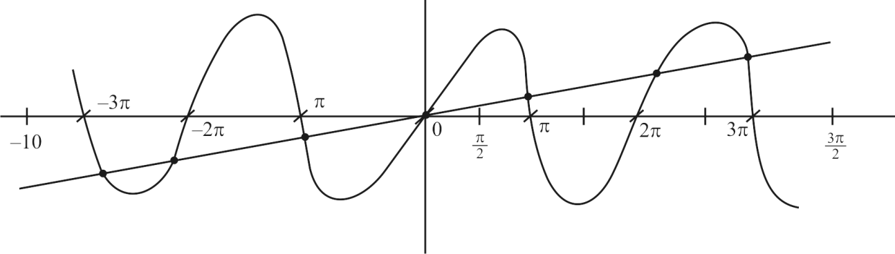

S6. Ans. (b)
Sol.
f(x) = $\sqrt{\left[x\right]-1}+\sqrt{4-\left[x\right]}$
[x]$-1≥0$ and $4-[x]≥0$
1$≤\left[x\right]≤4$ or 1 $≤$ x $≤$ 5

S7. Ans. (a)
Sol.
f(x) = log(x + $\sqrt{1+x^{2}})$
= log($-x+\sqrt{1+x^{2}})$
= log $\frac{(\sqrt{1+x^{2}}-x)(\sqrt{1+x^{2}}+x)}{(\sqrt{1+x^{2}}+x)}$
= log $\frac{1}{x+\sqrt{1+x^{2}}}$
= $-log(x+\sqrt{1+x^{2}})$
odd function

S8. Ans. (c)
Sol.
tan$\frac{π}{2}[x+T]$ = tan$\frac{π}{2}[x]$
$\frac{π}{2}\left[x+T\right]=\frac{π}{2}$[x]
period 2$∙$(least positive value)

S9. Ans. (a)
Sol.
f(x) = 3x – 2
$f^{-1}$(x) = $\frac{x+2}{3}$
(gof$)^{-1}x=x-2$
$f^{-1}og^{-1}$(x$)=x-2$
$$\frac{g^{-1}\left(x\right)+2}{3}=x-2$$
$$g^{-1}\left(x\right)=3x-8$$
g(x$)=\frac{x+8}{3}$

S10. Ans. (a)
Sol.
sin x period 2$π$
{x} period 1
Hence L.C.M. of 2$π$ and 1 not exit, not periodic.

LEVEL-III

Q1. The number of points in ($-∞, ∞)$, for which x² – xsinx –cosx = 0, is
(a) 6
(b) 4
(c) 2
(d) 0
L5Difficulty5
Qtag Mathematics
Qcreator Pagemaker10

Q2. $The function f :\left[0, 3\right]⟶$[1, 29], defined by f(x) = 2x³ – 15x² + 36x + 1, is
(a) one-one and onto
(b) onto but not one-one
(c) one-one but not onto
(d) neither one-one nor onto
L5Difficulty5
Qtag Mathematics
Qcreator Pagemaker10

Q3. $Let f\left(x\right)=x^{2}$ and g(x) = sinx for all x $∈$ $R$. Then the set of all x satisfying (fogogof) (x) = (gogof) (x), where (fog) (x) = f(g(x)), is
(a) ±$\sqrt{nπ}$, n $∈$ {0, 1, 2, ......}
(b) ±$\sqrt{nπ}$, n $∈$ {1, 2, ......}
(c) $\frac{π}{2}+2nπ$, n $∈$ {...., $-2, -1, 0, 1, 2,$ ......}
(d) $2nπ$, n $∈$ {...., $-2, -1, 0, 1, 2,$ ......}
L5Difficulty5
Qtag Mathematics
Qcreator Pagemaker10

Q4. If f"(x) = –f(x) and g(x) = f'(x) and F(x) = ${\left(f\left(\frac{x}{2}\right)\right)}^{2}$+${\left(g\left(\frac{x}{2}\right)\right)}^{2}$and given that F(5) = 5, then F(10) is equal to
(a) 5
(b) 10
(c) 0
(d) 15
L5Difficulty5
Qtag Mathematics
Qcreator Pagemaker10

Q5. If the functions f(x) and g(x) are defined on R$⟶$R such that
f(x) = $\left\{\begin{matrix}0, & x∈rational \\ x, & x∈irrational\end{matrix}\right.$ , g(x) = $\left\{\begin{matrix}0, & x∈irrational \\ x, & x∈rational\end{matrix}\right.$ , then (f – g)(x) is
(a) one-one and onto
(b) neither one-one nor onto
(c) one-one but not onto
(d) onto but not one-one
L5Difficulty5
Qtag Mathematics
Qcreator Pagemaker10

Q6. X and Y are two sets and f : X $⟶$ Y. If f(c) = {y; c $⊂$ X, y $⊂$ Y} and f^{–1}(d) = {x; d$⊂$Y, x $⊂$ X}, then the true statement is
(a) f(f^{–1}(b)) = b
(b) f^{–1}(f(a)) = a
(c) f(f^{–1}(b)) = b, b $⊂$ y
(d) f^{–1}(f(a)) = a, a $⊂$ x
L5Difficulty5
Qtag Mathematics
Qcreator Pagemaker10

Q7. $If f\left(x\right)=$sin x + cos x, g(x) = x² – 1, then g(f(x)) is invertible in the domain
(a) $\left[0, \frac{π}{2}\right]$
(b) $\left[-\frac{π}{4}, \frac{π}{4}\right]$
(c) $\left[-\frac{π}{2}, \frac{π}{2}\right]$
(d) [0, $π]$
L5Difficulty5
Qtag Mathematics
Qcreator Pagemaker10

Q8. If f : [0, $∞$) $⟶$ [0, $∞$), and f(x) = $\frac{x}{1+x}$ then f is
(a) one-one and onto
(b) one-one but not onto
(c) onto but not one-one
(d) neither one-one nor onto
L5Difficulty5
Qtag Mathematics
Qcreator Pagemaker10

Q9. Range of the function f(x) = $\frac{x^{2}+x+2}{x^{2}+x+1}$ ; x $∈$ R is
(a) (1, $∝$)
(b) (1, 11/7]
(c) (1, 7/3]
(d) (1, 7/5)
L5Difficulty5
Qtag Mathematics
Qcreator Pagemaker10

Q10. Domain of definition of the function f(x) = $\sqrt{sin^{-1}\left(2x\right)+\frac{π}{6}}$ for real valued, x is
(a) $\left[-\frac{1}{4}, \frac{1}{2}\right]$
(b) $\left[-\frac{1}{2}, \frac{1}{2}\right]$
(c) $\left[-\frac{1}{2}, \frac{1}{9}\right]$
(d) $\left[-\frac{1}{4}, \frac{1}{4}\right]$
L5Difficulty5
Qtag Mathematics
Qcreator Pagemaker10

Solutions

S1. Ans. (c)
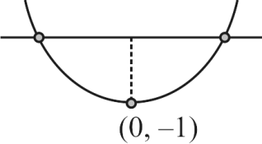
Sol.
Let f(x) = x² – x sin x – cos x $⇒$ f'(x) = 2x – x cos x
f(x) $⟶$ $∞$
f(x) $⟶$ $∞$
f(0) = –1
Hence 2 solutions.

S2. Ans. (b)
Sol.
f(x) = 2x³ – 15x² + 36x + 1
f'(x) = 6x² – 30x + 36
= 6 (x² – 5x + 6)
= 6 (x – 2) (x – 3)
f(x) is increasing in [0, 2] and decreasing in [2, 3]
f(x) is many one
f(0) = 1
f(2) = 29
f(3) = 28
Range is [1, 29]
Hence, f(x) is many-one-onto

S3. Ans. (a)
Sol.
(fogogof) (x) = sin² (sin x²)
(gogof) (x) = sin (sin x²)
$∴$ sin² (sin x²) = sin (sin x²)
$⇒$ sin (sin x²) [sin (sin x²) – 1] = 0 $⇒$ sin (sin x²) = 0 or 1
$⇒$ sin x² = n$π$ or 2m$π$ + $π$/2, where m, n $∈$ I
$⇒$ sin x² = 0
$⇒$ x² = n$π$ $⇒x$ = ± $\sqrt{nπ}$, n $∈$ {0, 1, 2, ...}.

S4. Ans. (a)
Sol.
f"(x) = –f(x) and f'(x) = g(x) $⇒$ f"(x) . f'(x) + f(x) . f'(x) = 0
$⇒$ f(x)² + (f'(x))² = c $⇒$ (f(x)² + (g(x))² = c $⇒$ F(x) = c.

S5. Ans. (a)
Sol. Let h(x) = f(x) – g(x) = $\left\{\begin{matrix}x; & x∈irrational \\ -x; & x∈rational\end{matrix}\right.$ $⇒$ the function h(x) is one-one and onto.

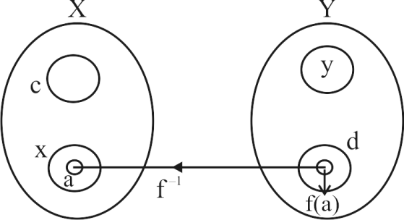
S6. Ans. (d)
Sol.
The given data is shown in the figure
Since $f^{-1}\left(d\right)= x$
$⇒$ f(x) = d
Now, if a $⊂$ x, f(a)$⊂$ d
$⇒$ $f^{-1}\left(f\left(a\right)\right)$ = a.

S7. Ans. (b)
Sol.
g(f(x)) = (sin x + cos x)² – 1 = sin 2x which is invertible in $\left[\frac{-π}{4}, \frac{π}{4}\right]$.

S8. Ans. (b)
Sol.
f'(x) = $\frac{1}{(1+{x)}^{2}}$ > 0 $∀$ x $∈$ [0, $∞$) and range $∈$ [0, 1) $⇒$ function is one-one but not onto

S9. Ans. (c)
Sol.
f(x) = 1 + $\frac{4}{(2x+1)^{2}+3}$ $⇒$ Range = (1, 7/3].

S10. Ans. (a)
Sol.
– $\frac{π}{6}$ $≤$ sin^{–1}(2x) $≤$ $\frac{π}{2}$ $⇒$ $-\frac{1}{2}$ $≤$ 2x $≤$ 1 $⇒$ x $∈$ $\left[-\frac{1}{4}, \frac{1}{2}\right]$.

