Q1. Which one of the following pair is NOT correctly matched?
Wildlife Sanctuary Location
(a) Mahavir Swami Sanctuary - Lalitpur District
(b) Lakh Bahosi Sanctuary - Kannauj District
(c) Kishanpur Wildlife Sanctuary - Balrampur District
(d) Kaimor Sanctuary - Mirzapur and Sonbhadra District

Q2. Which of the following Articles empowers the President to grant pardon?
(a) Art. 72
(b) Art. 74
(c) Art. 78
(d) Art. 80

Q3. Which of the following country was elected to the United Nations Human Rights Council for 2022-24 period in its election held in October 2021?
(a) Honduras
(b) France
(c) Canada
(d) Japan

Q4. In the reign of which Chola King first trade delegation was sent to China?
(a) Rajendra I
(b) Raja Raj
(c) Vikram Chola
(d) Raja Mahendra

Q5. Which one of the following Revolutionaries was NOT associated with the "Kakori Train Incident"?
(a) Rajendra Lahiri
(b) Ashfakullah Khan
(c) Khudiram Bose
(d) Roshan Singh

Q6. Who among the following became the first Indian women wrestler to win silver medal in World Wrestling Championship in October 2021?
(a) Vinesh Phogat
(b) Gita Phogat
(c) Anshu Malik
(d) Jyoti Tripathi

Q7. The Citizenship (Amendment) Bill 2019 was passed by the Parliament on which date?
(a) 11 December 2019
(b) 10 December 2019
(c) 9 December 2019
(d) 8 December 2019

Q8. Match List – I with List – II and select the correct answer using the codes given below the lists.
List – I List – II
(Vedas) (Brahmans)
A. Rigveda 1. Gopath Brahman
B. Yajurveda 2. Kaushitaki Brahman
C. Samveda 3. Satpath Brahman
D. Atharvaveda 4. Panchvish Brahman
Codes:
A B C D
(a) 2 3 4 1
(b) 3 4 2 1
(c) 2 1 3 4
(d) 1 2 4 3

Q9. Which Part of the Indian Constitution contains the Union-State Relations?
(a) Part - V
(b) Part - VII
(c) Part - VIII
(d) Part - XI

Q10. When was "Ek Bharat Shreshtha Bharat" announced?
(a) 2014
(b) 2015
(c) 2017
(d) 2018

Q11. To whom the credit is given to organize the labour movements is India?
(a) Bal Gangadhar Tilak
(b) Narain Medhji Lokhande
(c) N. M. Joshi
(d) Swami Sahjanand Saraswati

Q12. In which year was the National Development Council formed?
(a) 1947
(b) 1952
(c) 1965
(d) 1966

Q13. The "Chandra Prabha Wildlife3 Sanctuary" a major wildlife sanctuary of Uttar Pradesh is situated in which of the following?
(a) Pilibhit District
(b) Chandauli District
(c) Unnao District
(d) Maharajganj District

Q14. With reference to Nobel Peace Prize announced in October 2021, which of the following statement(s) is/are correct?
1. Maria Ressa and Dmitry Muratov have jointly won this prize.
2. Both the winners of this year's award are journalists.
Select the correct answer from the codes given below:
Codes:
(a) Only 1
(b) Only 2
(c) Both 1 and 2
(d) Neither 1 nor 2

Q15. How many members are there in the Committee on Privileges?
(a) 12
(b) 15
(c) 20
(d) 22

Q16. Which one of the following is NOT a Andaman and Nicobar groups of Islands?
(a) Rutland Island
(b) Narcondum Island
(c) Bompoka Island
(d) Amin Divi Island

Q17. Patron of Literature, Jahangir awarded the title of "Pandit Raj" to whom?
(a) Munishwar Das
(b) Bhagawati Swami
(c) Jagannath
(d) Raghunath

Q18. Who was the advisor of Constituent Assembly of India?
(a) Dr. B. R. Ambedkar
(b) Dr. Rajendra Prasad
(c) Sh. B. N. Rau
(d) Dr. K. M. Munshi

Q19. When did World Health Organisation declare COVID-19 a pandemic?
(a) 11 March 2020
(b) 13 January 2020
(c) 22 February 2020
(d) 21 January 2020

Q20. Consider the following events and arrange these in chronological order.
1. Simon Commission
2. Cabinet Mission Plan
3. First Meeting of Indian Constitution Assembly
4. Quit India Movement
Select the correct answer from the codes given below:
Codes:
(a) 1, 4, 2, 3
(b) 1, 2, 3, 4
(c) 2, 1, 3, 4
(d) 2, 1, 4, 3

Q21. Match List – I with List – II and select the correct answer from the codes given below.
List – I List – II
(Minerals) (Mines)
A. Copper 1. Bailadila
B. Iron ore 2. Balaghat
C. Manganese 3. Taloja
D. Mica 4. Nellor
Codes:
A B C D
(a) 3 2 4 1
(b) 2 1 4 3
(c) 4 1 2 3
(d) 3 1 2 4

Q22. The Tropic of Cancer passes through which of the following States?
1. Tripura
2. Mizoram
3. Manipur
4. West Bengal
Select the correct answer from the codes given below:
Codes:
(a) 1, 2 and 3
(b) 2, 3 and 4
(c) 1, 2 and 4
(d) 1, 3 and 4

Q23. Consider the following events and arrange them into chronological order.
I. Construction of Dhai Din Ka Jhopra
II. Construction of Quwat-ul-Islam Mosque
III. Construction of Siri Fort
IV. Construction of Sultan Garhi
Select the correct answer from the codes given below:
Codes:
(a) II, I, III and IV
(b) II, I, IV and III
(c) I, II, IV and III
(d) I, II, III and IV

Q24. With reference to the inauguration of the International Airport at Kushinagar in October 2021, which of the following statement(s) is/are correct?
1. The first inaugural flight to land was of Sri Lankan Airlines.
2. Kushinagar became the Fourth International Airport of Uttar Pradesh.
Select the correct answer from the codes given below:
Codes:
(a) Only 1
(b) Only 2
(c) Both 1 and 2
(d) Neither 1 nor 2

Q25. Which one of the following city was selected as 100th Smart City in India?
(a) Srinagar
(b) Shivamogga
(c) Shillong
(d) Satna

Q26. Which factors affect the volumetric efficiency of a single-stage reciprocating compressor?
1. Cylinder size
2. Clearance ratio
3. Delivery pressure
4. Compressor power
Select the correct code.
(a) 1 and 2
(b) 3 and 4
(c) 2 and 3
(d) 1 and 4

Q27. The pressure drop in a pipe flow is directly proportional to the mean velocity. It can be deduced that the
(a) Flow is laminar
(b) Flow is turbulent
(c) Pipe is smooth
(d) Pipe is rough

Q28. The depth of centre of pressure in a rectangular lamina immersed vertically in water upto a height of h is given by
(a) $\frac{h}{4}$
(b) $\frac{2h}{3}$
(c) $\frac{3h}{4}$
(d)$\frac{h}{2}$

Q29. A long cylindrical rod of radius 'R' has a surface heat flux of q₀. The uniform internal heat generation rate in the rod is
(a) $2\frac{q_{0}}{R}$
(b) $2 q_{0}$
(c) $\frac{q_{0}}{R}$
(d) $\frac{q_{0}}{R^{2}}$

Q30. In an aircraft refrigeration system, the pressure at cooling turbine exit is equal to
(a) ambient pressure
(b) cabin pressure
(c) pressure at the compressor inlet
(d) none of the above

Q31. A system of 100 kg mass undergoes a process in which its specific entropy increases from 0.3 to 0.4 kJ/kgK. At the same time, the entropy of the surroundings decreases from 80 kJ.K to 75 kJ/K. The process is
(a) reversible and isothermal
(b) irreversible
(c) reversible
(d) impossible

Q32. Cavitation in the turbine occurs near the
(a) inlet on the concave side of the blades
(b) outlet on the concave side of the blades
(c) outlet on the convex side of the blades
(d) inlet on the convex side of the blades

Q33. Across a normal shock, the stagnation
(a) decreases
(b) increases
(c) remains constant
(d) depends on irreversibility

Q34. Fins are used to increase the rate of heat transfer, but fins also act as insulation. Which of the non-dimensional number decides this factor?
(a) Eckert number
(b) Biot number
(c) Fourier number
(d) Peclet number

Q35. A Carnot engine is operating between source and sink temperatures of T₁ and T₂ respectively. It has efficiency of 30%. If the sink temperature is reduced by 25°C, then the efficiency is increased to 35%. The source temperature T₁ is
(a) 227°C
(b) 272°C
(c) 252°C
(d) 257°C

Q36. COP of a domestic refrigerator as compared to that of an air conditioner is generally
(a) more
(b) less
(c) same
(d) cannot be compared

Q37. If the dryness fraction of a steam sample by throttling calorimeter is 0.8 and that by separating calorimeter is also 0.8, then the actual dryness fraction of sample will be
(a) $\sqrt{0.8}$
(b) 0.8
(c) 0.4
(d) 0.64

Q38. The spark plug gap is normally kept between
(a) 0.1 to 0.2 mm
(b) 0.2 and 0.4 mm
(c) 0.45 to 0.6 mm
(d) 0.65 to 0.85 mm

Q39. A velocity field is given by the equation $v=\left(3x\right)i+\left(2y\right)j$. Then y-component of the acceleration, 'a_{y}' is
(a) 2y
(b) 9x
(c) 3x
(d) 4y

Q40. The temperature variation in a plate is shown in figure. Which of the following corresponds with the condition?
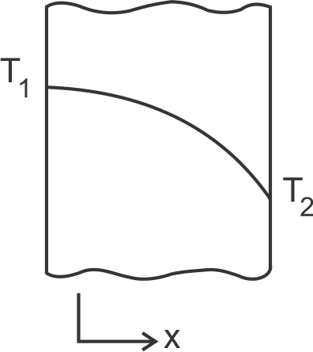
1. Unsteady heat transfer
2. Steady state heat transfer with variable 'k'
3. Steady state heat transfer with heat generation
Select the correct code.
(a) 2 alone
(b) 1 and 2
(c) 1 and 3
(d) 1, 2 and 3

Q41. Air Washer can work as
1. Humidifier only
2. Dehumidifier only
3. Filter only
Which of the statements given is correct?
(a) only 1
(b) only 2 and 3
(c) only 1 and 3
(d) 1, 2 and 3

Q42. Assertion (A): The work output of SI engines can be improved by increasing the compression ratio.
Reason (R): Fuels of higher octane number can be employed at higher compression ratio.
Select the correct answer.
(a) Both (A) and (R) are true and (R) is correct explanation of (A)
(b) Both (A) and (R) are true but (R) is not correct explanation of (A)
(c) (A) is true, (R) is false
(d) (A) is false, (R) is true

Q43. A cycle is shown in the Figure in P-V diagram. Same cycle on the T-S diagram will be represented by
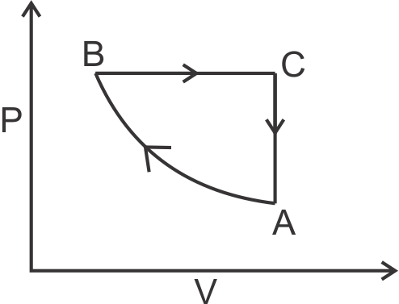
(a)
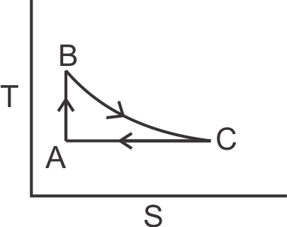
(b)
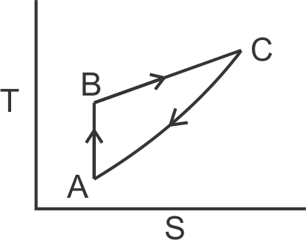
(c)
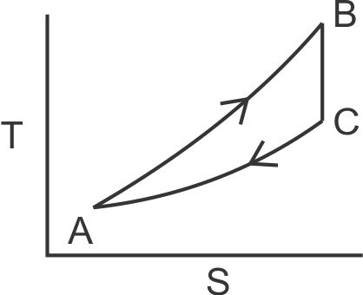
(d)
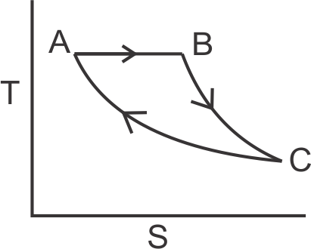

Q44. In an axial flow compressor stage, air enters and leaves the stage axially. If the whirl component of the air leaving the rotor is half the mean peripheral velocity of the rotor blades, then the degree of reaction will be
(a) 1.00
(b) 0.75
(c) 0.50
(d) 0.25

Q45. The compression ratio in a jet engine is proportional to
(a) speed
(b) (speed)²
(c) ${\left(speed\right)}^{\frac{1}{2}}$
(d) altitude

Q46. A simple pitot tube can be used to measure the following:
1. Static head
2. Datum head
3. Dynamic head
4. Friction head
5. Total head
Select the correct code.
(a) 1, 2 and 4
(b) 1, 3 and 5
(c) 2, 3 and 4
(d) 2, 3 and 5

Q47. 11 mm diameter wire is to be coated with enamel paint $\left(k=0.1\frac{W}{mK}\right)$. If the air convection heat transfer coefficient is $100\frac{W}{m^{2}K}$, the layer thickness of enamel paint for maximum heat transfer is
(a) 0.25 mm
(b) 0.5 mm
(c) 1 mm
(d) 2 mm

Q48. In a polytropic process the heat rejected is given by
(a) $\frac{γ}{γ-1}×work done$
(b) $\frac{γ-n}{γ-1}×work done$
(c) $\frac{γ-n}{γ}×work done$
(d)$\frac{γ-1}{n}×work done$

Q49. For a given sample of moist air relative humidity is increased isothermally.
Choose the correct option.
(a) WBT and enthalpy increases
(b) WBT and enthalpy decreases
(c) WBT increases but enthalpy decreases
(d) WBT decreases but enthalpy increases

Q50. An adiabatic steam value causes a drop of 0.8 kJ/kg in enthalpy. If inlet velocity is negligible, the steam velocity at the exit is
(a) 4 m/s
(b) 40 m/s
(c) 80 m/s
(d) 120 m/s

Q51. In liquid metals, the thermal boundary layer develops much faster than the velocity boundary layer due to
(a) low value of Nusselt number
(b) high value of Prandtl number
(c) low value of Prandtl number
(d) high value of Nusselt number

Q52. The standard value of solar constant as adopted by World Radiation Centre is
(a) 1192 $\frac{w}{m^{2}}$
(b) 1084 $\frac{w}{m^{2}}$
(c) 1927$\frac{w}{m^{2}}$
(d) 1367 $\frac{w}{m^{2}}$

Q53. For a laminar flow through circular pipe, the ratio of maximum velocity and average velocity is
(a) 1.0
(b) 1.33
(c) 1.5
(d) 2.0

Q54. Tds equation is
(a) $Tds=dh+Vdp$
(b) $Tds=dh-+Vdp$
(c) $Tds=dh-Pdv$
(d)$Tds=dh+Pdv$

Q55. A gas contained in a cylinder is compressed. The work done is 5000 kJ and during this process 2000 kJ heat is lost to the surroundings. The change in internal energy is
(a) $-7000 kJ$
(b) $-3000 kJ$
(c) $+3000 kJ$
(d)$+7000 kJ$

Q56. Greater the difference between jet velocity and aeroplane velocity
(a) greater is the propulsion efficiency
(b) smaller is the propulsion efficiency
(c) propulsion efficiency remains unaffected
(d) none of the above

Q57. The friction factor in a pipe flow near critical flow condition is around
(a) 0.064
(b) 0.025
(c) 0.64
(d) 0.032

Q58. For a double pipe counter flow heat exchanger with $\frac{C_{Min}}{C_{Max}}=1$, the effectiveness of heat exchanger is
(a) $1+\frac{1}{NTU}$
(b) $\frac{NTU}{NTU-1}$
(c) $\frac{NTU}{NTU+1}$
(d) $\frac{1+NTU}{1-NTU}$

Q59. Which of the following refrigerant has maximum latent heat at their normal boiling point?
(a) $SO_{2}$
(b) ${CO}_{2}$
(c) ${NH}_{3}$
(d) R-12

Q60. The vapour pressure is the characteristic fluid property involved in the phenomenon of
(a) water hammer in pipe flow
(b) cavitation
(c) rise of sap in a tree
(d) spherical shape of rain water drops

Q61. A Carnot engine operates between 27°C and 327°C. If the engine produces 300 kJ of work, the entropy change during heat addition is
(a) 0.5 kJ/K
(b) 1.0 kJ/K
(c) 1.5 kJ/K
(d) 2.0 kJ/K

Q62. For a given speed of rotation, the power required to drive a centrifugal pump is proportional to
(a) D
(b) D²
(c) D³
(d) D⁴
where D = Impeller Diameter.

Q63. For a fully developed turbulent flow in a pipe with heating, the Nusselt Number (Nu) varies with Reynold's Number (Re) and Prandtl Number (Pr), as
(a) Re^{0.5}. ${Pr}^{\frac{1}{3}}$
(b) Re^{0.8}. Pr^{0.2}
(c) Re^{0.8}. Pr^{0.4}
(d) Re^{0.8}. Pr^{0.3}

Q64. The chemical formula of environment friendly refrigerant R-134a is
(a) $C_{2}H_{2}F_{4}$
(b) $C_{2}{CI}_{3}F_{3}$
(c) $C_{2}{CI}_{2}F_{4}$
(d) $CHCI F_{4}$

Q65. A body whose absorptivity does not vary with temperature and wavelength of the incident ray is known as
(a) black body
(b) white body
(c) grey body
(d) opaque body

Q66. In a vapour compression system, the condition of refrigerant before entering the expansion valve is
(a) high pressure subcooled liquid
(b) wet vapour
(c) very wet vapour
(d) dry vapour

Q67. During chemical dehumidification process
(a) DBT and specific humidity decreases
(b) DBT and relative humidity remain unaffected
(c) DBT increases and specific humidity decreases
(d) DBT decreases and specific humidity increases

Q68. An ideal gas cycle is shown in the Figure. The thermodynamic efficiency is
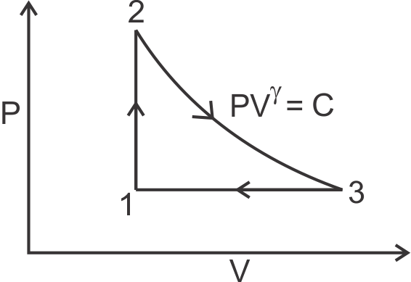
(a) $1-\left(\frac{V_{3}}{V_{1}}-1\right)$
(b) $1-\frac{1}{γ}\frac{(V_{3}/V_{1}-1)}{(P_{2}{/P}_{1}-1)}$
(c) $1-γ\frac{\left(V_{3}-V_{1}\right)}{\left(P_{2}-P_{1}\right)} \frac{P_{1}}{V_{1}}$
(d) $1-\frac{(V_{3}-V_{1})}{γ(P_{2}-P_{1})}\frac{P_{1}}{V_{1}}$

Q69. Assertion (A): Multistaging is done only in reciprocating compressors.
Reason (R): Reciprocating compressors are used to compress large pressure ratios at low discharge.
(a) both (A) and (R) are true and (R) is correct explanation of (A)
(b) both (A) and (R) are true but (R) is not a correct explanation of (A)
(c) (A) is true, (R) is false
(d) (R) is true, (A) is false

Q70. Which of the following substances has the minimum value of thermal conductivity?
(a) Rubber
(b) Ceramic
(c) Air
(d) Lubricating Oil

Q71. The latent heat of steam with increase in pressure
(a) Increases
(b) Decreases
(c) Does not change
(d) Remains unpredictable

Q72. Addition of fins increases heat transfer if $\sqrt{\frac{hA}{kP}}$ is
(a) Equal to 1
(b) Greater than 1
(c) Less than 1
(d) Greater than 1 but less than 2

Q73. In a cooling tower, the minimum temperature to which water can be cooled is equal to
(a) dew point temperature of air at inlet
(b) mean of dry bulb temperature and wet bulb temperature of air at inlet
(c) thermodynamic web bulb temperature of air at inlet
(d) mean of dry bulb temperature and dew point temperature of the air at inlet

Q74. In reciprocating compressors for minimum work, the compression of air should be done
(a) adiabatically
(b) isentropically
(c) isothermally
(d) polytropically

Q75. For the flow of fluid over a heated plate, viscosity = 0.001 Pa.s, c_{p} = 1 kJ/Kg.K and thermal conductivity = 1 w/m.K. The hydrodynamic boundary layer at a specified location on the plate is 1 mm, the thickness of the thermal boundary layer at the same location will be
(a) 0.001 mm
(b) 0.01 mm
(c) 0.1 mm
(d) 1 mm

Q76. For a room RTH = 100 kW, RSHF = 0.75, volume flow rate of air = 100 m³/min, room specific heat = 0.01 Kg/Kg dry air. What is the supply air's specific humidity?
(a) 0.010
(b) 0.0075
(c) 0.005
(d) 0.0025

Q77. A system undergoes a process such that $\int{}\frac{δQ}{T}=0$ and $∆S>0$, the process is
(a) not possible
(b) irreversible and adiabatic
(c) isothermal
(d) isobaric

Q78. By higher octane number of SI fuel, it is meant that fuel has
(a) Higher heating value
(b) Longer ignition delay
(c) Higher flash point
(d) Lower volatility

Q79. A correctly designed convergent divergent nozzle working at a designed load
(a) is always isentropic
(b) is always choked
(c) is never choked
(d) there is no pressure drop across normal shock

Q80. Two long parallel planes with same emissivity 0.5 are maintained at different temperatures and have radiation heat exchange between them. If a radiation shield of emissivity 0.25 is placed between them, the fraction reduction in heat transfer is
(a) $\frac{1}{2}$
(b) $\frac{1}{4}$
(c) $\frac{3}{10}$
(d) $\frac{3}{5}$

Q81. For a Pelton wheel the ratio of depth of bucket to the diameter of jet is of the order of
(a) 1.2
(b) 1.5
(c) 1.8
(d) 2.0

Q82. The efficiency of pin fin with insulated tip is
(a) $\frac{tanhtanh mL }{mL}$
(b) $\frac{tanhtanh mL }{\sqrt{hA/kP}}$
(c) $\frac{mL }{tanhtanh mL}$
(d)$\frac{\sqrt{hA/kP} }{tanhtanh mL}$
where $m= \sqrt{Ph/kA}$ and other symbols have their usual meaning.

Q83. Clearance volume of a reciprocating compressor is 100 ml and the volume of cylinder at the bottom dead centre is 1 litre. The clearance ratio of the compressor is
(a) $\frac{1}{11}$
(b) $\frac{1}{10}$
(c) $\frac{1}{9}$
(d) $\frac{1}{12}$

Q84. Availability function of a closed system is expressed as
(a) $ϕ=u+P_{o}v-T_{o}s$
(b) $ϕ=du+P_{o}dv-T_{o}ds$
(c) $ϕ=du+P_{o}dv+T_{o}ds$
(d)$ϕ=u_{o}+P_{o}v-T_{o}s$

Q85. An industrial heat pump operates between 27°C and –13°C temperatures. The rate of heart addition and heat rejection are 750W and 1000W respectively. The COP of the heat pump is
(a) 7.25
(b) 6.5
(c) 4.0
(d) 3.0

Q86. Decrease in air-fuel ratio in spark ignition engines results in
(a) increase in NO_{x}
(b) a decrease in CO and unburnt hydrocarbon
(c) an increase in CO and unburnt hydrocarbon
(d) none of the above

Q87. In a fully developed turbulent flow, if the diameter is reduced to half without changing the flow rate, the frictional drop will become
(a) 32 times
(b) 16 times
(c) 8 times
(d) 4 times

Q88. The laminar boundary layer thickness for flow over a flat plate varies with distance x from leading edge as
(a) $\frac{1}{x}$
(b) $\frac{1}{x^{\frac{1}{2}}}$
(c) $x^{\frac{1}{2}}$
(d) $x^{\frac{4}{5}}$

Q89. For the circular tube shown in the figure, view factor $F_{13}=0.17.$
The view factor $F_{12}$ will be
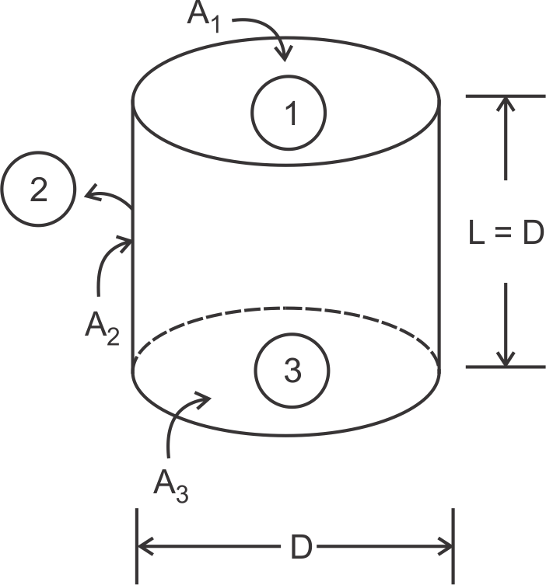
(a) 0.17
(b) 0.21
(c) 0.79
(d) 0.83

Q90. Change in entropy ∆s in an isothermal process is
(a) $–Rlnln \frac{V_{2}}{V_{1}}$
(b) $Rlnln \frac{P_{2}}{P_{1}}$
(c) $–Rlnln \frac{P_{2}}{P_{1}}$
(d) $–Rlnln \frac{V_{2}}{V_{1}}+ Rlnln \frac{P_{2}}{P_{1}}$

Q91. A room of size 20 m × 30 m × 4m has one air change peer hour due to infiltration. The outdoor and indoor DBT are 40°C and 25°C respectively. The sensible heat load due to infiltration is
(a) 734 kW
(b) 12.24 kW
(c) 0.204 kW
(d) 10 kW

Q92. A venture meter of 20 mm throat diameter is used to measure the velocity of water in a horizontal pipe of 40 mm diameter. If the pressure difference between the inlet and the throat is found to be 30 kPa, then neglecting frictional losses, the flow velocity is
(a) 0.2 m/s
(b) 1 m/s
(c) 1.4 m/s
(d) 2.0 m/s

Q93. The ratio of buoyant force to viscous force is called
(a) Prandtl number
(b) Reynold's number
(c) Eckert number
(d) Grashoff number

Q94. The entry length in a pipe flow will be higher for
(a) high viscosity fluids
(b) low viscosity fluids
(c) high velocity of flow
(d) small diameter

Q95. The equivalent thermal conductivity of the wall as shown in figure is
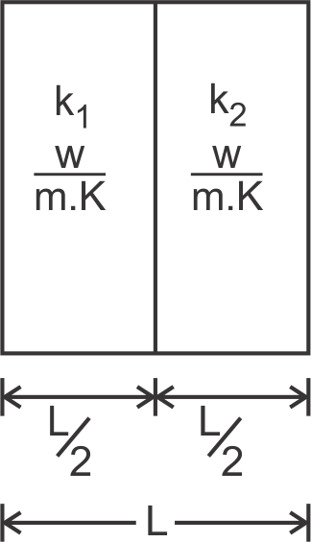
(a) $\frac{k_{1}+k_{2}}{2}$
(b) $\frac{k_{1}. k_{2}}{k_{1}+k_{2}}$
(c) $\frac{2k_{1}.k_{2}}{k_{1}+ k_{2}}$
(d) $\sqrt{k_{1}.k_{2}}$

Q96. Unit of thermal diffusivity is
(a) $\frac{m^{2}}{hr}$
(b) $\frac{m^{2}}{hr.°C}$
(c) $\frac{J}{m^{2}.hr.}$
(d) $\frac{J}{m^{2}.hr.°C}$

Q97. Moist air exists at a pressure of 1.01 bar. The partial pressure and saturation pressure of water vapour are 0.01 bar and 0.02 bar respectively. What are the values of RH and specific humidity respectively?
(a) 50%, 0.00622
(b) 100%, 0.0126
(c) 50%, 0.0126
(d) 100%, 0.00622

Q98. Areversible engine operates between temperatures 900 K and T₂ (T₂ < 900 K) and another reversible engine operates between temperatures T₂ and 400 K (T₂ > 400 K) in series, what is the value of T₂, if the work outputs of both the engines are equal?
(a) 600 K
(b) 625 K
(c) 650 K
(d) 675 K

Q99. Match the following and select the correct answer from the codes given below the lists.
List-I List-II
A. Steam Nozzle 1. Mach number
B. Compressible Flow 2. Reaction turbine
C. Surface Tension 3. Biot number
D. Heat conduction 4. Nusselt number
5. Super saturation
6. Weber number
Codes:
A B C D
(a) 1 3 5 6
(b) 1 2 4 5
(c) 4 1 6 2
(d) 5 1 6 3

Q100. The air-fuel ratio in a gas turbine is of the order of
(a) 7 : 1
(b) 15 : 1
(c) 30 : 1
(d) 50 : 1

Q101. In supersonic section of accelerating flow the area along flow direction
(a) decreases
(b) remains constant
(c) increases
(d) will depend on Mach number

Q102. The effectiveness of a fin will be maximum in an environment with
(a) free convection
(b) forced convection
(c) radiation
(d) convection and radiation

Q103. A heat engine having 70% efficiency is used to drive a refrigerator having a COP of 5. The cooling produced by refrigerator per kJ energy absorbed by engine from heat source is
(a) 0.14 kJ
(b) 0.71 kJ
(c) 3.5 kJ
(d) 7.1 kJ

Q104. Which of the following parameters are taken into account in effective temperature for human comfort?
1. DBT
2. WBT
3. Air Velocity
4. Solar radiation intensity
Select the correct code.
(a) 1 and 2
(b) 1 and 4
(c) 1, 3 and 4
(d) 1, 2 and 3

Q105. For a floating body, buoyant force acts at the
(a) centroid of the floating body
(b) centroid of the fluid vertically below the body
(c) centre of gravity of the body
(d) centroid of the displaced liquid

Q106. In a simple impulse turbine, the nozzle angle at the entrance is 30°. What is the blade-speed ratio $(\frac{u}{v})$ for maximum diagram efficiency?
(a) 0.25
(b) 0.55
(c) 0.433
(d) 0.866

Q107. During heating and humidification process, the final relative humidity
(a) increases
(b) decreases
(c) may increase or decrease
(d) remains constant

Q108. A cylindrical wood 20 cm in diameter and 1 m in height is placed in water in the vertical position. The specific gravity of wood is 0.6. It will
(a) float in stable equilibrium
(b) float in unstable equilibrium
(c) float in neutral equilibrium
(d) sink in water

Q109. The required mass of oxygen to convert 1 Kg of carbon into $\frac{11}{3}$ Kg of CO₂ is
(a) $\frac{8}{3}Kg$
(b) $\frac{4}{3}Kg$
(c) $\frac{11}{3}Kg$
(d) $\frac{3}{11}Kg$

Q110. An apartment with 300 MJ/day load, requires an air conditioner plant of the capacity of about
(a) 1 ton
(b) 5 tons
(c) 10 tons
(d) 100 tons

Q111. If the magnitude of $\int{}\left(–v\right) and \int{}\left(-v\right)dp$ for a thermodynamic system on calculation produces the same value during a process, then the process undergone is
(a) Isochoric
(b) Isentropic
(c) Isobaric
(d) Isothermal

Q112. In a radial blade centrifugal compressor the velocity of the blade tip is 400 m/s and the slip factor is 0.9. Assuming no whirl component of absolute velocity at inlet the work done per kg of flow is
(a) 36 kJ
(b) 72 kJ
(c) 144 kJ
(d) 360 kJ

Q113. A velocity field is given by the equation $v=\left(2+6x-6y\right)i+\left(3x+cx-y\right)j$. For the flow of the irrotational the value constant 'c' is
(a) –7
(b) –9
(c) 3
(d) 6

Q114. Critical radius of insulation for a sphere is equal to
(a) $\frac{k}{h}$
(b) $\sqrt{\frac{2k}{h}}$
(c) $\frac{h}{2k}$
(d) $\frac{2k}{h}$

Q115. The wet bulb depression is zero, when relative humidity is
(a) 100%
(b) 60%
(c) 50%
(d) zero

Q116. Which of the following would increase the probability of knocking in a CI engine?
1. Long ignition delay
2. High self ignition temperature
3. Low volatility of fuel
Select the correct answer from the codes given below.
(a) 1, 2 and 3
(b) 1 and 2
(c) 1 and 3
(d) 2 and 3

Q117. The unit discharge through a turbine is
(a) $\frac{Q}{H}$
(b) $\frac{Q}{\sqrt{H}}$
(c) $\frac{Q}{H^{\frac{3}{2}}}$
(d) $\frac{Q}{H^{\frac{5}{2}}}$

Q118. The pressure intensity at a point in a fluid is the same in all directions, only when the fluid
(a) is frictionless
(b) is frictionless and incompressible
(c) has zero viscosity and is at rest
(d) has no relative motion between adjacent fluid layers

Q119. Highest temperature encountered in refrigeration cycle should be
(a) near critical temperature of refrigerant
(b) above critical temperature
(c) much above critical temperature
(d) much below critical temperature

Q120. A system of perfect gas undergoes a reversible adiabatic expansion process.
1. Its entropy will increase
2. Its entropy change will be zero
3. The entropy change of the surroundings will be zero
Select the correct code.
(a) 1 and 3 are correct
(b) 2 alone is correct
(c) 2 and 3 are correct
(d) 1 alone is correct

Q121. Which of the following is considered to be a superior quality coal for power plants?
(a) Coke
(b) Lignite
(c) Bituminous
(d) Peat

Q122. The stream function of the flow field is given by the equation $Ψ=5+5y+6xy+2x$. The value of x-component of the velocity 'u' will be
(a) 5 + 6x
(b) 2 + 6x
(c) 6xy
(d) 2 + 6y

Q123. In a steam condenser, the partial pressure of steam and air are 0.06 bar and 0.007 bar respectively. The condenser operating pressure is
(a) 0.067 bar
(b) 0.06 bar
(c) 0.053 bar
(d) 0.007 bar

Q124. Air at DBT of 15°C enters a heating coil whose surface temperature is maintained at 40°C. The air leaves the heating coil at 25°C. The by-pass factor of the coil is
(a) 0.376
(b) 0.4
(c) 0.6
(d) 0.67

Q125. In a pipe flow Nusselt number (Nu) = 4.36, which of the following conditions apply for use of this equation?
(a) Laminar flow with constant wall temperature
(b) Turbulent flow with constant wall heat flux
(c) Turbulent flow with constant wall temperature
(d) Laminar flow with constant wall heat flux

Solutions
S1. Ans.()
S2. Ans.()
S3. Ans.()
S4. Ans.()
S5. Ans.()
S6. Ans.()
S7. Ans.()
S8. Ans.()
S9. Ans.()
S10. Ans.()
S11. Ans.()
S12. Ans.()
S13. Ans.()
S14. Ans.()
S15. Ans.()
S16. Ans.()
S17. Ans.()
S18. Ans.()
S19. Ans.()
S20. Ans.()
S21. Ans.()
S22. Ans.()
S23. Ans.()
S24. Ans.()
S25. Ans.()
S26. Ans.(c)
S27. Ans.(a)
S28. Ans.(b)
S29. Ans.(a)
S30. Ans.()
S31. Ans.(b)
S32. Ans.()
S33. Ans.(c)
S34. Ans.(b)
S35. Ans.(a)
S36. Ans.(b)
S37. Ans.(b)
S38. Ans.(c)
S39. Ans.(d)
S40. Ans.(a)
S41. Ans.(d)
S42. Ans.(b)
S43. Ans.(b)
S44. Ans.(d)
S45. Ans.()
S46. Ans.(b)
S47. Ans.(b)
S48. Ans.(b)
S49. Ans.(a)
S50. Ans.(b)
S51. Ans.(c)
S52. Ans.(d)
S53. Ans.(d)
S54. Ans.(b)
S55. Ans.(c)
S56. Ans.(b)
S57. Ans.()
S58. Ans.(c)
S59. Ans.(c)
S60. Ans.(b)
S61. Ans.(b)
S62. Ans.(c)
S63. Ans.(c)
S64. Ans.(a)
S65. Ans.(c)
S66. Ans.(a)
S67. Ans.(a)
S68. Ans.(c)
S69. Ans.()
S70. Ans.(c)
S71. Ans.(b)
S72. Ans.(b)
S73. Ans.(a)
S74. Ans.(b)
S75. Ans.(d)
S76. Ans.()
S77. Ans.(b)
S78. Ans.()
S79. Ans.(b)
S80. Ans.(a)
S81. Ans.()
S82. Ans.(a)
S83. Ans.(b)
S84. Ans.(a)
S85. Ans.(c)
S86. Ans.()
S87. Ans.(a)
S88. Ans.(c)
S89. Ans.(d)
S90. Ans.(c)
S91. Ans.()
S92. Ans.(d)
S93. Ans.(d)
S94. Ans.(a)
S95. Ans.(c)
S96. Ans.(a)
S97. Ans.(c)
S98. Ans.(a)
S99. Ans.(d)
S100. Ans.(d)
S101. Ans.(a)
S102. Ans.(b)
S103. Ans.(c)
S104. Ans.(d)
S105. Ans.(d)
S106. Ans.(d)
S107. Ans.(b)
S108. Ans.(b)
S109. Ans.(a)
S110. Ans.()
S111. Ans.(d)
S112. Ans.(b)
S113. Ans.(b)
S114. Ans.(d)
S115. Ans.(a)
S116. Ans.(c)
S117. Ans.(b)
S118. Ans.(d)
S119. Ans.()
S120. Ans.(c)
S121. Ans.(c)
S122. Ans.(a)
S123. Ans.(a)
S124. Ans.(c)
S125. Ans.(a)

